

Mobile Application Development  
2025-26

**Name**: Priyansh Nandan

**Registration** **Number**: 230953450

**Section**: CCE-D2

**Roll Number**: 50

Index

|  |  |  |
| --- | --- | --- |
| **S.No.** | **Title** | **Date** |
| 01 | Lab1- Basics of Android Mobile Application Development Tools | 08/01/26 |
| 02 | Lab2- Introduction to Activities and Layouts in Android | 15/01/26 |
| 03 | Lab3- Activities and Layouts continued | 22/01/26 |
| 04 | Lab4- Input Controls in Android | 29/01/26 |
| 05 | Lab5- Input Controls: Spinners and Pickers | 05/02/26 |
| 06 | Lab6- Introduction to Menus | 12/02/26 |
| 07 | Lab7- Creating Contextual and Pop-Up Menus | 12/02/26 |
| 08 | Lab8- |  |

**Lab 1- Basics of Android Mobile Application Development**

Question 1:

Create an Android application to show the demo of displaying text with justifying elements, changing text colors, fonts etc.

Layout Design

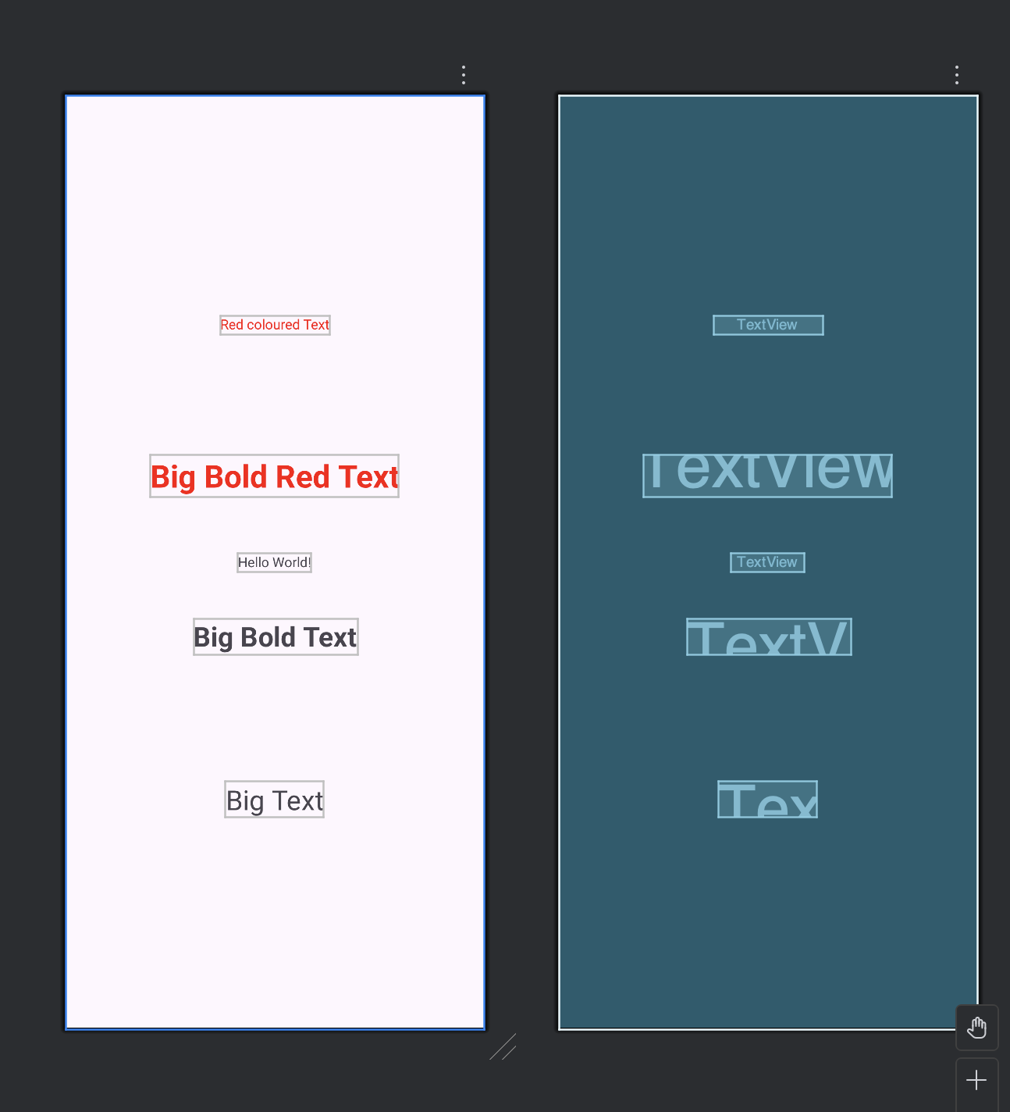

XML for activity_main

<TextView  
 android:id="@+id/textView5"  
 android:layout_width="wrap_content"  
 android:layout_height="wrap_content"  
 android:text="@string/BoldRed"  
 android:textColor="@color/red"  
 android:textSize="32sp"  
 android:textStyle="bold"  
 app:layout_constraintBottom_toTopOf="@+id/tv4"  
 app:layout_constraintEnd_toEndOf="parent"  
 app:layout_constraintStart_toStartOf="parent"  
 app:layout_constraintTop_toBottomOf="@+id/tv1" />

XML for colors

<?xml version="1.0" encoding="utf-8"?>  
<resources>  
 <color name="black">#FF000000</color>  
 <color name="white">#FFFFFFFF</color>  
 <color name="red">#FF0000</color>  
</resources>

XML for strings

<resources>  
 <string name="app_name">Question1</string>  
 <string name="RedColored">Red coloured Text</string>  
 <string name="BigText">Big Text</string>  
 <string name="BoldText">Big Bold Text</string>  
 <string name="BoldRed">Big Bold Red Text</string>  
</resources>

Output:

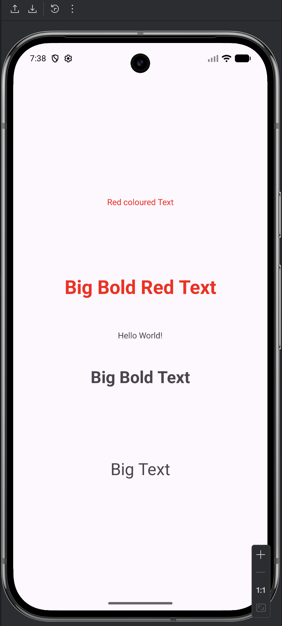

Question 2:

Find the “hello word” text in the XML document and modify the text.

Layout Design

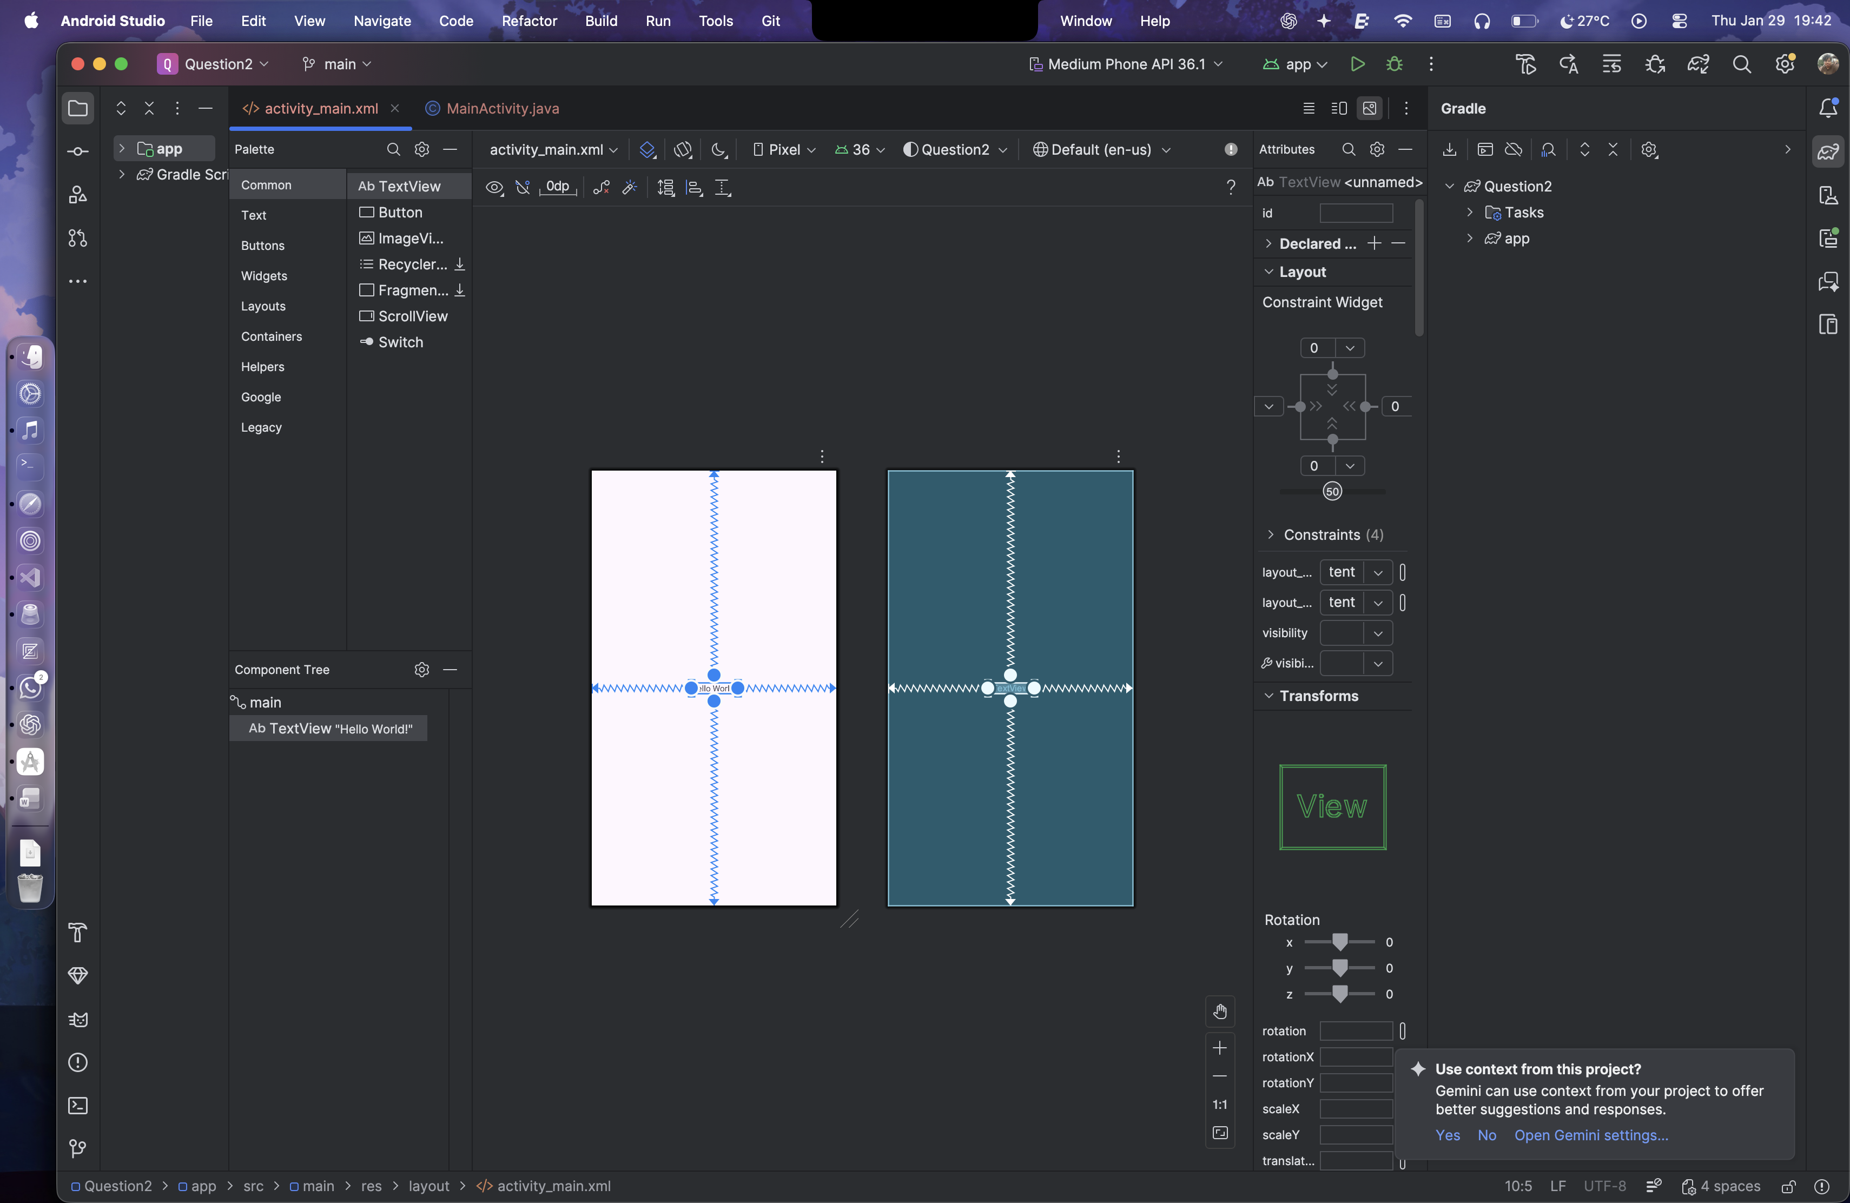

XML for activity_main

<?xml version="1.0" encoding="utf-8"?>  
<androidx.constraintlayout.widget.ConstraintLayout xmlns:android="http://schemas.android.com/apk/res/android"  
 xmlns:app="http://schemas.android.com/apk/res-auto"  
 xmlns:tools="http://schemas.android.com/tools"  
 android:id="@+id/main"  
 android:layout_width="match_parent"  
 android:layout_height="match_parent"  
 tools:context=".MainActivity">  
  
 <TextView  
 android:layout_width="wrap_content"  
 android:layout_height="wrap_content"  
 android:text="@string/q2"  
 app:layout_constraintBottom_toBottomOf="parent"  
 app:layout_constraintEnd_toEndOf="parent"  
 app:layout_constraintStart_toStartOf="parent"  
 app:layout_constraintTop_toTopOf="parent" />  
  
</androidx.constraintlayout.widget.ConstraintLayout>

Output:

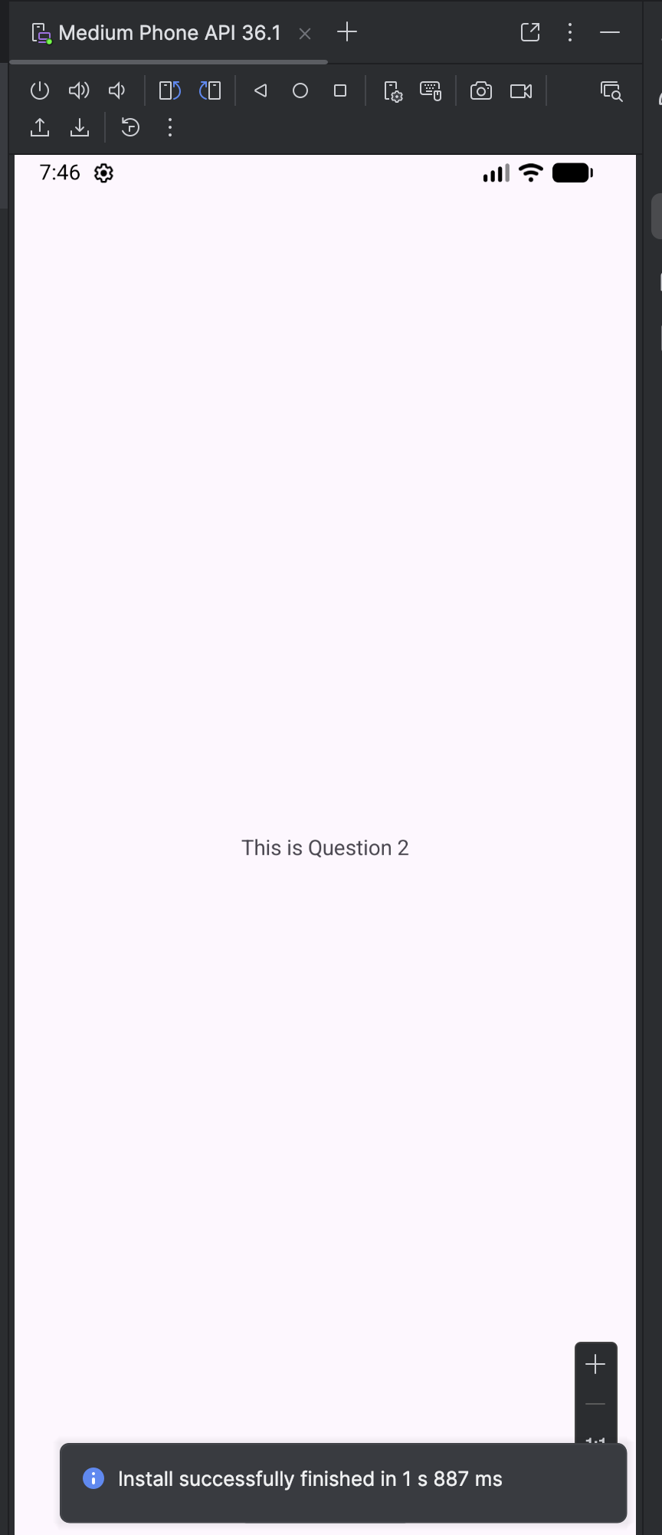

**Lab 2- Introduction to Activities and Layouts in Android**

Question 1:

Create an app that illustrates that the activity lifecycle method being triggered by various action. Understand when onCreate(),onStart(),onResume event occur.

Layout Design:

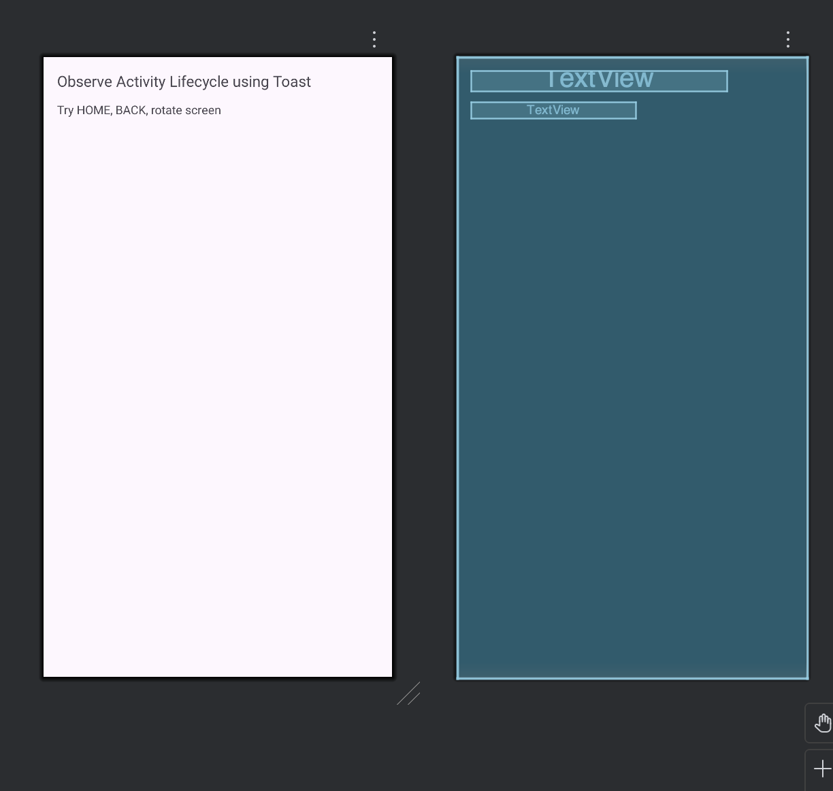

XML for Activity:

<?xml version="1.0" encoding="utf-8"?>  
<LinearLayout xmlns:android="http://schemas.android.com/apk/res/android"  
 android:layout_width="match_parent"  
 android:layout_height="match_parent"  
 android:orientation="vertical"  
 android:padding="16dp">  
  
 <TextView  
 android:layout_width="wrap_content"  
 android:layout_height="wrap_content"  
 android:text="Observe Activity Lifecycle using Toast"  
 android:textSize="18sp"/>  
  
 <TextView  
 android:layout_width="wrap_content"  
 android:layout_height="wrap_content"  
 android:text="Try HOME, BACK, rotate screen"  
 android:layout_marginTop="12dp"/>  
  
</LinearLayout>

Java Code:

package com.example.question1;  
  
import androidx.appcompat.app.AppCompatActivity;  
import android.os.Bundle;  
import android.util.Log;  
import android.widget.Toast;  
  
public class MainActivity extends AppCompatActivity {  
  
 String TAG = "LifecycleDemo";  
  
 @Override  
 protected void onCreate(Bundle savedInstanceState) {  
 super.onCreate(savedInstanceState);  
 setContentView(R.layout.*activity_main*);  
 Toast.*makeText*(this, "onCreate()", Toast.*LENGTH_SHORT*).show();  
 Log.*d*(TAG, "onCreate");  
 }  
  
 @Override  
 protected void onStart() {  
 super.onStart();  
 Toast.*makeText*(this, "onStart()", Toast.*LENGTH_SHORT*).show();  
 Log.*d*(TAG, "onStart");  
 }  
  
 @Override  
 protected void onResume() {  
 super.onResume();  
 Toast.*makeText*(this, "onResume()", Toast.*LENGTH_SHORT*).show();  
 Log.*d*(TAG, "onResume");  
 }  
  
 @Override  
 protected void onPause() {  
 super.onPause();  
 Toast.*makeText*(this, "onPause()", Toast.*LENGTH_SHORT*).show();  
 Log.*d*(TAG, "onPause");  
 }  
  
 @Override  
 protected void onStop() {  
 super.onStop();  
 Toast.*makeText*(this, "onStop()", Toast.*LENGTH_SHORT*).show();  
 Log.*d*(TAG, "onStop");  
 }  
  
 @Override  
 protected void onRestart() {  
 super.onRestart();  
 Toast.*makeText*(this, "onRestart()", Toast.*LENGTH_SHORT*).show();  
 Log.*d*(TAG, "onRestart");  
 }  
  
 @Override  
 protected void onDestroy() {  
 super.onDestroy();  
 Toast.*makeText*(this, "onDestroy()", Toast.*LENGTH_SHORT*).show();  
 Log.*d*(TAG, "onDestroy");  
 }  
}

Output:

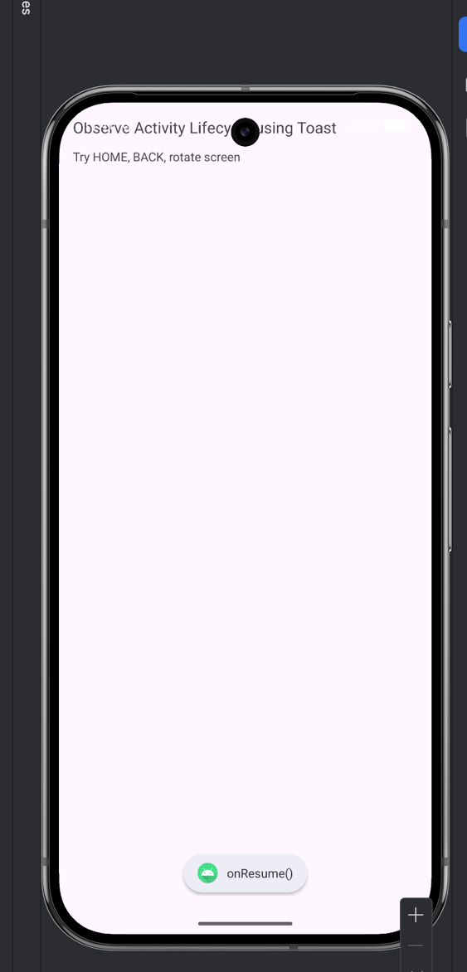

Question 2:

Create a Calculator app that does the function of multiplication, addition, division, subtraction but displays the result in the format of:-Num1 operator num2 = result. Back button on the next activity should get back to the calculator activity again.

Layout Design

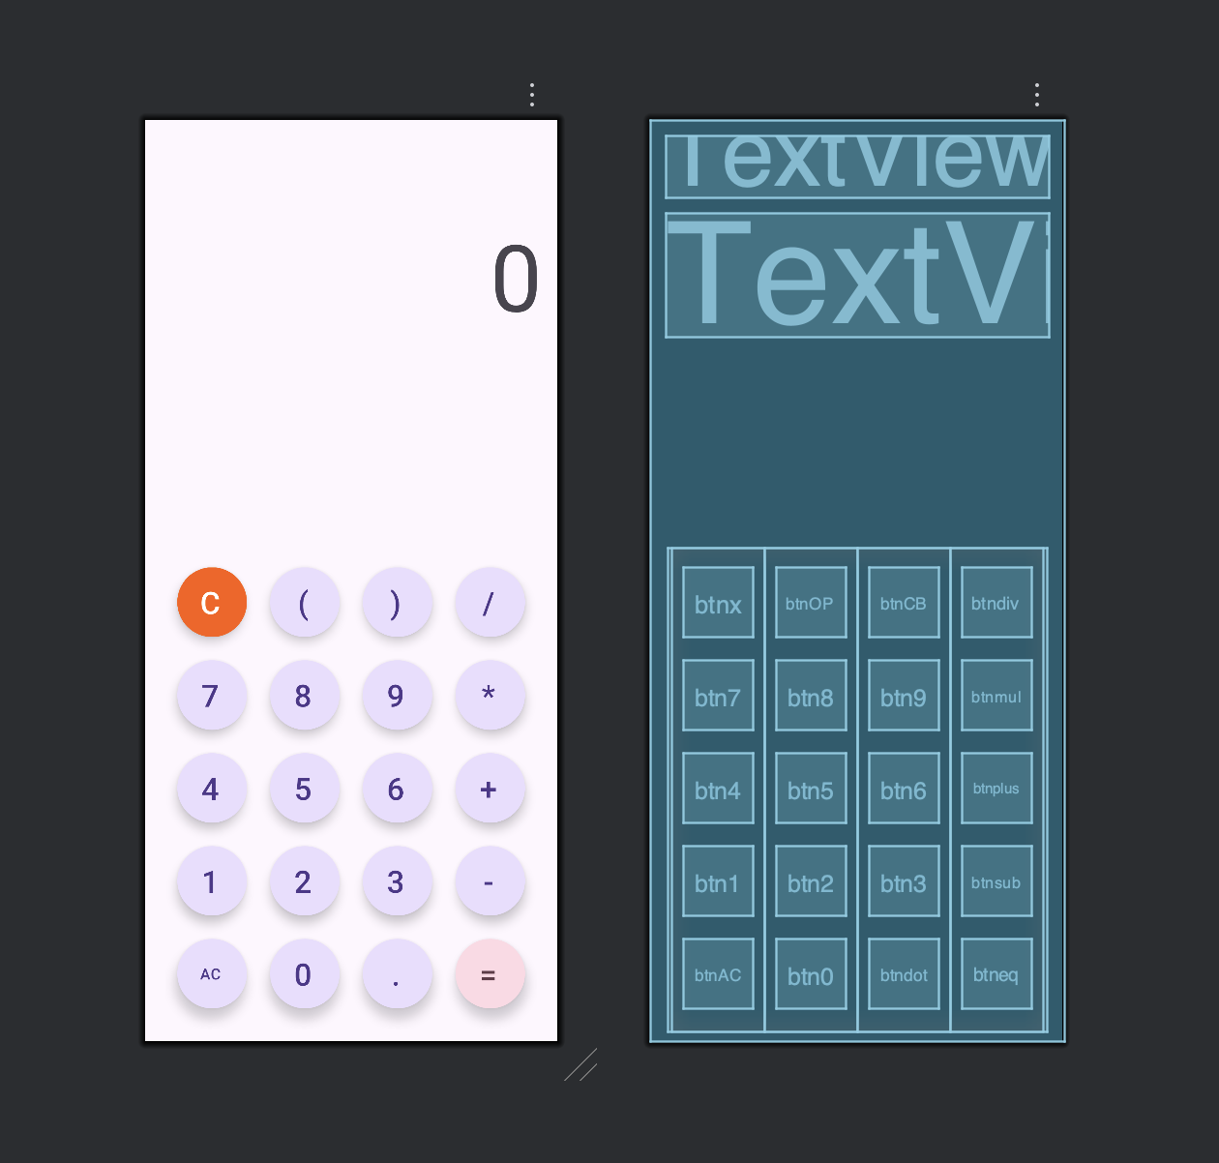

XML for activity_main

<?xml version="1.0" encoding="utf-8"?>  
<androidx.constraintlayout.widget.ConstraintLayout xmlns:android="http://schemas.android.com/apk/res/android"  
 xmlns:app="http://schemas.android.com/apk/res-auto"  
 xmlns:tools="http://schemas.android.com/tools"  
 android:id="@+id/main"  
 android:layout_width="match_parent"  
 android:layout_height="match_parent"  
 tools:context=".MainActivity">  
  
 <TextView  
 android:id="@+id/calc"  
 android:layout_width="match_parent"  
 android:layout_height="wrap_content"  
 android:layout_margin="16dp"  
 android:layout_marginTop="168dp"  
 android:textSize="48sp"  
 app:layout_constraintEnd_toEndOf="parent"  
 app:layout_constraintHorizontal_bias="0.692"  
 app:layout_constraintStart_toStartOf="parent"  
 app:layout_constraintTop_toTopOf="parent" />  
  
  
 <TextView  
 android:id="@+id/res"  
 android:layout_width="match_parent"  
 android:layout_height="wrap_content"  
 android:layout_margin="16dp"  
 android:text="@string/txt0"  
 android:textAlignment="viewEnd"  
 android:textSize="96sp"  
 app:layout_constraintTop_toBottomOf="@+id/calc"  
 tools:layout_editor_absoluteX="23dp" />  
  
 <LinearLayout  
 android:layout_width="392dp"  
 android:layout_height="499dp"  
 android:layout_margin="12dp"  
 android:gravity="center"  
 android:orientation="horizontal"  
 app:layout_constraintBottom_toBottomOf="parent"  
 app:layout_constraintEnd_toEndOf="parent"  
 app:layout_constraintStart_toStartOf="parent">  
  
 <LinearLayout  
 android:layout_width="wrap_content"  
 android:layout_height="match_parent"  
 android:gravity="center"  
 android:orientation="vertical">  
  
  
 <com.google.android.material.button.MaterialButton  
 android:id="@+id/btnx"  
 style="@style/Widget.Material3.ExtendedFloatingActionButton.Icon.Primary"  
 android:layout_width="72dp"  
 android:layout_height="72dp"  
 android:layout_margin="12dp"  
 android:backgroundTint="#FF5C00"  
 android:text="@string/btnC"  
 android:textAlignment="center"  
 android:textColor="#FFFFFF"  
 android:textSize="32sp"  
 app:cornerRadius="36dp" />  
  
 <com.google.android.material.button.MaterialButton  
 android:id="@+id/btn7"  
 style="@style/Widget.Material3.ExtendedFloatingActionButton.Icon.Primary"  
 android:layout_width="72dp"  
 android:layout_height="72dp"  
 android:layout_margin="12dp"  
 android:text="@string/btn7"  
 android:textSize="32sp"  
 app:cornerRadius="36dp" />  
  
 <com.google.android.material.button.MaterialButton  
 android:id="@+id/btn4"  
 style="@style/Widget.Material3.ExtendedFloatingActionButton.Icon.Primary"  
 android:layout_width="72dp"  
 android:layout_height="72dp"  
 android:layout_margin="12dp"  
 android:text="@string/btn4"  
 android:textSize="32sp"  
 app:cornerRadius="36dp" />  
  
 <com.google.android.material.button.MaterialButton  
 android:id="@+id/btn1"  
 style="@style/Widget.Material3.ExtendedFloatingActionButton.Icon.Primary"  
 android:layout_width="72dp"  
 android:layout_height="72dp"  
 android:layout_margin="12dp"  
 android:text="@string/btn1"  
 android:textSize="32sp"  
 app:cornerRadius="36dp" />  
  
 <com.google.android.material.button.MaterialButton  
 android:id="@+id/btnAC"  
 style="@style/Widget.Material3.ExtendedFloatingActionButton.Icon.Primary"  
 android:layout_width="72dp"  
 android:layout_height="72dp"  
 android:layout_margin="12dp"  
 android:text="@string/btnAC"  
 android:textSize="16sp"  
 app:cornerRadius="36dp" />  
  
  
 </LinearLayout>  
  
 <LinearLayout  
 android:layout_width="wrap_content"  
 android:layout_height="match_parent"  
 android:gravity="center"  
 android:orientation="vertical">  
  
 <com.google.android.material.button.MaterialButton  
 android:id="@+id/btnOP"  
 style="@style/Widget.Material3.ExtendedFloatingActionButton.Icon.Primary"  
 android:layout_width="72dp"  
 android:layout_height="72dp"  
 android:layout_margin="12dp"  
 android:text="@string/btnOB"  
 android:textSize="32sp"  
 app:cornerRadius="36dp" />  
  
 <com.google.android.material.button.MaterialButton  
 android:id="@+id/btn8"  
 style="@style/Widget.Material3.ExtendedFloatingActionButton.Icon.Primary"  
 android:layout_width="72dp"  
 android:layout_height="72dp"  
 android:layout_margin="12dp"  
 android:text="@string/btn8"  
 android:textSize="32sp"  
 app:cornerRadius="36dp" />  
  
 <com.google.android.material.button.MaterialButton  
 android:id="@+id/btn5"  
 style="@style/Widget.Material3.ExtendedFloatingActionButton.Icon.Primary"  
 android:layout_width="72dp"  
 android:layout_height="72dp"  
 android:layout_margin="12dp"  
 android:text="@string/btn5"  
 android:textSize="32sp"  
 app:cornerRadius="36dp" />  
  
 <com.google.android.material.button.MaterialButton  
 android:id="@+id/btn2"  
 style="@style/Widget.Material3.ExtendedFloatingActionButton.Icon.Primary"  
 android:layout_width="72dp"  
 android:layout_height="72dp"  
 android:layout_margin="12dp"  
 android:text="@string/btn2"  
 android:textSize="32sp"  
 app:cornerRadius="36dp" />  
  
 <com.google.android.material.button.MaterialButton  
 android:id="@+id/btn0"  
 style="@style/Widget.Material3.ExtendedFloatingActionButton.Icon.Primary"  
 android:layout_width="72dp"  
 android:layout_height="72dp"  
 android:layout_margin="12dp"  
 android:text="@string/btn0"  
 android:textSize="32sp"  
 app:cornerRadius="36dp" />  
 </LinearLayout>  
  
 <LinearLayout  
 android:layout_width="wrap_content"  
 android:layout_height="match_parent"  
 android:gravity="center"  
 android:orientation="vertical">  
  
 <com.google.android.material.button.MaterialButton  
 android:id="@+id/btnCB"  
 style="@style/Widget.Material3.ExtendedFloatingActionButton.Icon.Primary"  
 android:layout_width="72dp"  
 android:layout_height="72dp"  
 android:layout_margin="12dp"  
 android:text="@string/btnCB"  
 android:textSize="32dp"  
 app:cornerRadius="36dp" />  
  
 <com.google.android.material.button.MaterialButton  
 android:id="@+id/btn9"  
 style="@style/Widget.Material3.ExtendedFloatingActionButton.Icon.Primary"  
 android:layout_width="72dp"  
 android:layout_height="72dp"  
 android:layout_margin="12dp"  
 android:text="@string/btn9"  
 android:textSize="32sp"  
 app:cornerRadius="36dp" />  
  
 <com.google.android.material.button.MaterialButton  
 android:id="@+id/btn6"  
 style="@style/Widget.Material3.ExtendedFloatingActionButton.Icon.Primary"  
 android:layout_width="72dp"  
 android:layout_height="72dp"  
 android:layout_margin="12dp"  
 android:text="@string/btn6"  
 android:textSize="32sp"  
 app:cornerRadius="36dp" />  
  
 <com.google.android.material.button.MaterialButton  
 android:id="@+id/btn3"  
 style="@style/Widget.Material3.ExtendedFloatingActionButton.Icon.Primary"  
 android:layout_width="72dp"  
 android:layout_height="72dp"  
 android:layout_margin="12dp"  
 android:text="@string/btn3"  
 android:textSize="32sp"  
 app:cornerRadius="36dp" />  
  
 <com.google.android.material.button.MaterialButton  
 android:id="@+id/btndot"  
 style="@style/Widget.Material3.ExtendedFloatingActionButton.Icon.Primary"  
 android:layout_width="72dp"  
 android:layout_height="72dp"  
 android:layout_margin="12dp"  
 android:text="@string/btndot"  
 android:textSize="32sp"  
 app:cornerRadius="36dp" />  
 </LinearLayout>  
  
 <LinearLayout  
 android:layout_width="wrap_content"  
 android:layout_height="match_parent"  
 android:gravity="center"  
 android:orientation="vertical">  
  
 <com.google.android.material.button.MaterialButton  
 android:id="@+id/btndiv"  
 style="@style/Widget.Material3.ExtendedFloatingActionButton.Icon.Primary"  
 android:layout_width="72dp"  
 android:layout_height="72dp"  
 android:layout_margin="12dp"  
 android:text="@string/btndiv"  
 android:textSize="32sp"  
 app:cornerRadius="36dp" />  
  
 <com.google.android.material.button.MaterialButton  
 android:id="@+id/btnmul"  
 style="@style/Widget.Material3.ExtendedFloatingActionButton.Icon.Primary"  
 android:layout_width="72dp"  
 android:layout_height="72dp"  
 android:layout_margin="12dp"  
 android:text="@string/btnmul"  
 android:textSize="32dp"  
 app:cornerRadius="36dp" />  
  
 <com.google.android.material.button.MaterialButton  
 android:id="@+id/btnplus"  
 style="@style/Widget.Material3.ExtendedFloatingActionButton.Icon.Primary"  
 android:layout_width="72dp"  
 android:layout_height="72dp"  
 android:layout_margin="12dp"  
 android:text="@string/btnplus"  
 android:textSize="32sp"  
 app:cornerRadius="36dp" />  
  
 <com.google.android.material.button.MaterialButton  
 android:id="@+id/btnsub"  
 style="@style/Widget.Material3.ExtendedFloatingActionButton.Icon.Primary"  
 android:layout_width="72dp"  
 android:layout_height="72dp"  
 android:layout_margin="12dp"  
 android:text="@string/btnsub"  
 android:textSize="32sp"  
 app:cornerRadius="36dp" />  
  
 <com.google.android.material.button.MaterialButton  
 android:id="@+id/btneq"  
 style="@style/Widget.Material3.ExtendedFloatingActionButton.Icon.Tertiary"  
 android:layout_width="72dp"  
 android:layout_height="72dp"  
 android:layout_margin="12dp"  
 android:text="@string/btneq"  
 android:textSize="32sp"  
 app:cornerRadius="36dp" />  
  
 </LinearLayout>  
  
 </LinearLayout>  
  
</androidx.constraintlayout.widget.ConstraintLayout>

XML for strings

<resources>  
 <string name="app_name">Calculator</string>  
 <string name="txt0">0</string>  
 <string name="btnAC">AC</string>  
 <string name="btnOB">(</string>  
 <string name="btnCB">)</string>  
 <string name="btnC"> C </string>  
 <string name="btn7">7</string>  
 <string name="btn8">8</string>  
 <string name="btn9">9</string>  
 <string name="btn4">4</string>  
 <string name="btn5">5</string>  
 <string name="btn6">6</string>  
 <string name="btn1">1</string>  
 <string name="btn2">2</string>  
 <string name="btn3">3</string>  
 <string name="btn0">0</string>  
 <string name="btnplus">+</string>  
 <string name="btnsub">-</string>  
 <string name="btndiv">/</string>  
 <string name="btnmul">*</string>  
 <string name="btneq">=</string>  
 <string name="btndot">.</string>  
 <string name="btnmod">%</string>  
</resources>

Java Source code

package com.example.calculator;  
  
import android.os.Bundle;  
import android.view.ContextThemeWrapper;  
import android.view.View;  
import android.widget.TextView;  
  
import androidx.activity.EdgeToEdge;  
import androidx.appcompat.app.AppCompatActivity;  
import androidx.core.graphics.Insets;  
import androidx.core.graphics.MatrixKt;  
import androidx.core.view.ViewCompat;  
import androidx.core.view.WindowInsetsCompat;  
  
import com.google.android.material.button.MaterialButton;  
import org.mozilla.javascript.Context;  
import org.mozilla.javascript.Scriptable;  
  
public class MainActivity extends AppCompatActivity implements View.OnClickListener{  
 TextView res,cal;  
 MaterialButton[] numbers=new MaterialButton[10];  
 int[] buttonids = {R.id.*btn0*,R.id.*btn1*,R.id.*btn2*,R.id.*btn3*,R.id.*btn4*,R.id.*btn5*, R.id.*btn6*,R.id.*btn7*,R.id.*btn8*,R.id.*btn9*};  
  
 MaterialButton add,sub,mul,div;  
 MaterialButton c,ac,eq,ob,cb,dot;  
 @Override  
 protected void onCreate(Bundle savedInstanceState) {  
 super.onCreate(savedInstanceState);  
 EdgeToEdge.*enable*(this);  
 setContentView(R.layout.*activity_main*);  
 ViewCompat.*setOnApplyWindowInsetsListener*(findViewById(R.id.*main*), (v, insets) -> {  
 Insets systemBars = insets.getInsets(WindowInsetsCompat.Type.*systemBars*());  
 v.setPadding(systemBars.left, systemBars.top, systemBars.right, systemBars.bottom);  
 return insets;  
 });  
 res = findViewById(R.id.*res*);  
 cal= findViewById(R.id.*calc*);  
  
 for(int i=0;i<10;i++){  
 assign_id(numbers[i],buttonids[i]);  
 }  
 assign_id(mul,R.id.*btnmul*);  
 assign_id(div,R.id.*btndiv*);  
 assign_id(add,R.id.*btnplus*);  
 assign_id(sub,R.id.*btnsub*);  
  
 assign_id(c,R.id.*btnx*);  
 assign_id(ac,R.id.*btnAC*);  
 assign_id(dot,R.id.*btndot*);  
 assign_id(ob,R.id.*btnOP*);  
 assign_id(cb,R.id.*btnCB*);  
 assign_id(eq,R.id.*btneq*);  
  
 }  
 void assign_id(MaterialButton btn, int id){  
 btn=findViewById(id);  
 btn.setOnClickListener(this);  
 }  
  
 @Override  
 public void onClick(View v) {  
 MaterialButton button = (MaterialButton) v;  
 String btntext=button.getText().toString();  
 String expression=cal.getText().toString();  
 if(btntext.equals("AC")){  
 res.setText("0");  
 cal.setText("");  
 return;  
 }  
 if(btntext.equals("=")){  
 res.setText(res.getText());  
 }  
 if(btntext.equals("C")){  
 expression=expression.substring(0,expression.length()-1);  
 }else {  
 if(!btntext.equals("=")){  
 expression=expression+btntext;  
 }  
 }  
  
 cal.setText(expression);  
 String finalResult=getResult(expression);  
 if(!finalResult.equals("Err")){  
 res.setText(finalResult);  
 }  
 }  
  
 String getResult(String expression){  
 try{  
 Context context=Context.*enter*();  
 context.setOptimizationLevel(-1);  
 Scriptable scriptable=context.initStandardObjects();  
 String result=context.evaluateString(scriptable,expression,"Javascript",1,null).toString();  
 return result;  
 }catch(Exception e){  
 return "Err";  
 }  
 }  
}

Output:

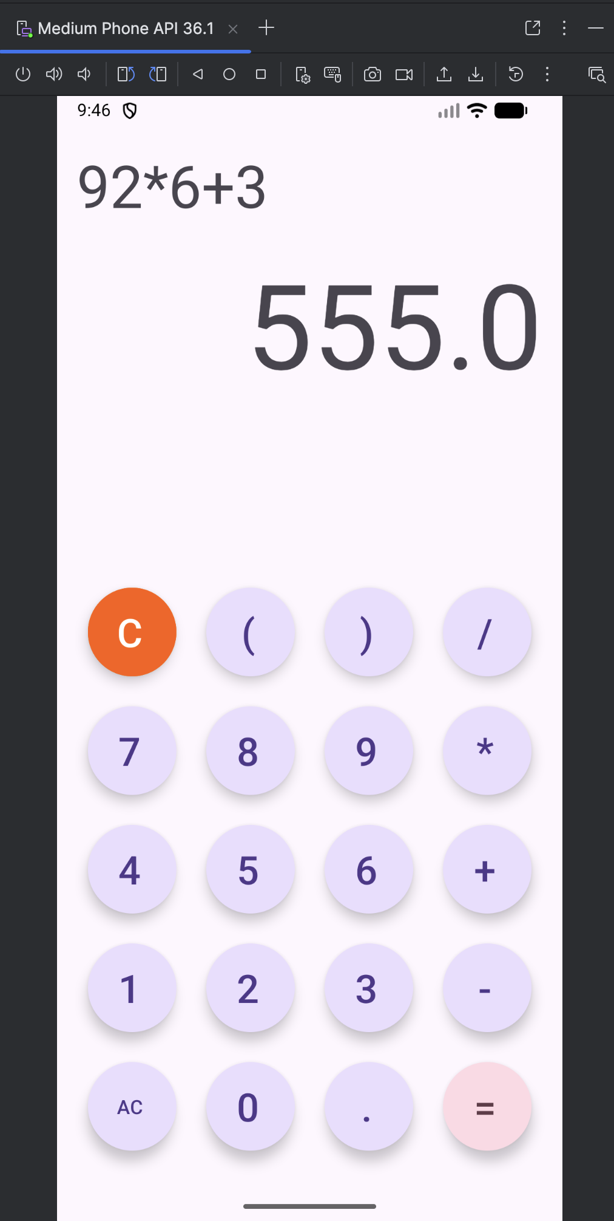

Question3:

Create the following scenario using linear and relative layout concept

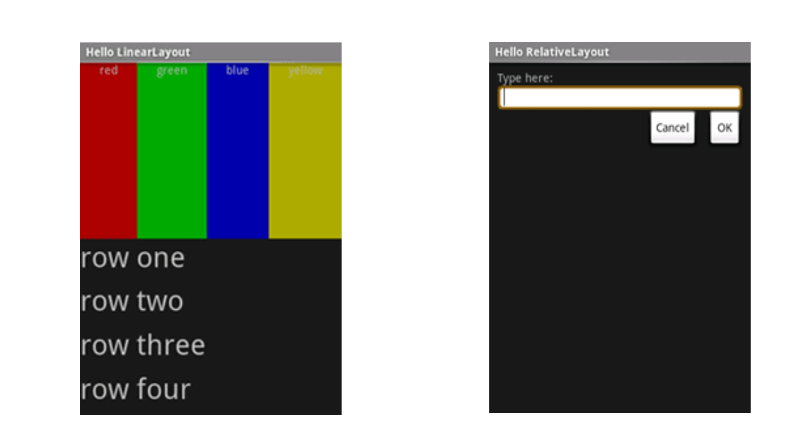

Layout Design Linear

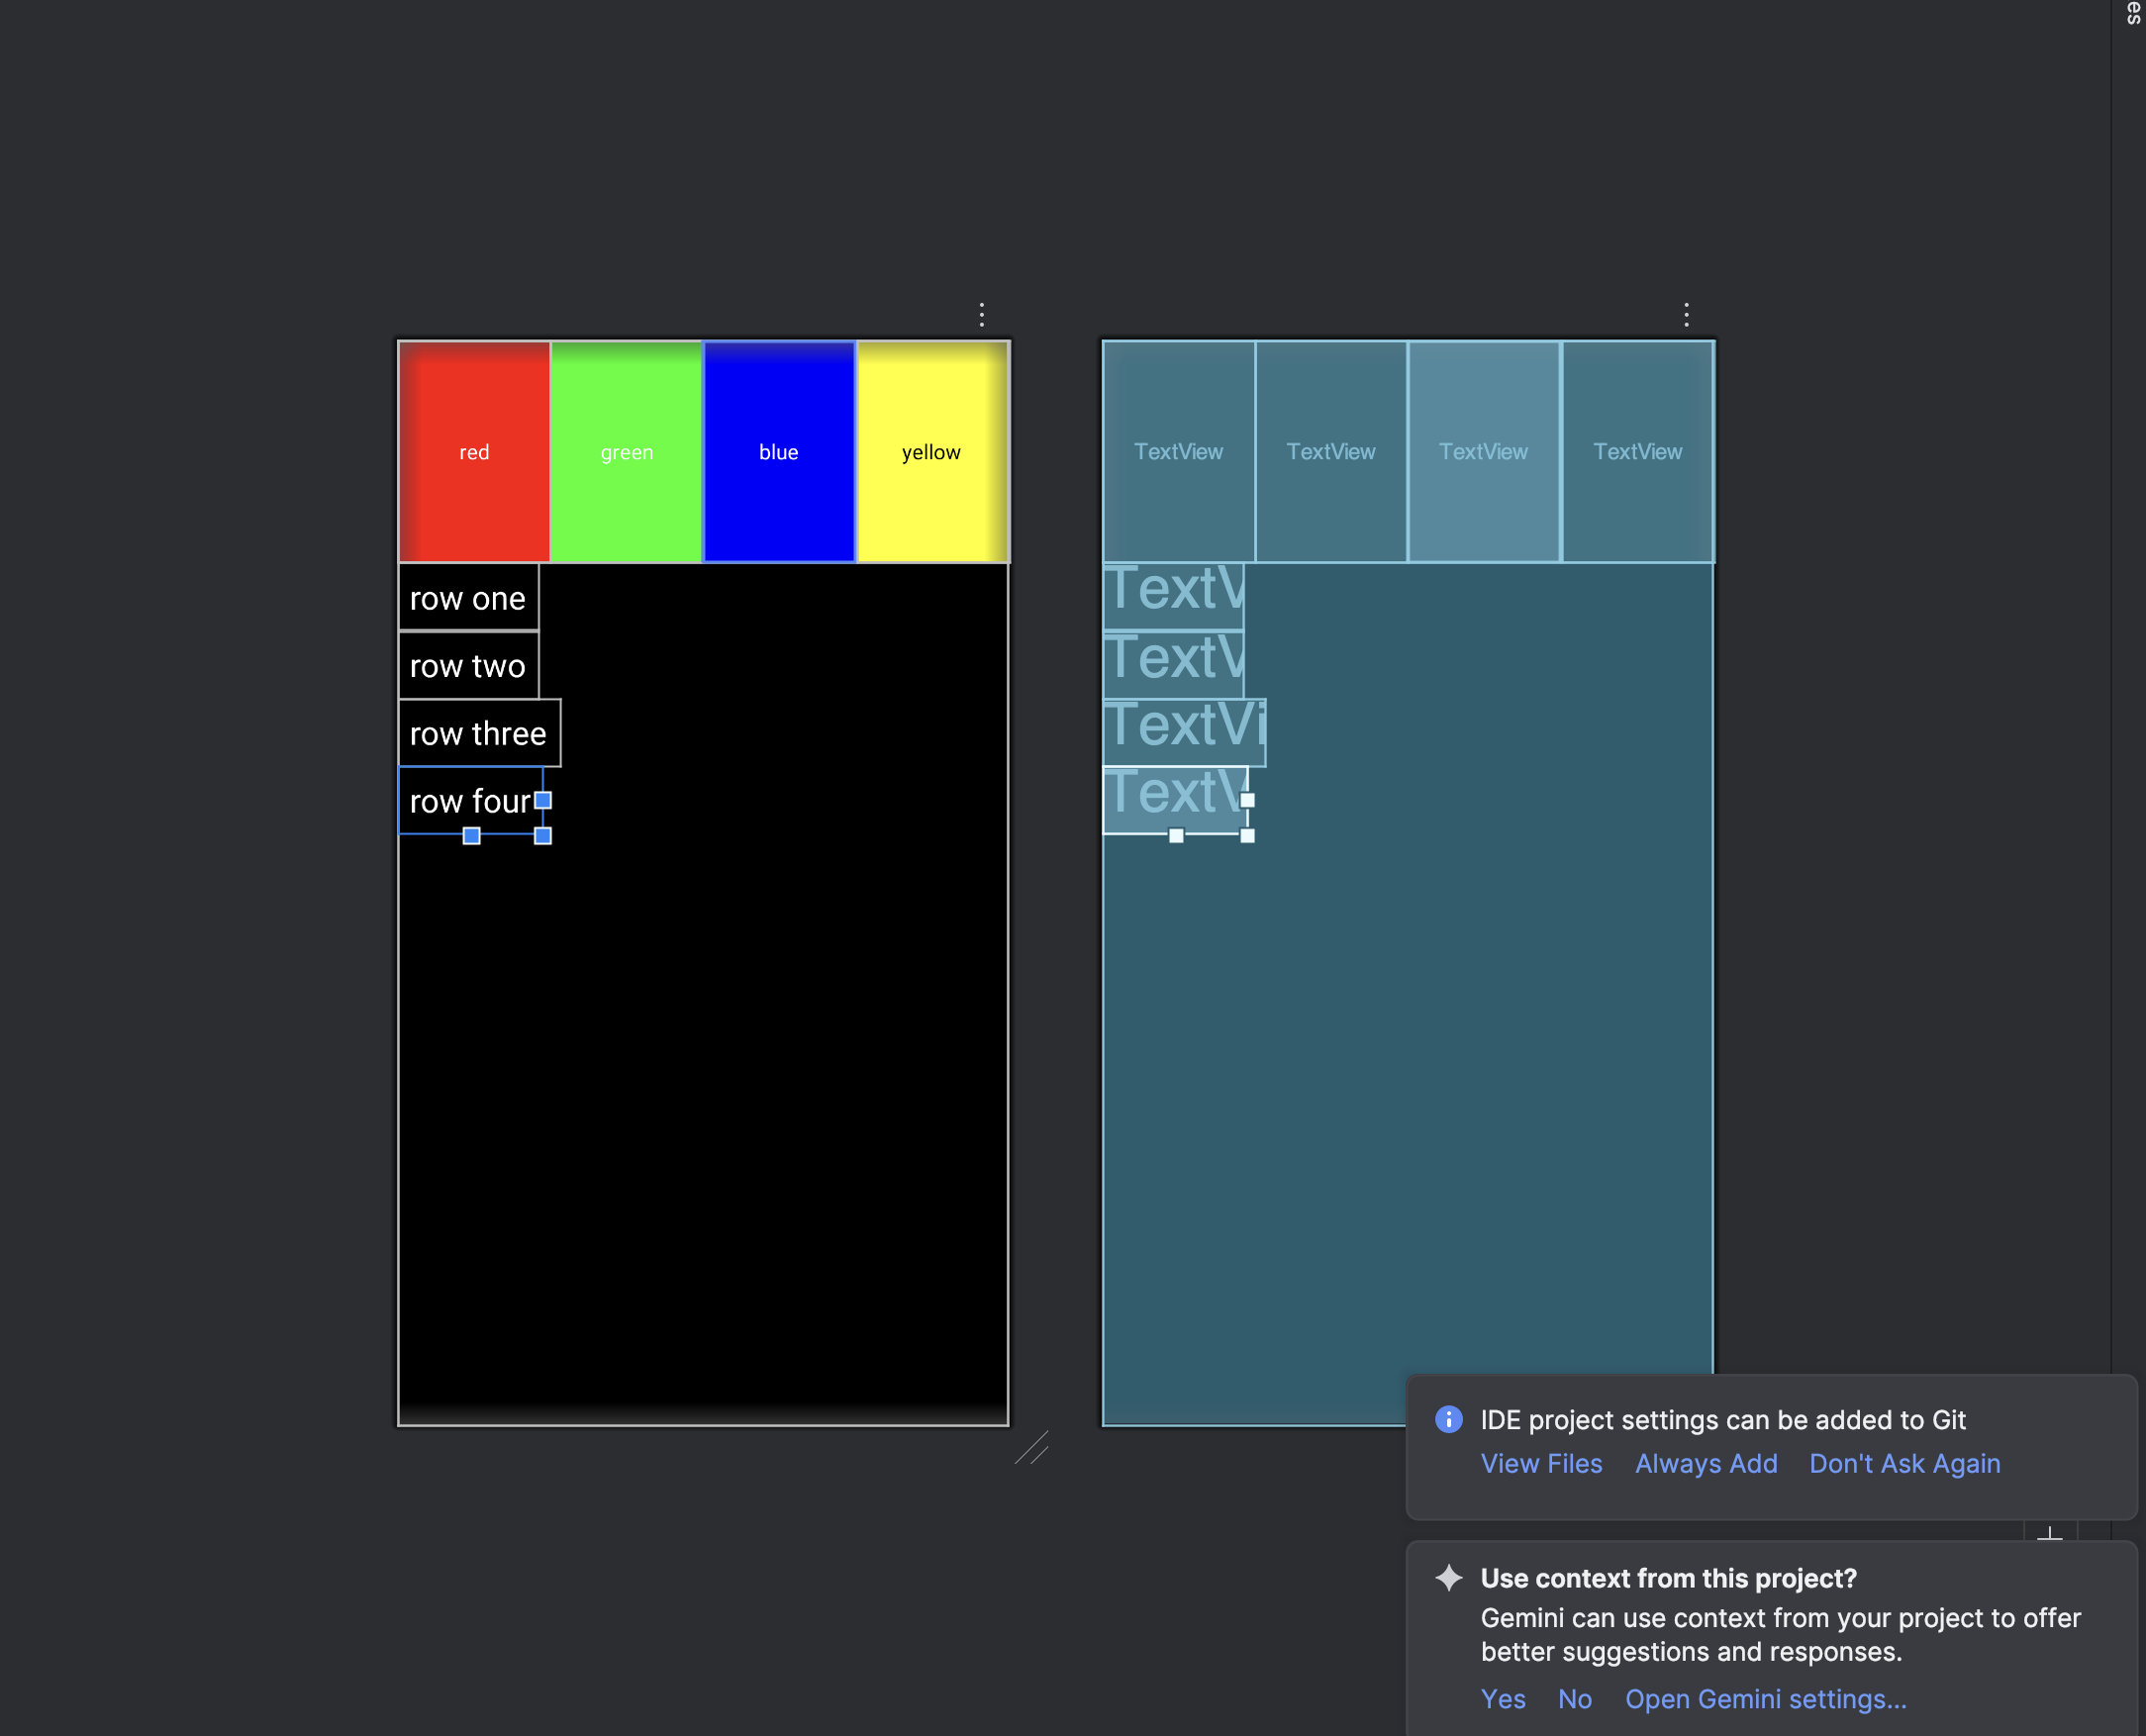

XML for Linear Layout Design

<?xml version="1.0" encoding="utf-8"?>  
<LinearLayout xmlns:android="http://schemas.android.com/apk/res/android"  
 android:layout_width="match_parent"  
 android:layout_height="match_parent"  
 android:orientation="vertical"  
 android:background="#000000">  
  
 <LinearLayout  
 android:layout_width="match_parent"  
 android:layout_height="150dp"  
 android:orientation="horizontal">  
  
 <TextView  
 android:layout_width="0dp"  
 android:layout_height="match_parent"  
 android:layout_weight="1"  
 android:background="#FF0000"  
 android:text="red"  
 android:textColor="#FFFFFF"  
 android:gravity="center"/>  
  
 <TextView  
 android:layout_width="0dp"  
 android:layout_height="match_parent"  
 android:layout_weight="1"  
 android:background="#00FF00"  
 android:text="green"  
 android:textColor="#FFFFFF"  
 android:gravity="center"/>  
  
 <TextView  
 android:layout_width="0dp"  
 android:layout_height="match_parent"  
 android:layout_weight="1"  
 android:background="#0000FF"  
 android:text="blue"  
 android:textColor="#FFFFFF"  
 android:gravity="center"/>  
  
 <TextView  
 android:layout_width="0dp"  
 android:layout_height="match_parent"  
 android:layout_weight="1"  
 android:background="#FFFF00"  
 android:text="yellow"  
 android:textColor="#000000"  
 android:gravity="center"/>  
 </LinearLayout>  
  
 <TextView  
 android:layout_height="wrap_content"  
 android:layout_width="wrap_content"  
 android:text="row one"  
 android:textSize="22sp"  
 android:textColor="#FFFFFF"  
 android:padding="8dp"/>  
  
 <TextView  
 android:layout_height="wrap_content"  
 android:layout_width="wrap_content"  
 android:text="row two"  
 android:textSize="22sp"  
 android:textColor="#FFFFFF"  
 android:padding="8dp"/>  
  
 <TextView  
 android:layout_height="wrap_content"  
 android:layout_width="wrap_content"  
 android:text="row three"  
 android:textSize="22sp"  
 android:textColor="#FFFFFF"  
 android:padding="8dp"/>  
  
 <TextView  
 android:layout_height="wrap_content"  
 android:layout_width="wrap_content"  
 android:text="row four"  
 android:textSize="22sp"  
 android:textColor="#FFFFFF"  
 android:padding="8dp"/>  
  
</LinearLayout>

Layout Design - Relative

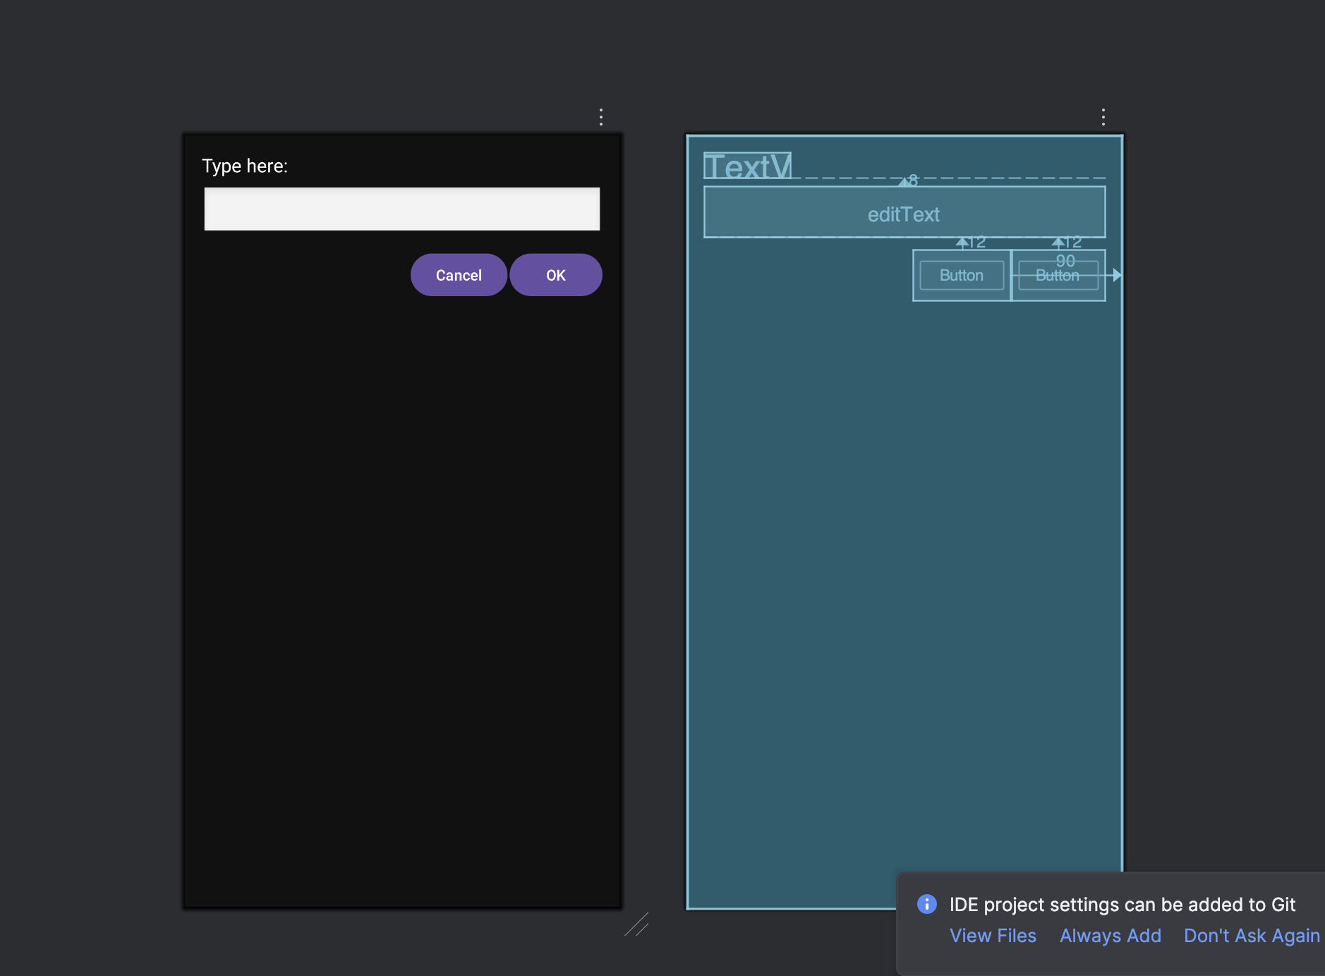

XML for Relative Layout Design

<?xml version="1.0" encoding="utf-8"?>  
<RelativeLayout xmlns:android="http://schemas.android.com/apk/res/android"  
 android:layout_width="match_parent"  
 android:layout_height="match_parent"  
 android:background="#111111"  
 android:padding="16dp">  
  
 <TextView  
 android:id="@+id/tvLabel"  
 android:layout_width="wrap_content"  
 android:layout_height="wrap_content"  
 android:text="Type here:"  
 android:textColor="#FFFFFF"  
 android:textSize="18sp"/>  
  
 <EditText  
 android:id="@+id/editText"  
 android:layout_width="match_parent"  
 android:layout_height="wrap_content"  
 android:layout_below="@id/tvLabel"  
 android:layout_marginTop="8dp"  
 android:background="@android:drawable/edit_text"/>  
  
 <Button  
 android:id="@+id/btnCancel"  
 android:layout_width="wrap_content"  
 android:layout_height="wrap_content"  
 android:text="Cancel"  
 android:layout_below="@id/editText"  
 android:layout_alignParentEnd="true"  
 android:layout_marginTop="12dp"  
 android:layout_marginEnd="90dp"/>  
  
 <Button  
 android:id="@+id/btnOk"  
 android:layout_width="wrap_content"  
 android:layout_height="wrap_content"  
 android:text="OK"  
 android:layout_below="@id/editText"  
 android:layout_alignParentEnd="true"  
 android:layout_marginTop="12dp"/>  
  
</RelativeLayout>

Question4:

Create an app such that when the user click on the given URL typed by the user, it visits the corresponding page.

Layout Design:

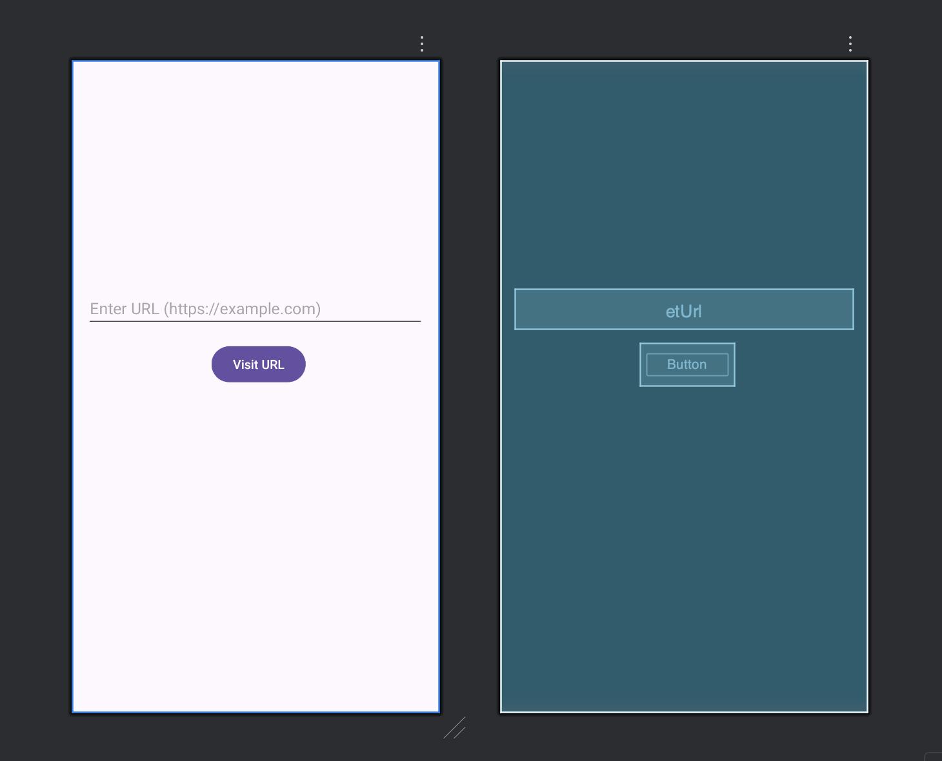

XML for Design:

<?xml version="1.0" encoding="utf-8"?>  
<LinearLayout xmlns:android="http://schemas.android.com/apk/res/android"  
 android:layout_width="match_parent"  
 android:layout_height="match_parent"  
 android:orientation="vertical"  
 android:padding="16dp">  
  
 <EditText  
 android:id="@+id/etUrl"  
 android:layout_marginTop="240dp"  
 android:layout_width="match_parent"  
 android:layout_height="wrap_content"  
 android:hint="Enter URL (https://example.com)"  
 android:inputType="textUri" />  
  
 <Button  
 android:id="@+id/btnVisit"  
 android:layout_width="wrap_content"  
 android:layout_height="wrap_content"  
 android:layout_marginLeft="140dp"  
 android:layout_marginTop="16dp"  
 android:text="Visit URL" />  
  
</LinearLayout>

Java Code:

package com.priyansh.myapplication;  
  
import androidx.appcompat.app.AppCompatActivity;  
  
import android.content.Intent;  
import android.net.Uri;  
import android.os.Bundle;  
import android.view.View;  
import android.widget.Button;  
import android.widget.EditText;  
import android.widget.Toast;  
  
public class MainActivity extends AppCompatActivity {  
  
 EditText etUrl;  
 Button btnVisit;  
  
 @Override  
 protected void onCreate(Bundle savedInstanceState) {  
 super.onCreate(savedInstanceState);  
 setContentView(R.layout.*activity_main*);  
  
 etUrl = findViewById(R.id.*etUrl*);  
 btnVisit = findViewById(R.id.*btnVisit*);  
  
 btnVisit.setOnClickListener(new View.OnClickListener() {  
 @Override  
 public void onClick(View v) {  
  
 String url = etUrl.getText().toString().trim();  
  
 if (url.isEmpty()) {  
 Toast.*makeText*(MainActivity.this,  
 "Please enter a URL", Toast.*LENGTH_SHORT*).show();  
 return;  
 }  
  
 if (!url.startsWith("http://") && !url.startsWith("https://")) {  
 url = "https://" + url;  
 }  
  
 Intent intent = new Intent(Intent.*ACTION_VIEW*);  
 intent.setData(Uri.*parse*(url));  
 startActivity(intent);  
 }  
 });  
 }  
}

Output:

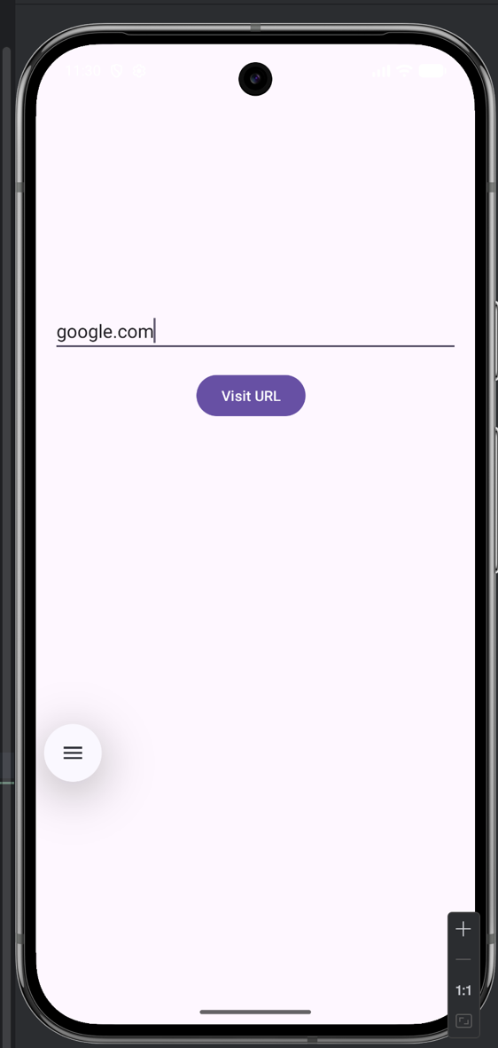 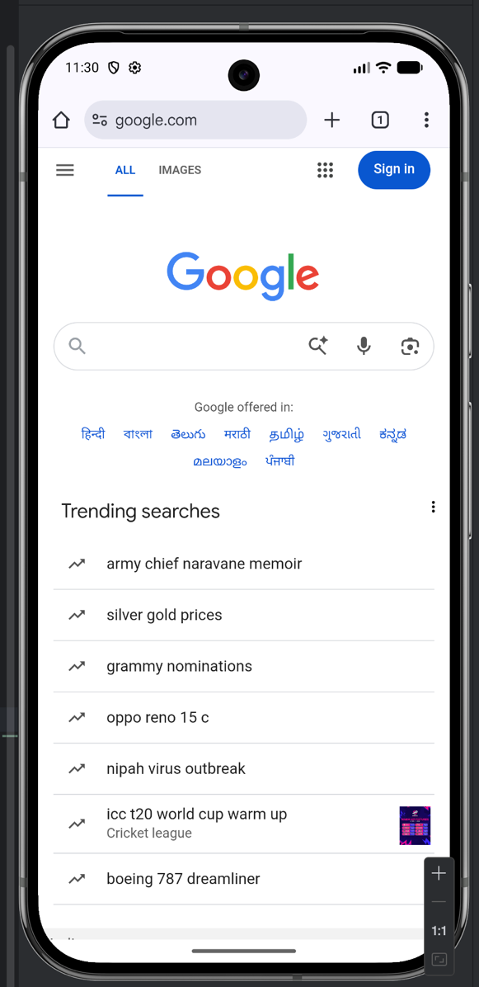

**Lab 3- Activities and Layouts Continued**

Question1:

Using given scenario develop an application to perform following layout operations

* List view
* Grid view
* Tab layout
* Table layout

Layout Designs:

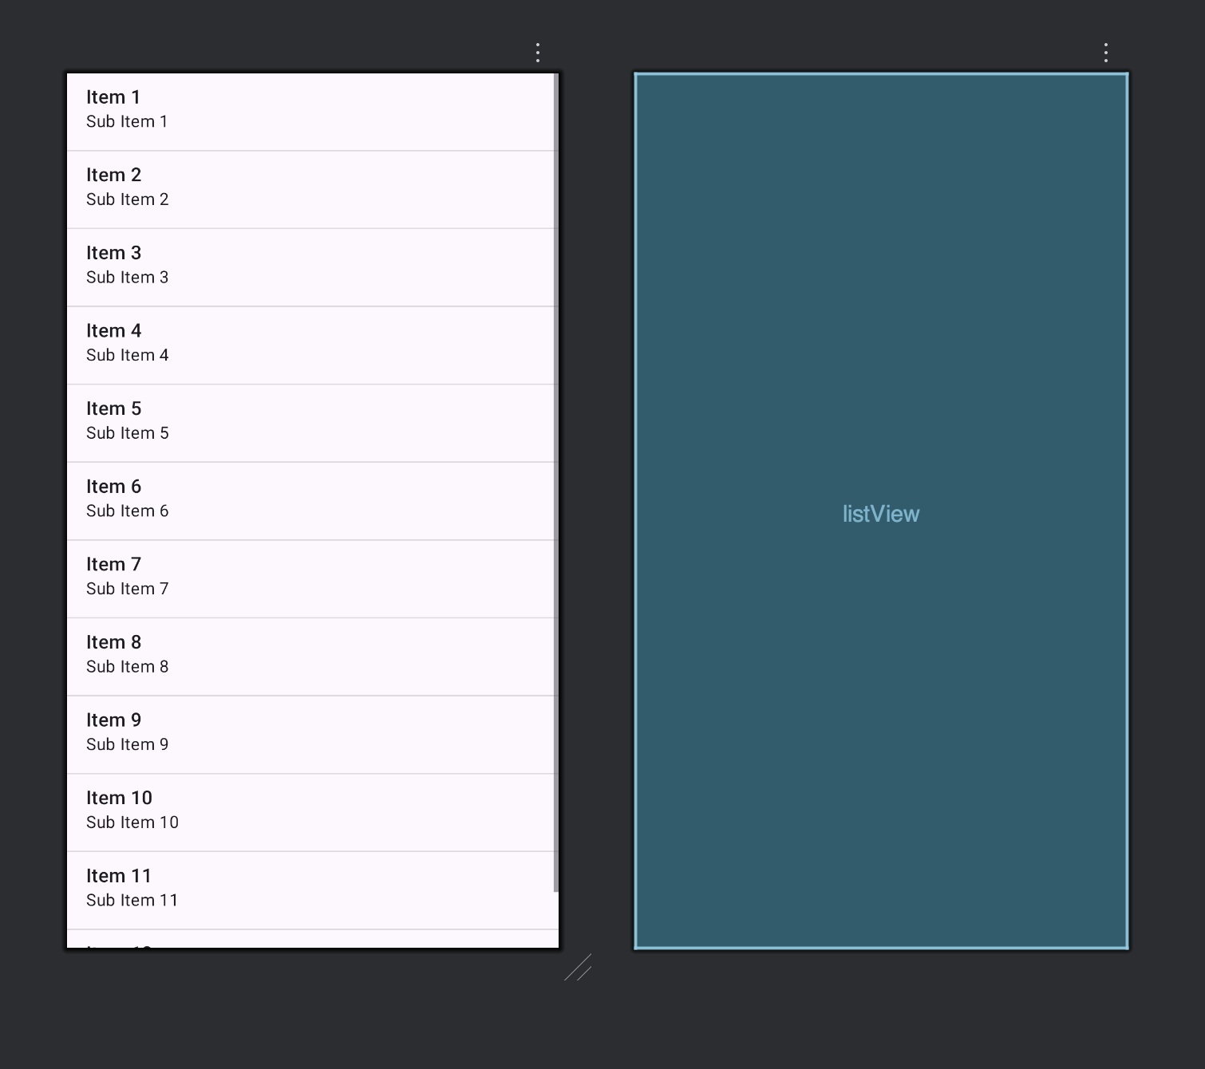

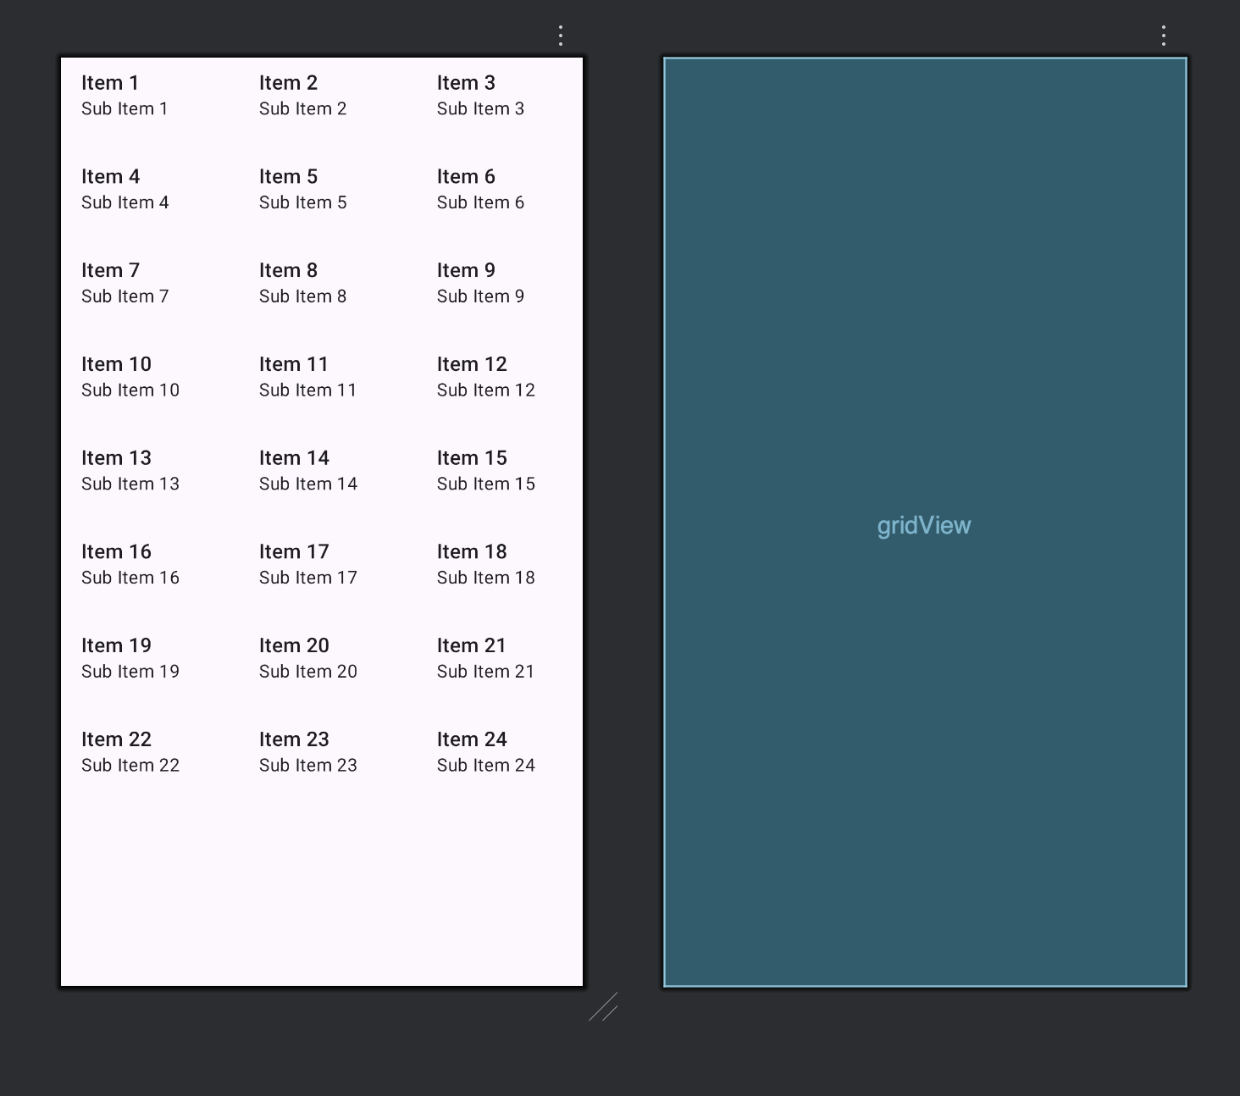

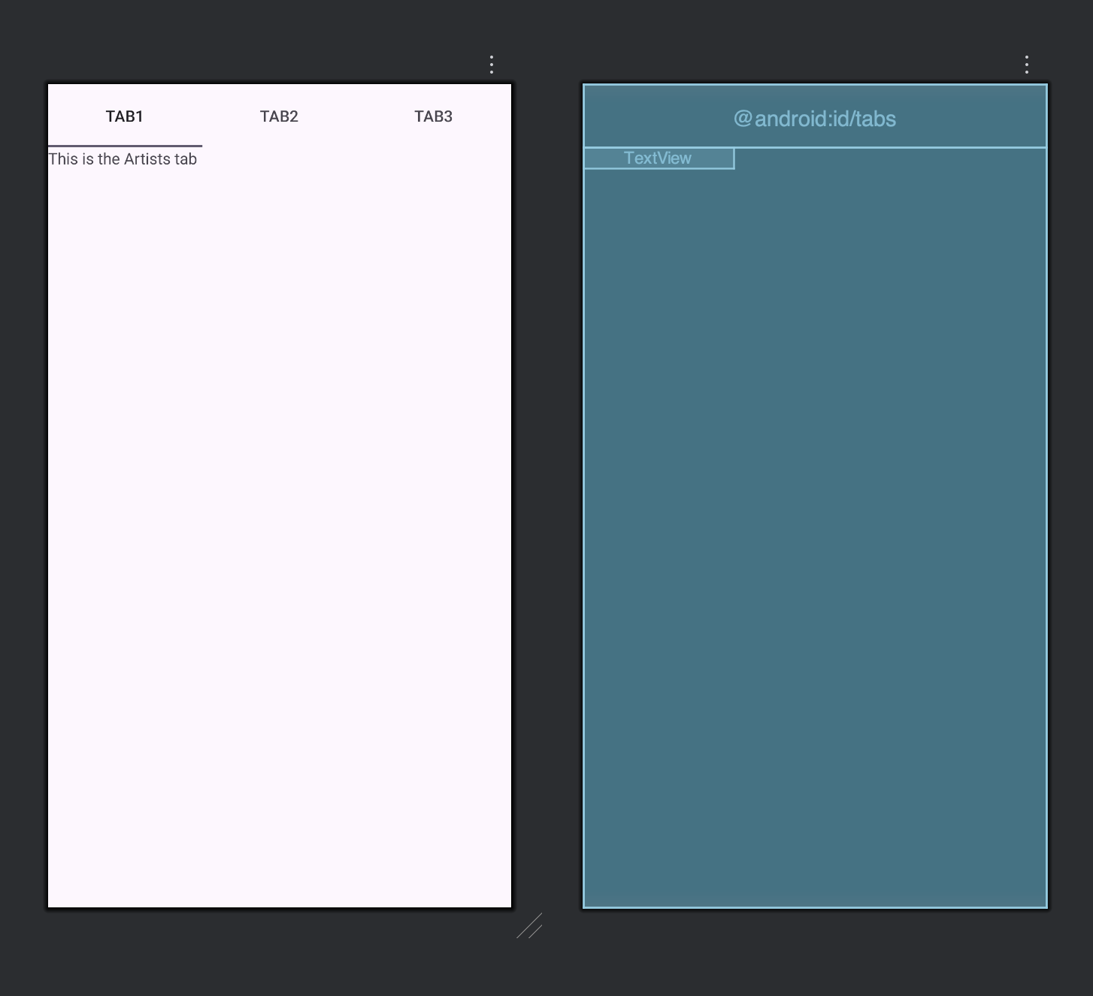

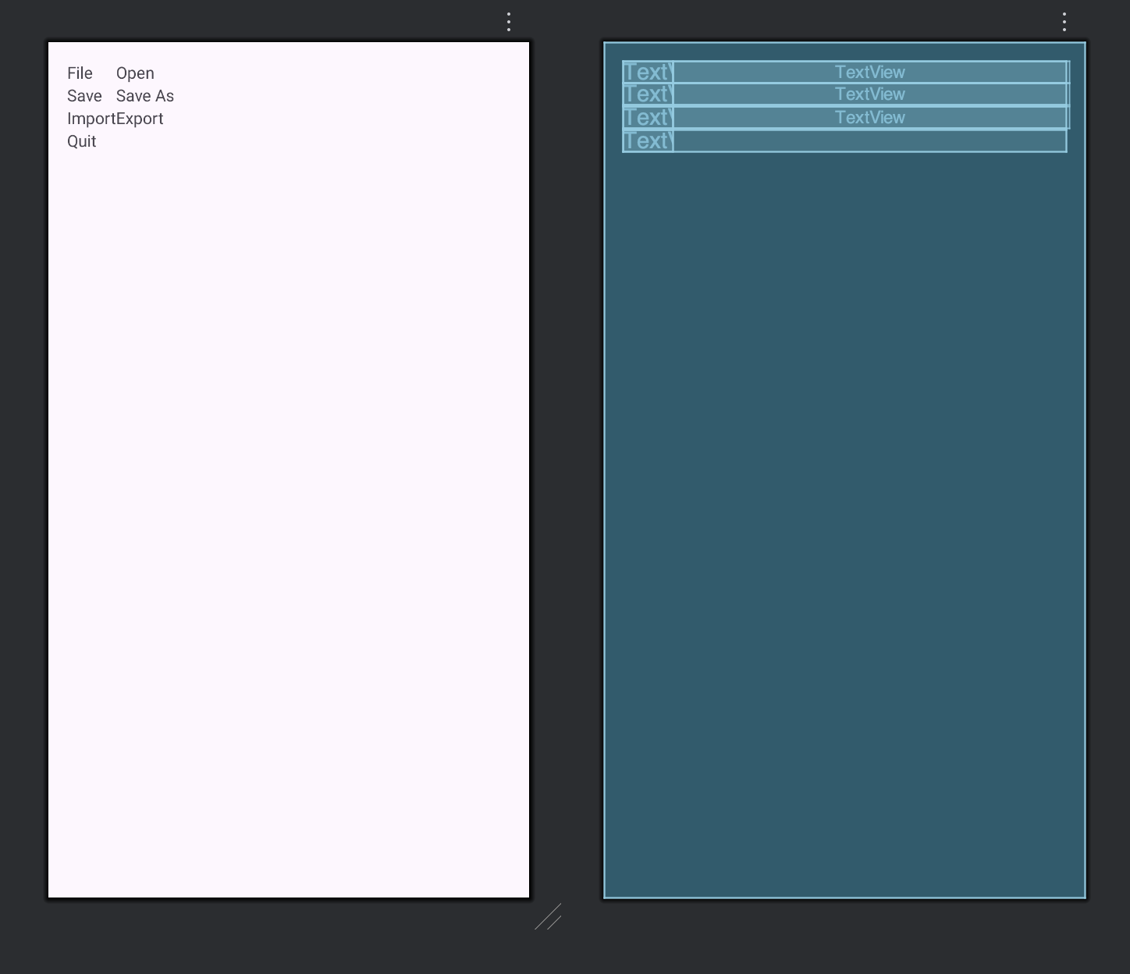

XML Code:

Linear Layout

<ListView xmlns:android="http://schemas.android.com/apk/res/android"  
 android:id="@+id/listView"  
 android:layout_width="match_parent"  
 android:layout_height="match_parent"/>

Grid Layout

<GridView xmlns:android="http://schemas.android.com/apk/res/android"  
 android:id="@+id/gridView"  
 android:layout_width="match_parent"  
 android:layout_height="match_parent"  
 android:numColumns="3"  
 android:verticalSpacing="10dp"  
 android:horizontalSpacing="10dp"  
 android:gravity="center"/>

Tab Layout

<TabHost xmlns:android="http://schemas.android.com/apk/res/android"  
 android:id="@android:id/tabhost"  
 android:layout_width="match_parent"  
 android:layout_height="match_parent">  
  
 <LinearLayout  
 android:layout_width="match_parent"  
 android:layout_height="match_parent"  
 android:orientation="vertical">  
  
 <TabWidget  
 android:id="@android:id/tabs"  
 android:layout_width="match_parent"  
 android:layout_height="wrap_content"/>  
  
 <FrameLayout  
 android:id="@android:id/tabcontent"  
 android:layout_width="match_parent"  
 android:layout_height="match_parent">  
  
 <TextView  
 android:id="@+id/tab1"  
 android:text="This is the Artists tab"  
 android:layout_width="wrap_content"  
 android:layout_height="wrap_content"/>  
  
 <TextView  
 android:id="@+id/tab2"  
 android:text="This is the Albums tab"  
 android:layout_width="wrap_content"  
 android:layout_height="wrap_content"/>  
  
 <TextView  
 android:id="@+id/tab3"  
 android:text="This is the Songs tab"  
 android:layout_width="wrap_content"  
 android:layout_height="wrap_content"/>  
 </FrameLayout>  
  
 </LinearLayout>  
</TabHost>

Table Layout

<TableLayout xmlns:android="http://schemas.android.com/apk/res/android"  
 android:layout_width="match_parent"  
 android:layout_height="match_parent"  
 android:stretchColumns="1"  
 android:padding="16dp">  
  
 <TableRow>  
 <TextView android:text="File"/>  
 <TextView android:text="Open"/>  
 </TableRow>  
  
 <TableRow>  
 <TextView android:text="Save"/>  
 <TextView android:text="Save As"/>  
 </TableRow>  
  
 <TableRow>  
 <TextView android:text="Import"/>  
 <TextView android:text="Export"/>  
 </TableRow>  
  
 <TableRow>  
 <TextView android:text="Quit"/>  
 </TableRow>  
  
</TableLayout>

Java Codes:

Linear

package com.priyansh.question1;  
  
import android.os.Bundle;  
import android.widget.ArrayAdapter;  
import android.widget.ListView;  
import androidx.appcompat.app.AppCompatActivity;  
  
public class MainActivity extends AppCompatActivity {  
  
 String[] countries = {  
 "American Samoa",  
 "El Salvador",  
 "Saint Helena",  
 "Saint Lucia",  
 "Samoa",  
 "San Marino"  
 };  
  
 @Override  
 protected void onCreate(Bundle savedInstanceState) {  
 super.onCreate(savedInstanceState);  
 setContentView(R.layout.*activity_main*);  
  
 ListView listView = findViewById(R.id.*listView*);  
 ArrayAdapter<String> adapter =  
 new ArrayAdapter<>(this,  
 android.R.layout.*simple_list_item_1*,  
 countries);  
  
 listView.setAdapter(adapter);  
 }  
}

Grid

package com.priyansh.question1;  
  
import android.os.Bundle;  
import android.widget.ArrayAdapter;  
  
import androidx.appcompat.app.AppCompatActivity;  
  
public class GridView extends AppCompatActivity {  
  
 String[] items = {  
 "One", "Two", "Three",  
 "Four", "Five", "Six",  
 "Seven", "Eight", "Nine"  
 };  
  
 @Override  
 protected void onCreate(Bundle savedInstanceState) {  
 super.onCreate(savedInstanceState);  
 setContentView(R.layout.*activity_grid_view*);  
  
 android.widget.GridView gridView = findViewById(R.id.*gridView*);  
 ArrayAdapter<String> adapter =  
 new ArrayAdapter<>(this,  
 android.R.layout.*simple_list_item_1*,  
 items);  
  
 gridView.setAdapter(adapter);  
 }  
}

Tab

package com.priyansh.question1;  
  
import android.os.Bundle;  
import android.widget.TabHost;  
import androidx.appcompat.app.AppCompatActivity;  
  
public class TabLayout extends AppCompatActivity {  
  
 @Override  
 protected void onCreate(Bundle savedInstanceState) {  
 super.onCreate(savedInstanceState);  
 setContentView(R.layout.*activity_tab_layout*);  
  
 TabHost tabHost = findViewById(android.R.id.*tabhost*);  
 tabHost.setup();  
  
 TabHost.TabSpec spec;  
  
 spec = tabHost.newTabSpec("Artists");  
 spec.setContent(R.id.*tab1*);  
 spec.setIndicator("Artists");  
 tabHost.addTab(spec);  
  
 spec = tabHost.newTabSpec("Albums");  
 spec.setContent(R.id.*tab2*);  
 spec.setIndicator("Albums");  
 tabHost.addTab(spec);  
  
 spec = tabHost.newTabSpec("Songs");  
 spec.setContent(R.id.*tab3*);  
 spec.setIndicator("Songs");  
 tabHost.addTab(spec);  
 }  
}

Output Example:

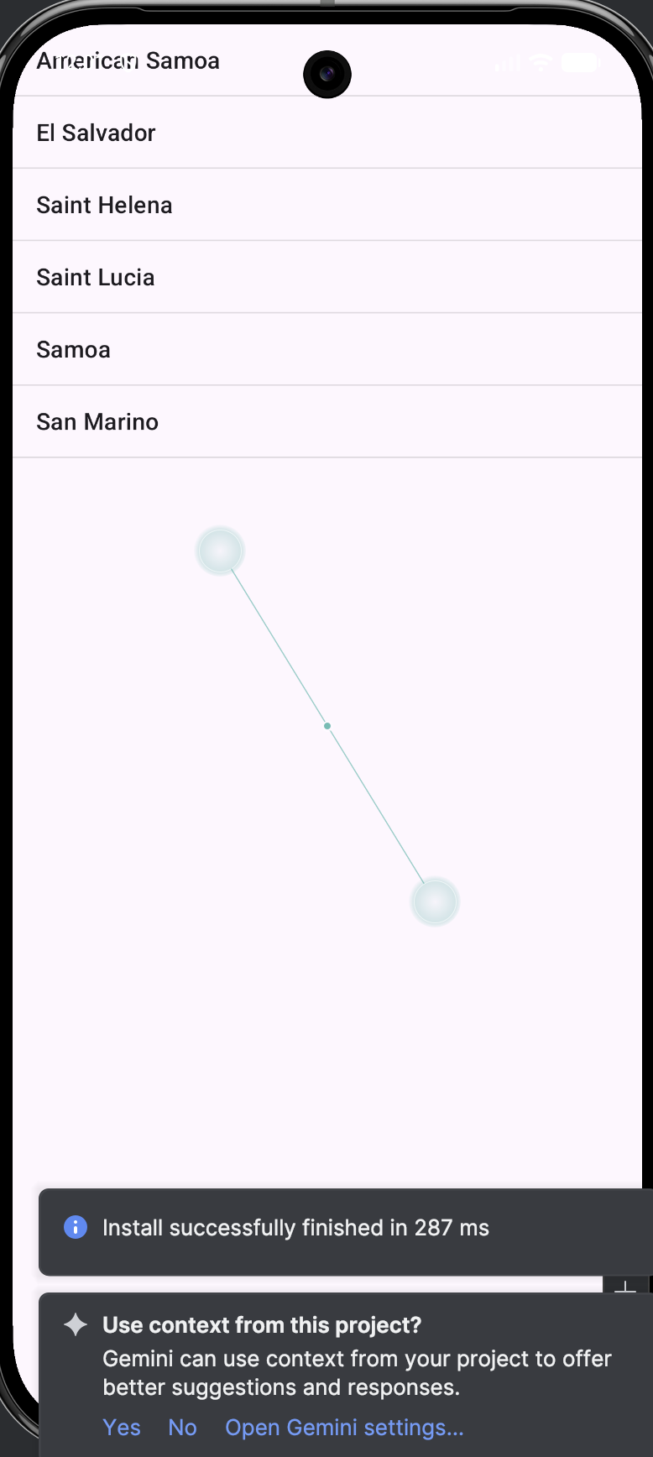

Question 2:

Write a program to list different sports, and when a sport is selected, display a message showing the selected sport.

Layout Design:

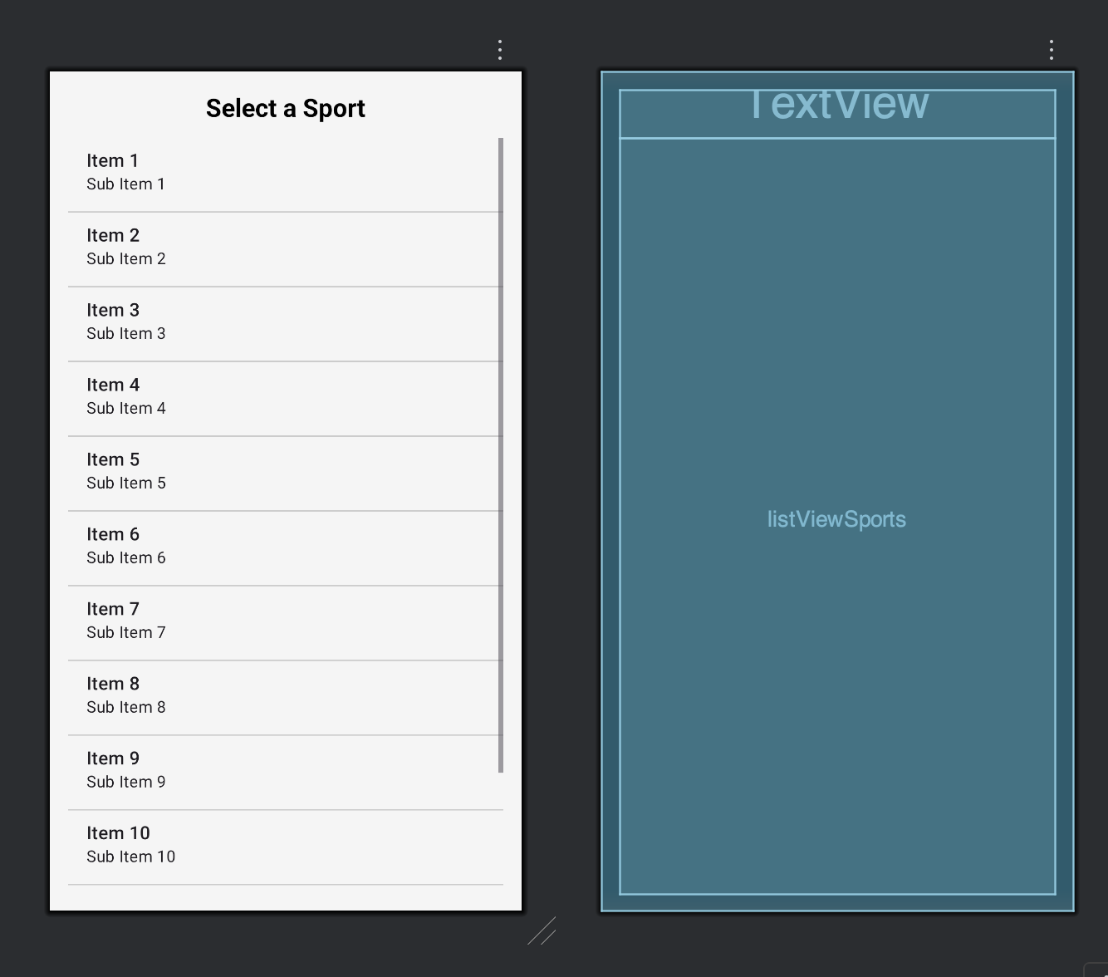

XML:

<?xml version="1.0" encoding="utf-8"?>  
<LinearLayout xmlns:android="http://schemas.android.com/apk/res/android"  
 android:layout_width="match_parent"  
 android:layout_height="match_parent"  
 android:orientation="vertical"  
 android:padding="16dp"  
 android:background="#F5F5F5">  
  
 <TextView  
 android:layout_width="match_parent"  
 android:layout_height="wrap_content"  
 android:text="Select a Sport"  
 android:textSize="22sp"  
 android:textStyle="bold"  
 android:textColor="#000000"  
 android:gravity="center"  
 android:paddingBottom="12dp"/>  
  
 <ListView  
 android:id="@+id/listViewSports"  
 android:layout_width="match_parent"  
 android:layout_height="match_parent"  
 android:divider="#CCCCCC"  
 android:dividerHeight="1dp"/>  
</LinearLayout>

Java:

package com.priyansh.question2;  
  
import androidx.appcompat.app.AppCompatActivity;  
import android.os.Bundle;  
import android.view.View;  
import android.widget.AdapterView;  
import android.widget.ArrayAdapter;  
import android.widget.ListView;  
import android.widget.Toast;  
  
public class MainActivity extends AppCompatActivity {  
  
 ListView listView;  
 String[] sports = {  
 "Cricket",  
 "Football",  
 "Basketball",  
 "Tennis",  
 "Hockey",  
 "Badminton"  
 };  
  
 @Override  
 protected void onCreate(Bundle savedInstanceState) {  
 super.onCreate(savedInstanceState);  
 setContentView(R.layout.*activity_main*);  
  
 listView = findViewById(R.id.*listViewSports*);  
  
 ArrayAdapter<String> adapter =  
 new ArrayAdapter<>(this,  
 android.R.layout.*simple_list_item_1*,  
 sports);  
  
 listView.setAdapter(adapter);  
  
 listView.setOnItemClickListener(new AdapterView.OnItemClickListener() {  
 @Override  
 public void onItemClick(AdapterView<?> parent,  
 View view,  
 int position,  
 long id) {  
  
 String selectedSport = sports[position];  
 Toast.*makeText*(MainActivity.this,  
 "Selected sport: " + selectedSport,  
 Toast.*LENGTH_SHORT*).show();  
 }  
 });  
 }  
}

Output:

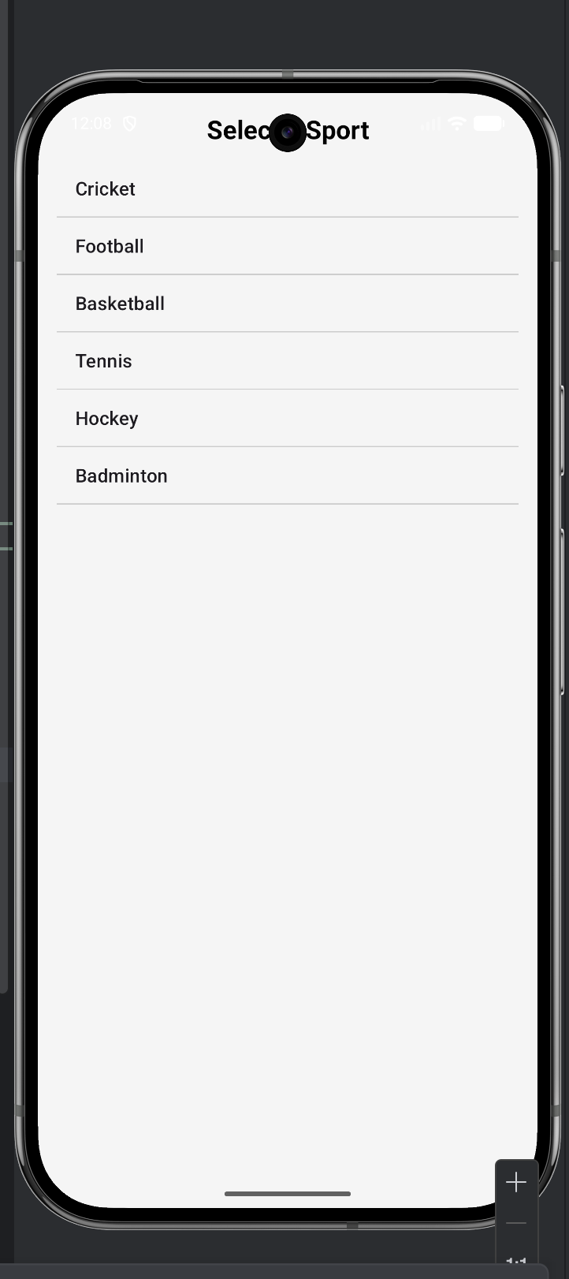 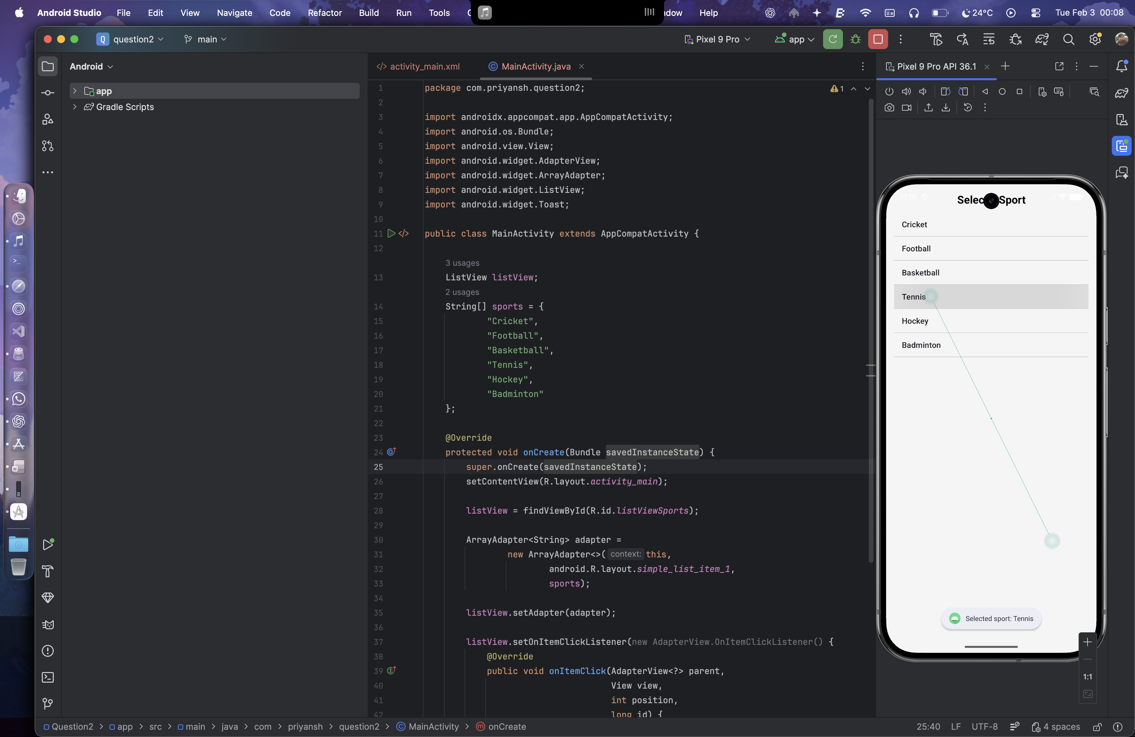

Question 3:

Design an news application and Implement the navigation between the sections like Top Stories, Sports, and Entertainment using tab layout

Layout Designs:

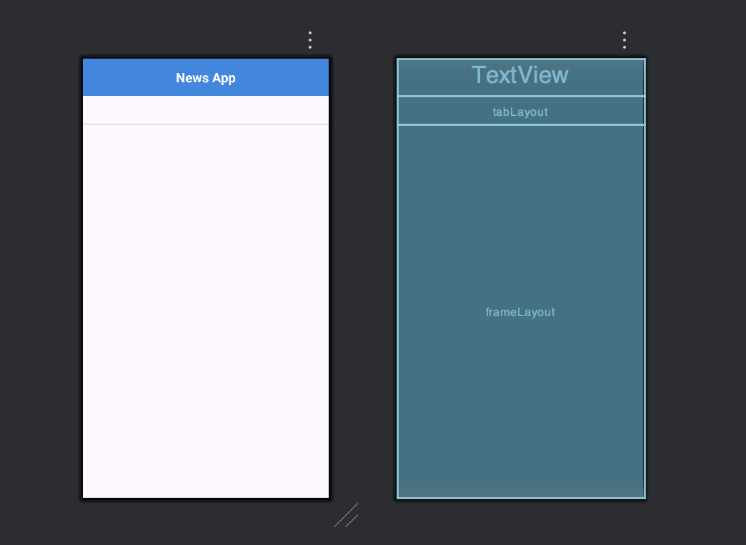

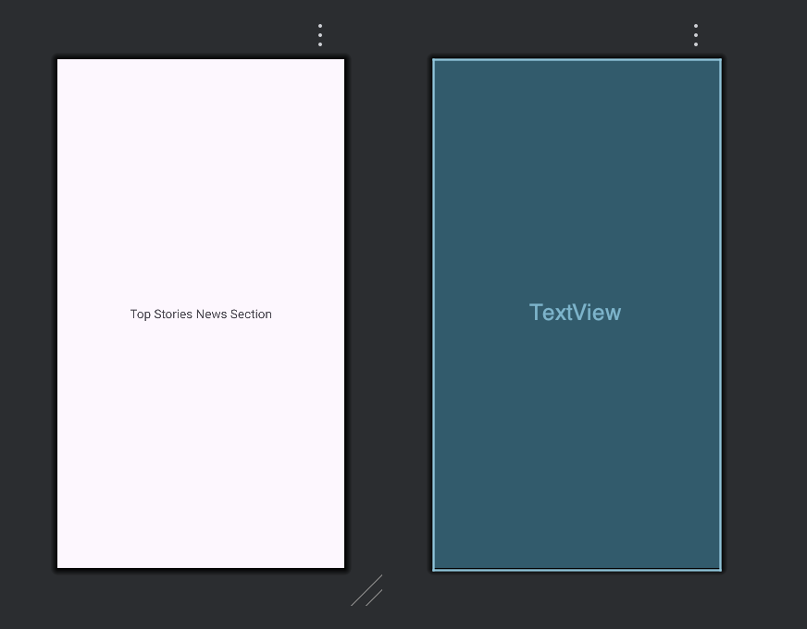

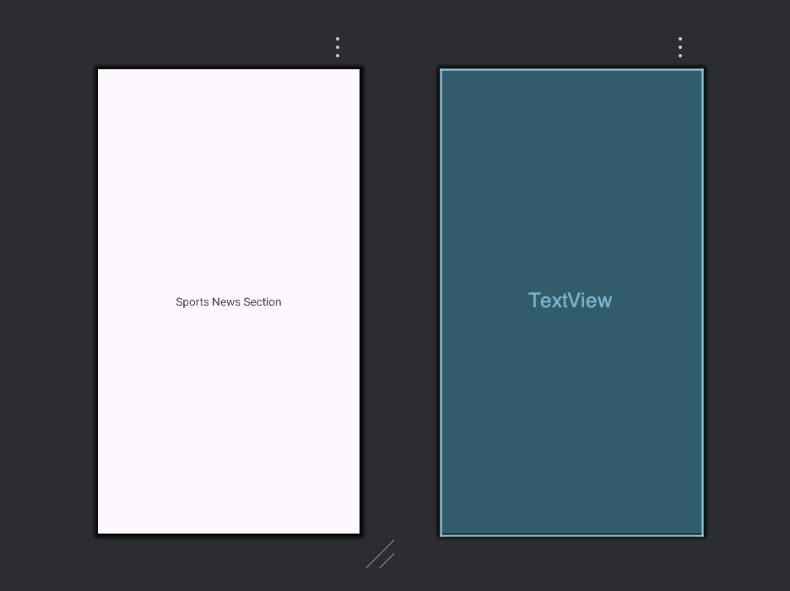

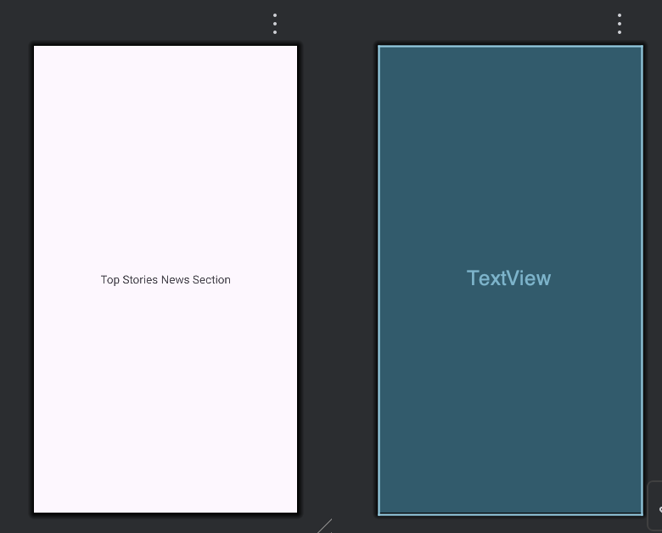

XML for Designs

activity_main.xml

<?xml version="1.0" encoding="utf-8"?>  
<LinearLayout xmlns:android="http://schemas.android.com/apk/res/android"  
 xmlns:app="http://schemas.android.com/apk/res-auto"  
 android:layout_width="match_parent"  
 android:layout_height="match_parent"  
 android:orientation="vertical">  
  
 <TextView  
 android:layout_width="match_parent"  
 android:layout_height="wrap_content"  
 android:text="News App"  
 android:textSize="22sp"  
 android:textStyle="bold"  
 android:padding="16dp"  
 android:gravity="center"  
 android:background="#1E88E5"  
 android:textColor="#FFFFFF"/>  
  
 <com.google.android.material.tabs.TabLayout  
 android:id="@+id/tabLayout"  
 android:layout_width="match_parent"  
 android:layout_height="wrap_content"  
 app:tabIndicatorColor="#1E88E5"  
 app:tabSelectedTextColor="#1E88E5"  
 app:tabTextColor="#666666"  
 app:tabMode="fixed"  
 app:tabGravity="fill"/>  
  
 <!-- Content Area -->  
 <FrameLayout  
 android:id="@+id/frameLayout"  
 android:layout_width="match_parent"  
 android:layout_height="match_parent"  
 android:padding="16dp"/>  
  
</LinearLayout>

top_stories.xml

<TextView xmlns:android="http://schemas.android.com/apk/res/android"  
 android:layout_width="match_parent"  
 android:layout_height="match_parent"  
 android:text="Top Stories News Section"  
 android:textSize="18sp"  
 android:gravity="center"/>

sports.xml

<TextView xmlns:android="http://schemas.android.com/apk/res/android"  
 android:layout_width="match_parent"  
 android:layout_height="match_parent"  
 android:text="Sports News Section"  
 android:textSize="18sp"  
 android:gravity="center"/>

entertainment.xml

<TextView xmlns:android="http://schemas.android.com/apk/res/android"  
 android:layout_width="match_parent"  
 android:layout_height="match_parent"  
 android:text="Top Stories News Section"  
 android:textSize="18sp"  
 android:gravity="center"/>

Java Code:

package com.priyansh.question3;  
  
import android.os.Bundle;  
import android.view.LayoutInflater;  
import android.view.View;  
import android.widget.FrameLayout;  
  
import androidx.appcompat.app.AppCompatActivity;  
  
import com.google.android.material.tabs.TabLayout;  
  
public class MainActivity extends AppCompatActivity {  
  
 TabLayout tabLayout;  
 FrameLayout frameLayout;  
  
 @Override  
 protected void onCreate(Bundle savedInstanceState) {  
 super.onCreate(savedInstanceState);  
 setContentView(R.layout.*activity_main*);  
  
 tabLayout = findViewById(R.id.*tabLayout*);  
 frameLayout = findViewById(R.id.*frameLayout*);  
  
 tabLayout.addTab(tabLayout.newTab().setText("Top Stories"));  
 tabLayout.addTab(tabLayout.newTab().setText("Sports"));  
 tabLayout.addTab(tabLayout.newTab().setText("Entertainment"));  
  
 loadLayout(R.layout.*top_stories*);  
  
 tabLayout.addOnTabSelectedListener(new TabLayout.OnTabSelectedListener() {  
 @Override  
 public void onTabSelected(TabLayout.Tab tab) {  
 switch (tab.getPosition()) {  
 case 0:  
 loadLayout(R.layout.*top_stories*);  
 break;  
 case 1:  
 loadLayout(R.layout.*sports*);  
 break;  
 case 2:  
 loadLayout(R.layout.*entertainment*);  
 break;  
 }  
 }  
  
 @Override public void onTabUnselected(TabLayout.Tab tab) {}  
 @Override public void onTabReselected(TabLayout.Tab tab) {}  
 });  
 }  
  
 private void loadLayout(int layoutId) {  
 frameLayout.removeAllViews();  
 View view = LayoutInflater.*from*(this).inflate(layoutId, frameLayout, false);  
 frameLayout.addView(view);  
 }  
}

Output:

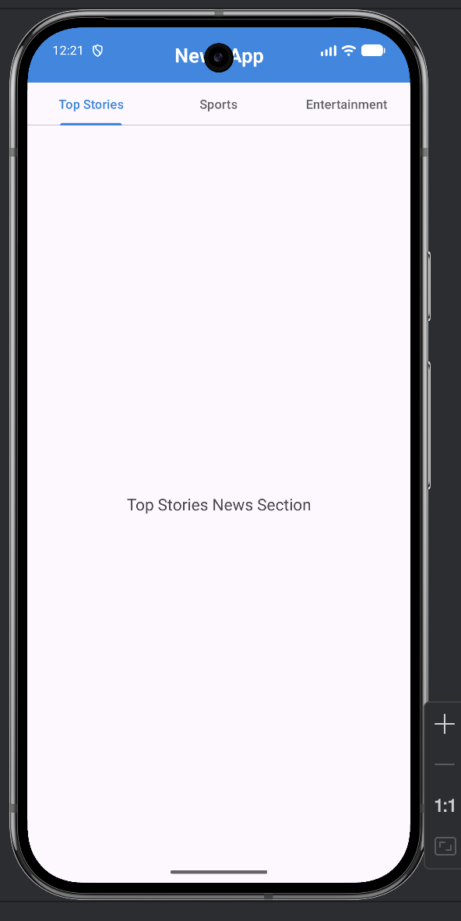 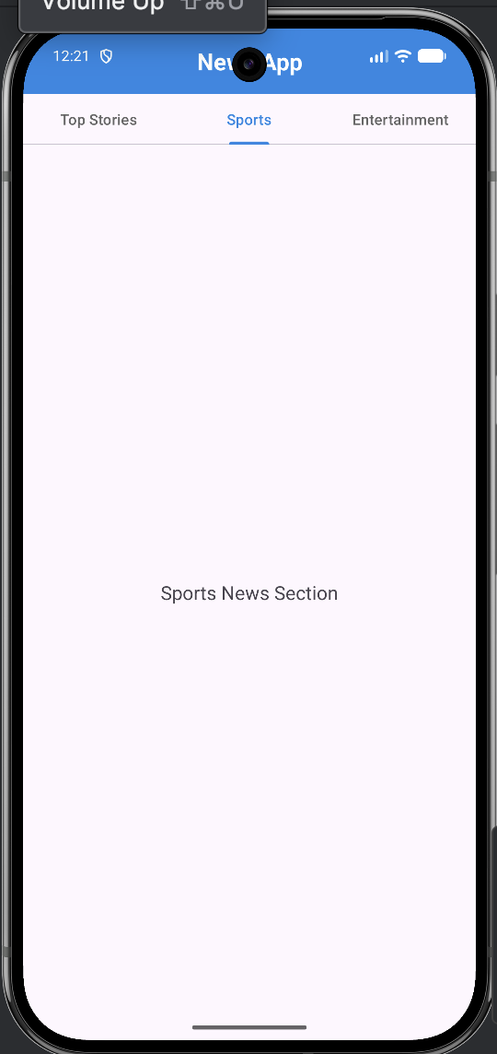

**Lab 4- Input Controls in Android**

Question 1:

Develop a “Test app” that includes a layout with a button and a ToggleButton. When each button is clicked a custom Toast message should be displayed with different images as their content.

Layout Design:

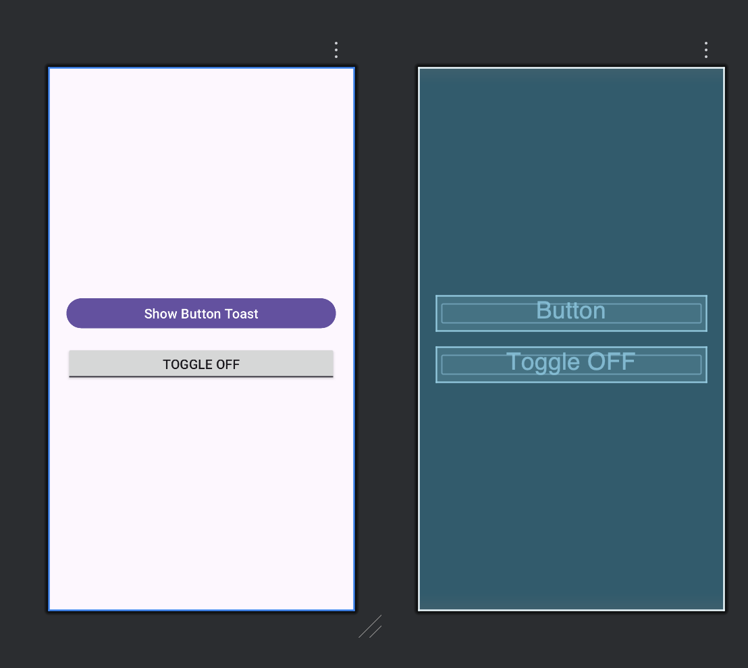

XML for activity_main.xml

<?xml version="1.0" encoding="utf-8"?>  
<LinearLayout xmlns:android="http://schemas.android.com/apk/res/android"  
 android:layout_width="match_parent"  
 android:layout_height="match_parent"  
 android:orientation="vertical"  
 android:gravity="center"  
 android:padding="24dp">  
  
 <Button  
 android:id="@+id/btnShow"  
 android:layout_width="match_parent"  
 android:layout_height="wrap_content"  
 android:text="Show Button Toast"  
 android:textSize="18sp"  
 android:layout_marginBottom="20dp"/>  
  
 <ToggleButton  
 android:id="@+id/toggleBtn"  
 android:layout_width="match_parent"  
 android:layout_height="wrap_content"  
 android:textOn="Toggle ON"  
 android:textOff="Toggle OFF"  
 android:textSize="18sp"/>  
  
</LinearLayout>

XML for custom_toast.xml

<?xml version="1.0" encoding="utf-8"?>  
<LinearLayout xmlns:android="http://schemas.android.com/apk/res/android"  
 android:layout_width="wrap_content"  
 android:layout_height="wrap_content"  
 android:orientation="horizontal"  
 android:padding="12dp"  
 android:background="#CC000000"  
 android:gravity="center">  
  
 <ImageView  
 android:id="@+id/toastImage"  
 android:layout_width="40dp"  
 android:layout_height="40dp"  
 android:layout_marginEnd="10dp"/>  
  
 <TextView  
 android:id="@+id/toastText"  
 android:layout_width="wrap_content"  
 android:layout_height="wrap_content"  
 android:textColor="#FFFFFF"  
 android:textSize="16sp"/>  
  
</LinearLayout>

Java Code:

public class MainActivity extends AppCompatActivity {  
  
 Button btnShow;  
 ToggleButton toggleBtn;  
  
 @Override  
 protected void onCreate(Bundle savedInstanceState) {  
 super.onCreate(savedInstanceState);  
 setContentView(R.layout.*activity_main*);  
  
 btnShow = findViewById(R.id.*btnShow*);  
 toggleBtn = findViewById(R.id.*toggleBtn*);  
  
 btnShow.setOnClickListener(v ->  
 showCustomToast("Button Clicked!", R.drawable.*button_img*)  
 );  
  
 toggleBtn.setOnClickListener(v -> {  
 if (toggleBtn.isChecked()) {  
 showCustomToast("Toggle is ON", R.drawable.*toggle_on*);  
 } else {  
 showCustomToast("Toggle is OFF", R.drawable.*toggle_off*);  
 }  
 });  
 }  
  
 private void showCustomToast(String message, int imageRes) {  
 LayoutInflater inflater = getLayoutInflater();  
 View toastView = inflater.inflate(R.layout.*custom_toast*, null);  
  
 ImageView image = toastView.findViewById(R.id.*toastImage*);  
 TextView text = toastView.findViewById(R.id.*toastText*);  
  
 image.setImageResource(imageRes);  
 text.setText(message);  
  
 Toast toast = new Toast(getApplicationContext());  
 toast.setDuration(Toast.*LENGTH_SHORT*);  
 toast.setView(toastView);  
 toast.show();  
 }  
}

Images are added to the drawable folder:  
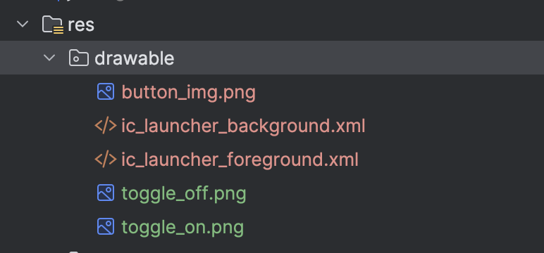

Output:

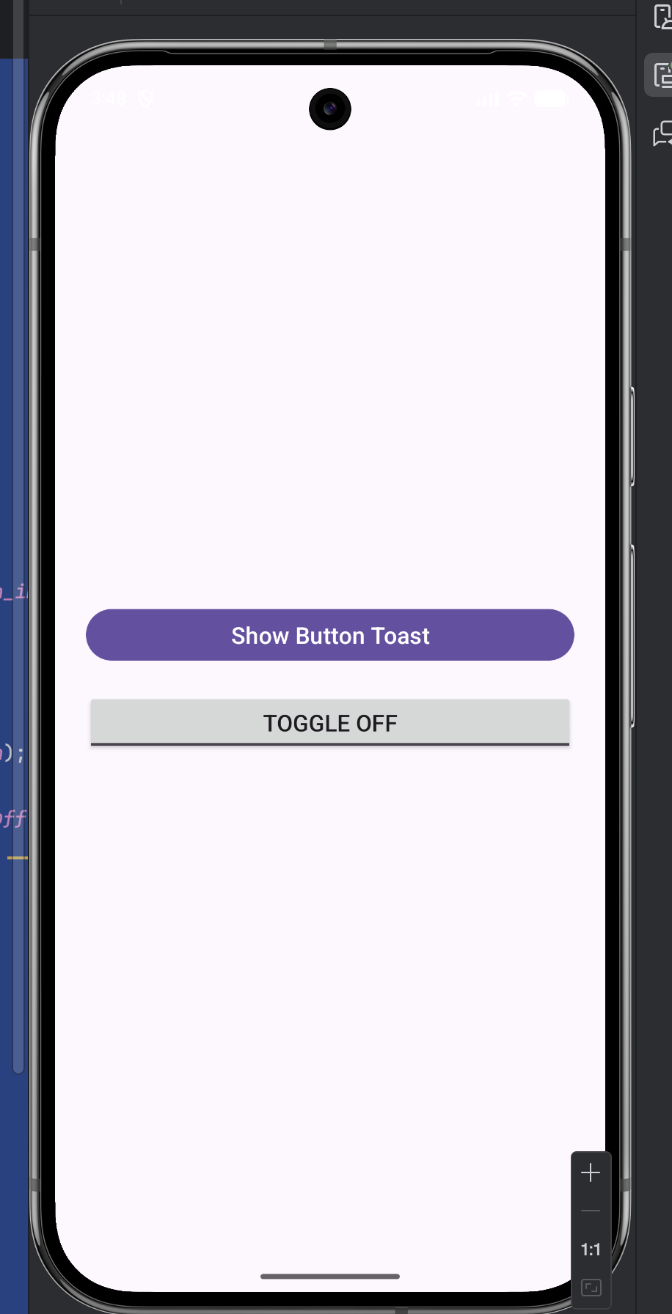 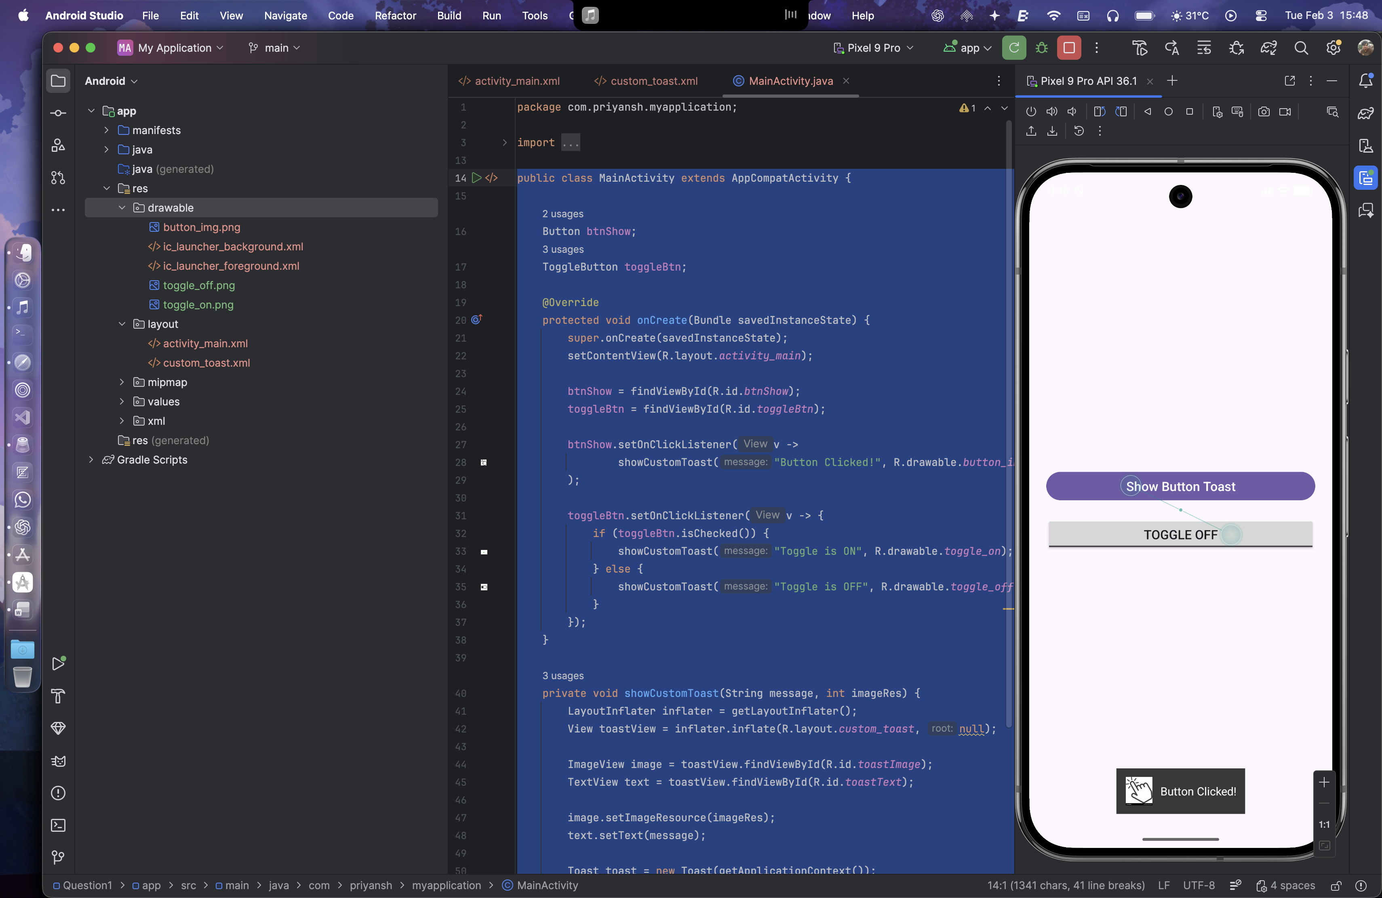 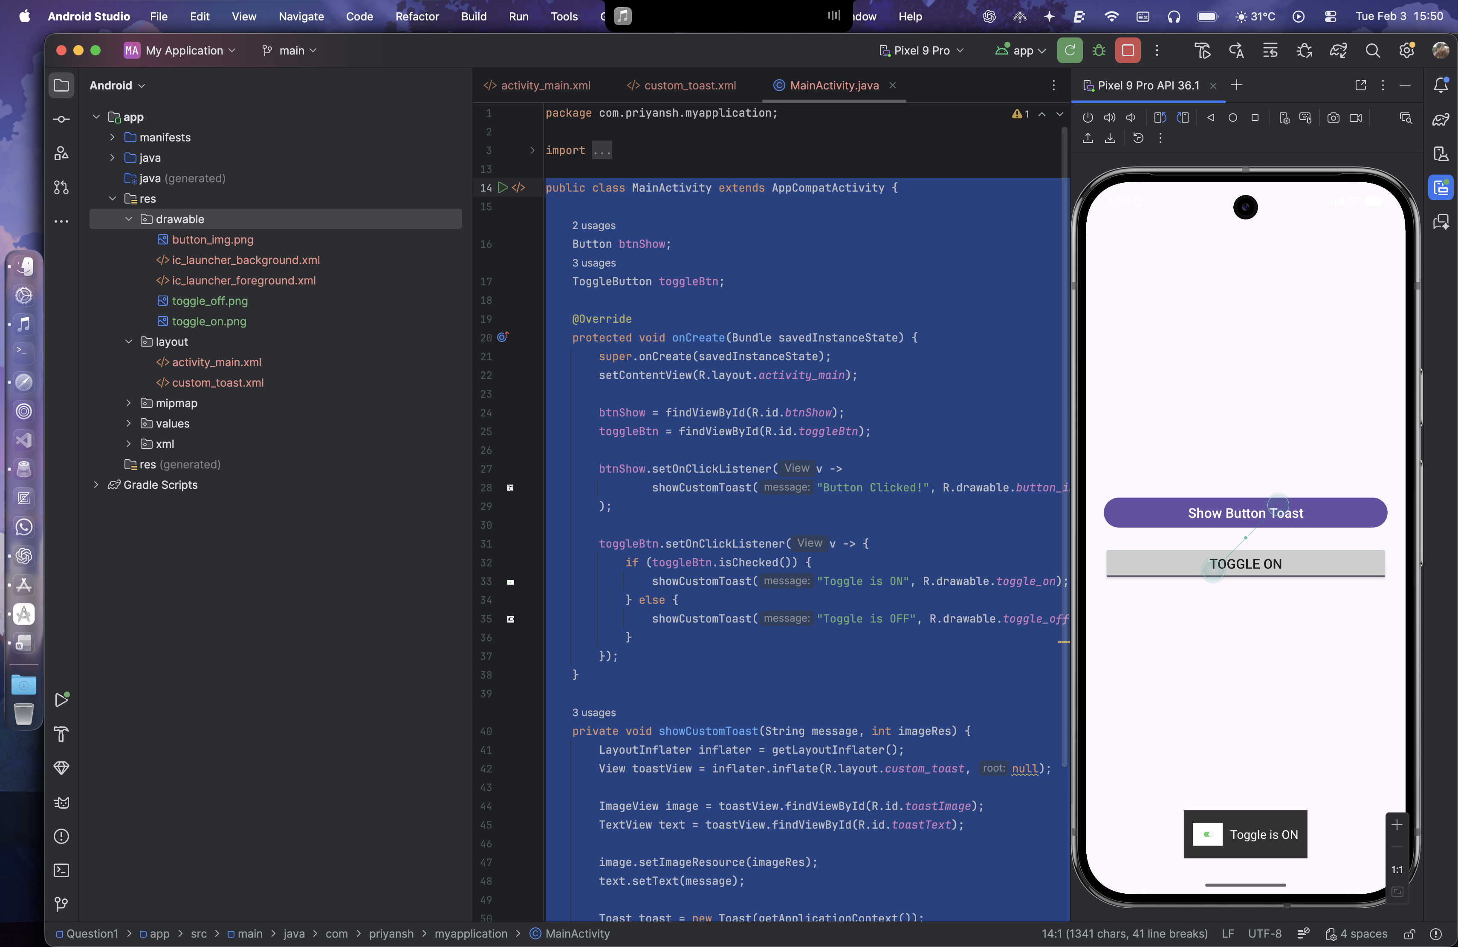 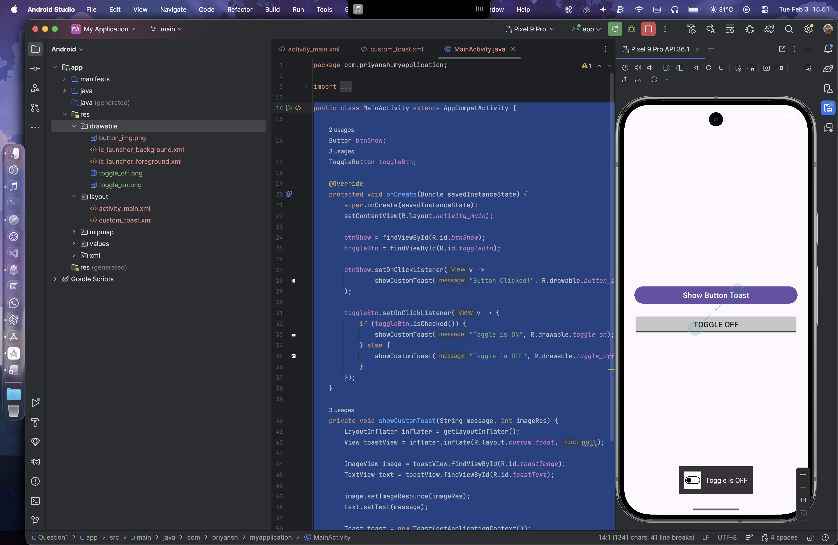

Question 2:

Create an app that contains a view with multiple buttons, each labeled with different Android versions. When a button is clicked, a Toast message should appear, displaying the corresponding Android version's name along with its associated icon.

Layout Design:

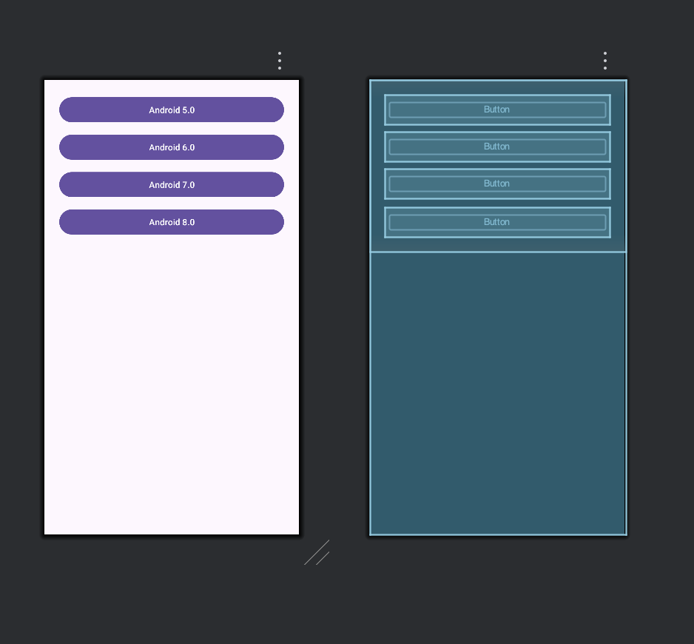

XML for activity_mail.xml

<?xml version="1.0" encoding="utf-8"?>  
<ScrollView xmlns:android="http://schemas.android.com/apk/res/android"  
 android:layout_width="match_parent"  
 android:layout_height="match_parent">  
  
 <LinearLayout  
 android:layout_width="match_parent"  
 android:layout_height="wrap_content"  
 android:orientation="vertical"  
 android:gravity="center"  
 android:padding="24dp">  
  
 <Button  
 android:id="@+id/btnLollipop"  
 android:layout_width="match_parent"  
 android:layout_height="wrap_content"  
 android:text="Android 5.0"  
 android:layout_marginBottom="12dp"/>  
  
 <Button  
 android:id="@+id/btnMarshmallow"  
 android:layout_width="match_parent"  
 android:layout_height="wrap_content"  
 android:text="Android 6.0"  
 android:layout_marginBottom="12dp"/>  
  
 <Button  
 android:id="@+id/btnNougat"  
 android:layout_width="match_parent"  
 android:layout_height="wrap_content"  
 android:text="Android 7.0"  
 android:layout_marginBottom="12dp"/>  
  
 <Button  
 android:id="@+id/btnOreo"  
 android:layout_width="match_parent"  
 android:layout_height="wrap_content"  
 android:text="Android 8.0"/>  
  
 </LinearLayout>  
</ScrollView>

XML for custom_toast.xml

<?xml version="1.0" encoding="utf-8"?>  
<LinearLayout xmlns:android="http://schemas.android.com/apk/res/android"  
 android:layout_width="wrap_content"  
 android:layout_height="wrap_content"  
 android:orientation="horizontal"  
 android:padding="12dp"  
 android:gravity="center"  
 android:background="#CC000000">  
  
 <ImageView  
 android:id="@+id/toastIcon"  
 android:layout_width="40dp"  
 android:layout_height="40dp"  
 android:layout_marginEnd="10dp"/>  
  
 <TextView  
 android:id="@+id/toastText"  
 android:layout_width="wrap_content"  
 android:layout_height="wrap_content"  
 android:textColor="#FFFFFF"  
 android:textSize="16sp"/>  
</LinearLayout>

Java Code:

public class MainActivity extends AppCompatActivity {  
  
 @Override  
 protected void onCreate(Bundle savedInstanceState) {  
 super.onCreate(savedInstanceState);  
 setContentView(R.layout.*activity_main*);  
  
 Button lollipop = findViewById(R.id.*btnLollipop*);  
 Button marshmallow = findViewById(R.id.*btnMarshmallow*);  
 Button nougat = findViewById(R.id.*btnNougat*);  
 Button oreo = findViewById(R.id.*btnOreo*);  
  
 lollipop.setOnClickListener(v ->  
 showCustomToast("Android Lollipop", R.drawable.*android_lollipop*));  
  
 marshmallow.setOnClickListener(v ->  
 showCustomToast("Android Marshmallow", R.drawable.*android_marshmallow*));  
  
 nougat.setOnClickListener(v ->  
 showCustomToast("Android Nougat", R.drawable.*android_nougat*));  
  
 oreo.setOnClickListener(v ->  
 showCustomToast("Android Oreo", R.drawable.*android_oreo*));  
 }  
  
 private void showCustomToast(String text, int imageRes) {  
 LayoutInflater inflater = getLayoutInflater();  
 View view = inflater.inflate(R.layout.*custom_toast*, null);  
  
 ImageView icon = view.findViewById(R.id.*toastIcon*);  
 TextView message = view.findViewById(R.id.*toastText*);  
  
 icon.setImageResource(imageRes);  
 message.setText(text);  
  
 Toast toast = new Toast(getApplicationContext());  
 toast.setDuration(Toast.*LENGTH_SHORT*);  
 toast.setView(view);  
 toast.show();  
 }  
}

Images are stored in drawable folder

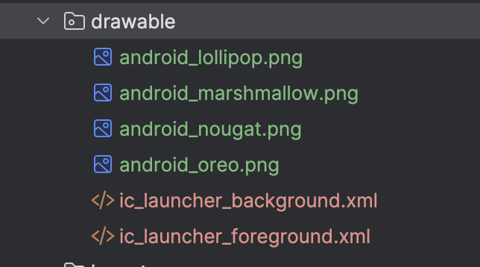

Output:

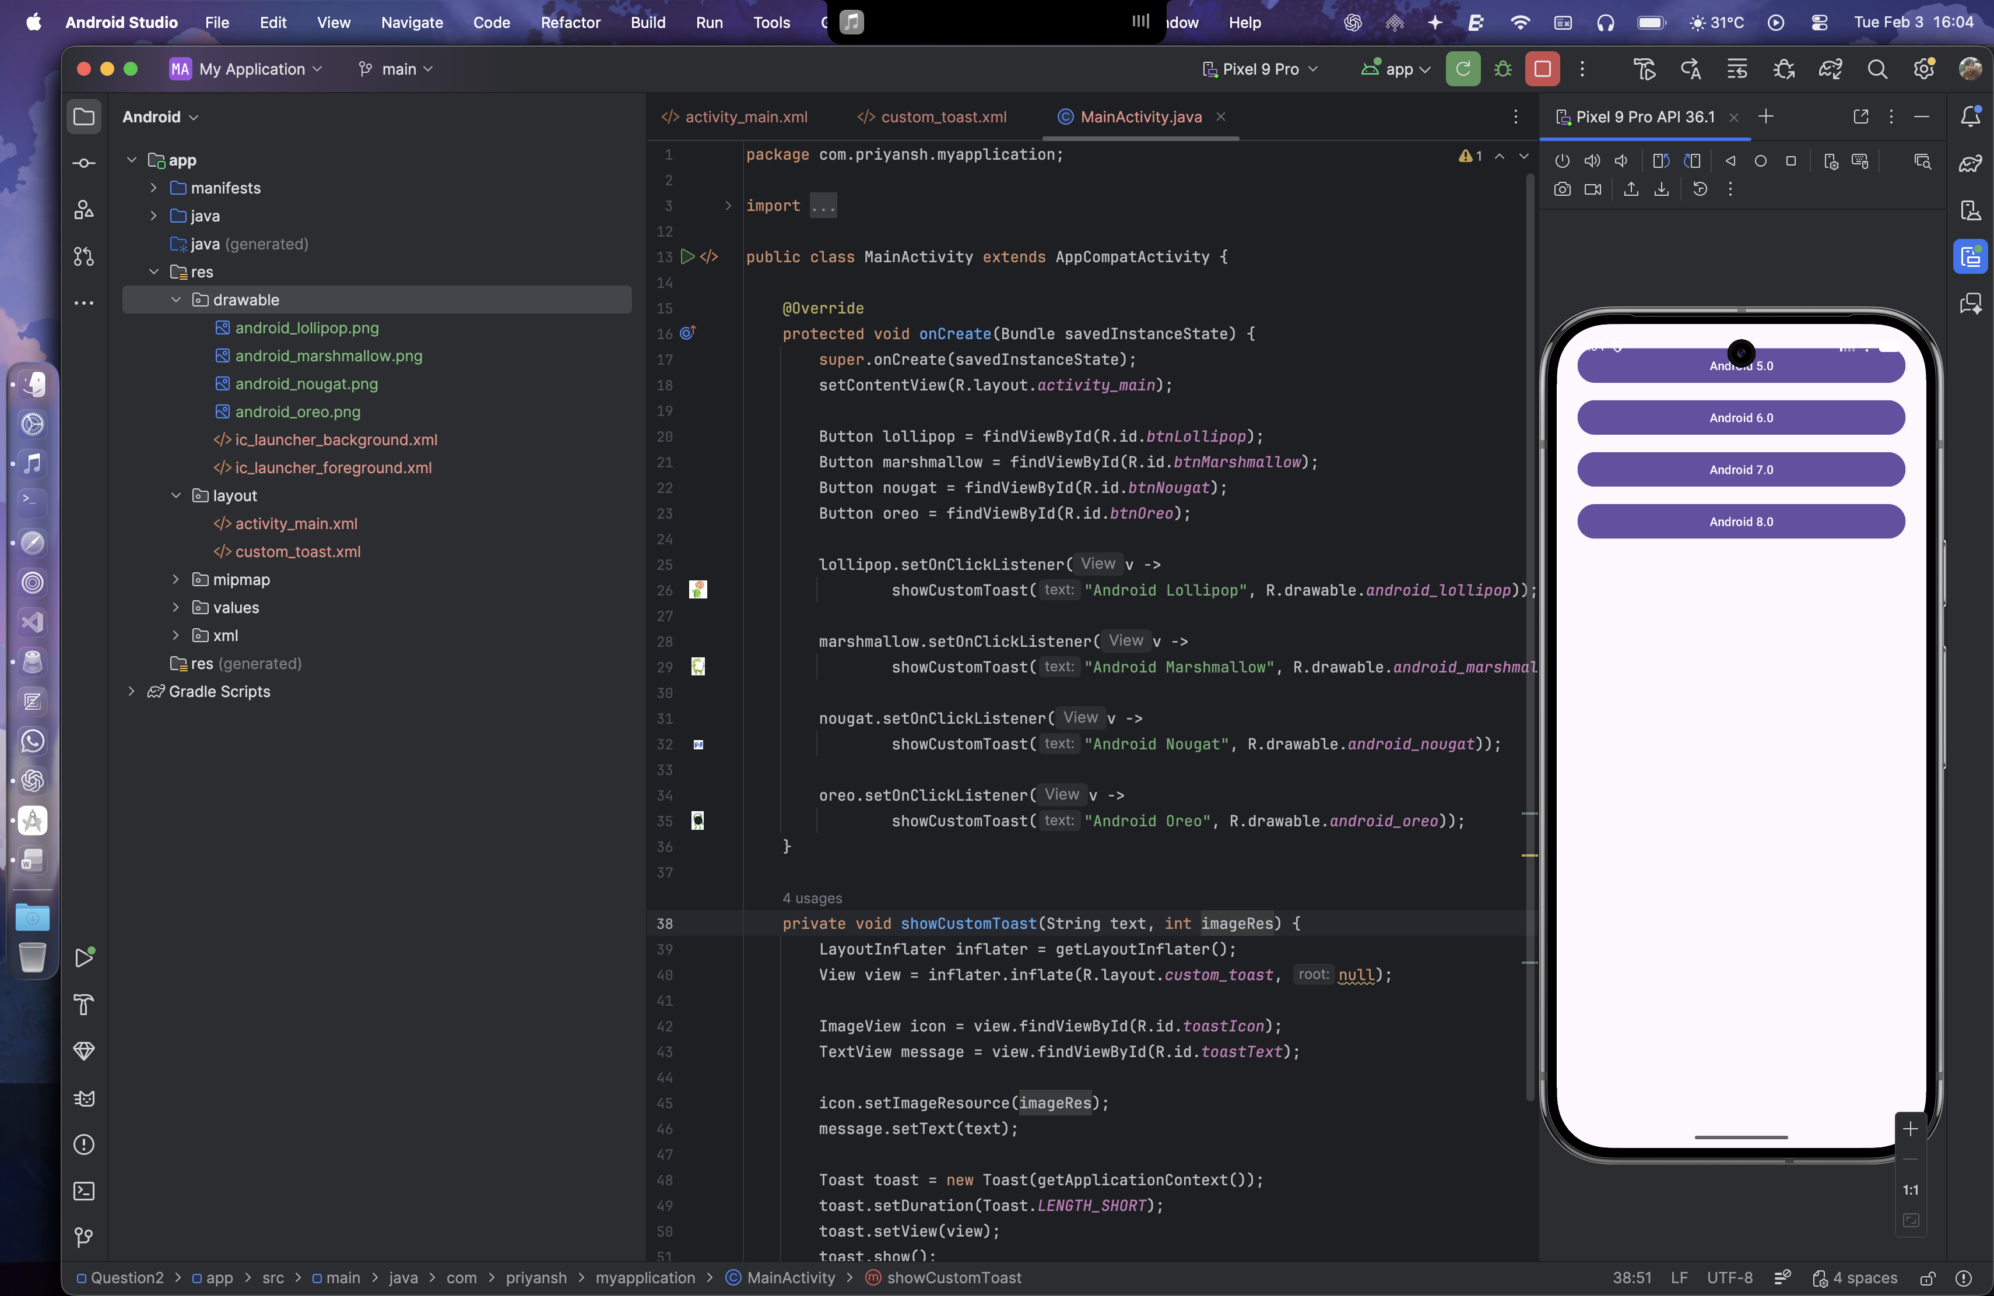 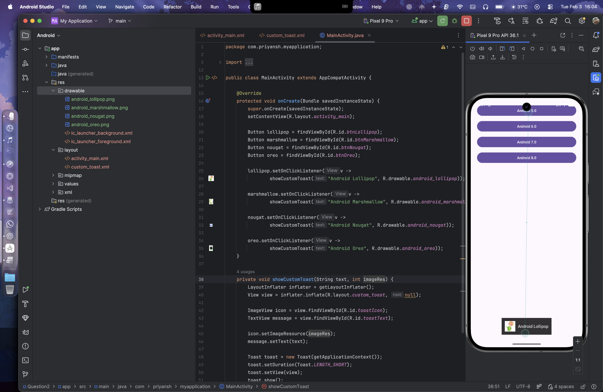 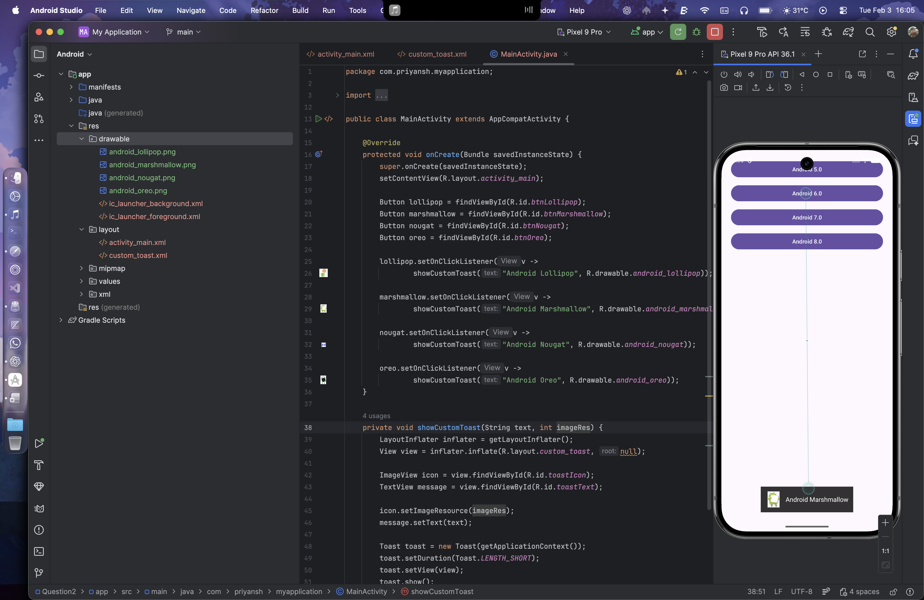 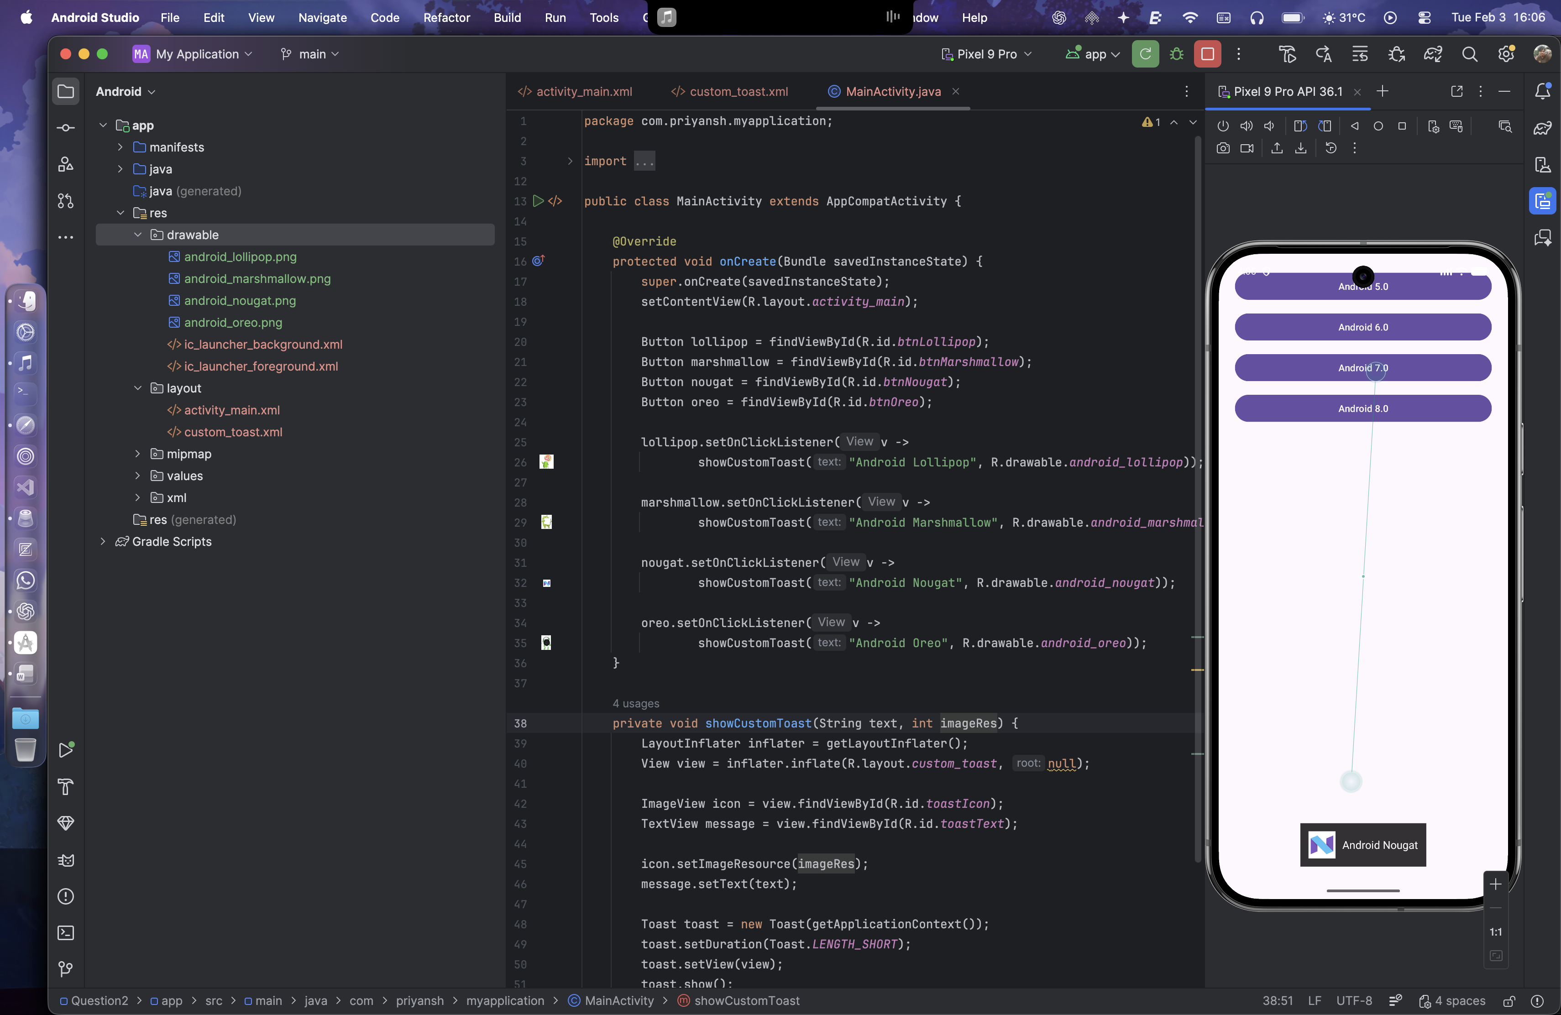 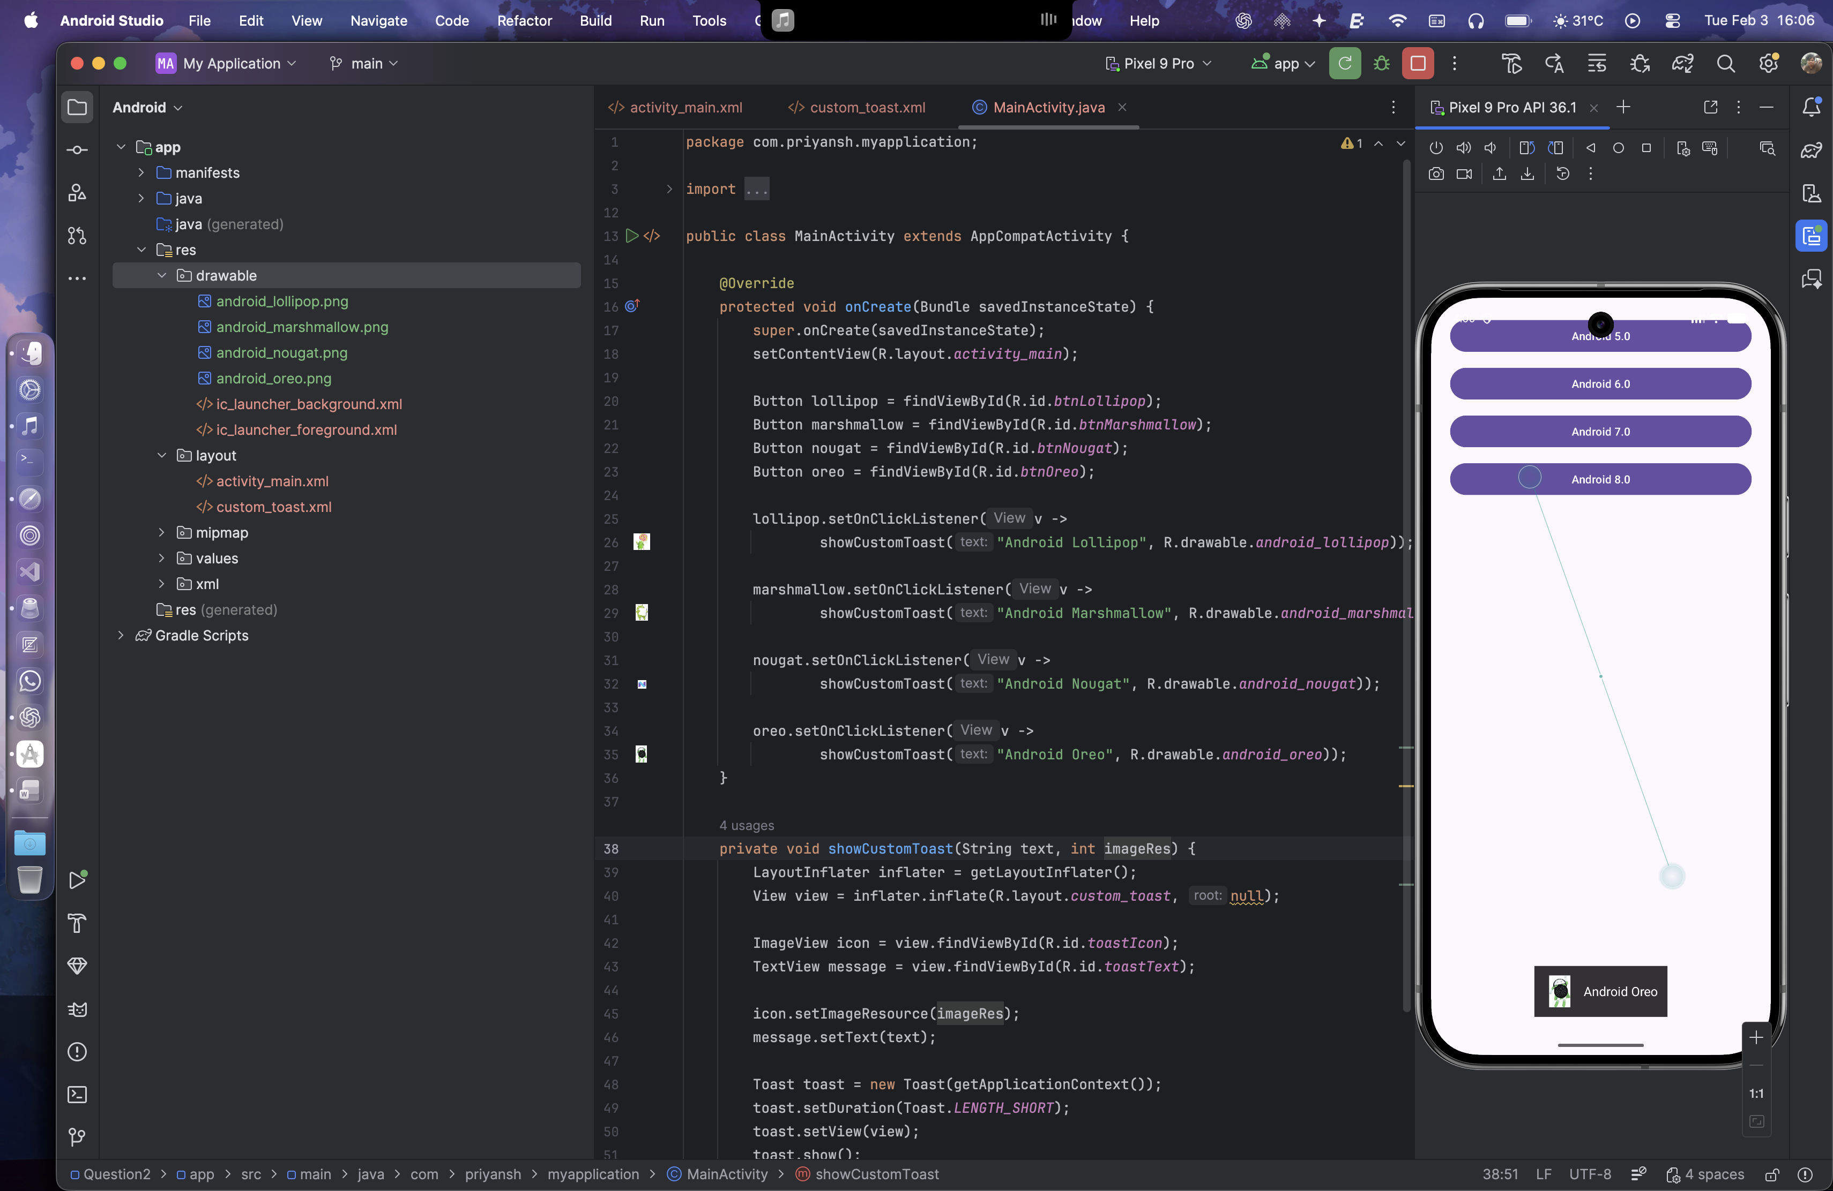

Question 3:

Develop a view with a ToggleButton labeled "Current Mode" that has two states: "Wi-Fi" and "Mobile Data." Based on the state of the toggle button, an image corresponding to the selected mode should appear, and a Toast message should display the current mode. Additionally, when the user clicks the "Change Mode" button, the app should switch to the corresponding mode and update the image accordingly.

Layout Design:

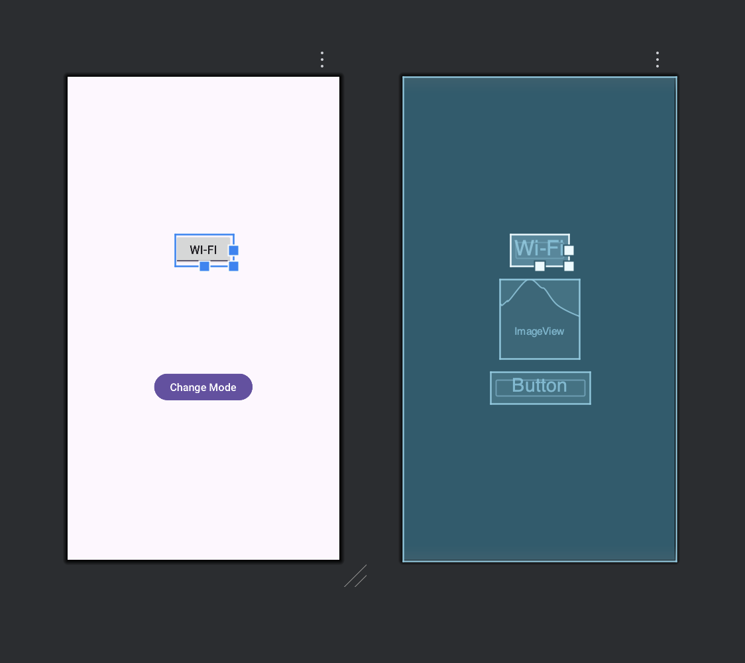

XML for activity_main.xml

<?xml version="1.0" encoding="utf-8"?>  
<LinearLayout xmlns:android="http://schemas.android.com/apk/res/android"  
 android:layout_width="match_parent"  
 android:layout_height="match_parent"  
 android:orientation="vertical"  
 android:gravity="center"  
 android:padding="24dp">  
  
 <ToggleButton  
 android:id="@+id/toggleMode"  
 android:layout_width="wrap_content"  
 android:layout_height="wrap_content"  
 android:textOn="Wi-Fi"  
 android:textOff="Mobile Data"  
 android:checked="true"  
 android:textSize="18sp"  
 android:layout_marginBottom="20dp"/>  
  
 <ImageView  
 android:id="@+id/modeImage"  
 android:layout_width="120dp"  
 android:layout_height="120dp"  
 android:layout_marginBottom="20dp"  
 android:contentDescription="Mode Image"/>  
  
 <Button  
 android:id="@+id/btnChangeMode"  
 android:layout_width="wrap_content"  
 android:layout_height="wrap_content"  
 android:text="Change Mode"  
 android:textSize="16sp"/>  
  
</LinearLayout>

Java Code:

import androidx.appcompat.app.AppCompatActivity;  
  
public class MainActivity extends AppCompatActivity {  
  
 ToggleButton toggleMode;  
 ImageView modeImage;  
 Button btnChangeMode;  
  
 @Override  
 protected void onCreate(Bundle savedInstanceState) {  
 super.onCreate(savedInstanceState);  
 setContentView(R.layout.*activity_main*);  
  
 toggleMode = findViewById(R.id.*toggleMode*);  
 modeImage = findViewById(R.id.*modeImage*);  
 btnChangeMode = findViewById(R.id.*btnChangeMode*);  
  
 updateUI(toggleMode.isChecked());  
  
 toggleMode.setOnClickListener(v -> {  
 updateUI(toggleMode.isChecked());  
 });  
  
 btnChangeMode.setOnClickListener(v -> {  
 toggleMode.setChecked(!toggleMode.isChecked());  
 updateUI(toggleMode.isChecked());  
 });  
 }  
  
 private void updateUI(boolean isWifi) {  
 if (isWifi) {  
 modeImage.setImageResource(R.drawable.*wifi*);  
 Toast.*makeText*(this, "Current Mode: Wi-Fi", Toast.*LENGTH_SHORT*).show();  
 } else {  
 modeImage.setImageResource(R.drawable.*mobile_data*);  
 Toast.*makeText*(this, "Current Mode: Mobile Data", Toast.*LENGTH_SHORT*).show();  
 }  
 }  
}

Images are stored in the drawable folder

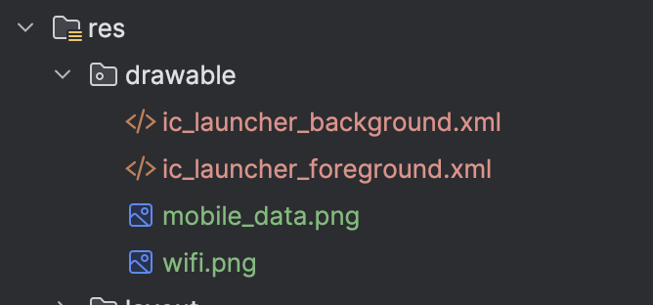

Output:

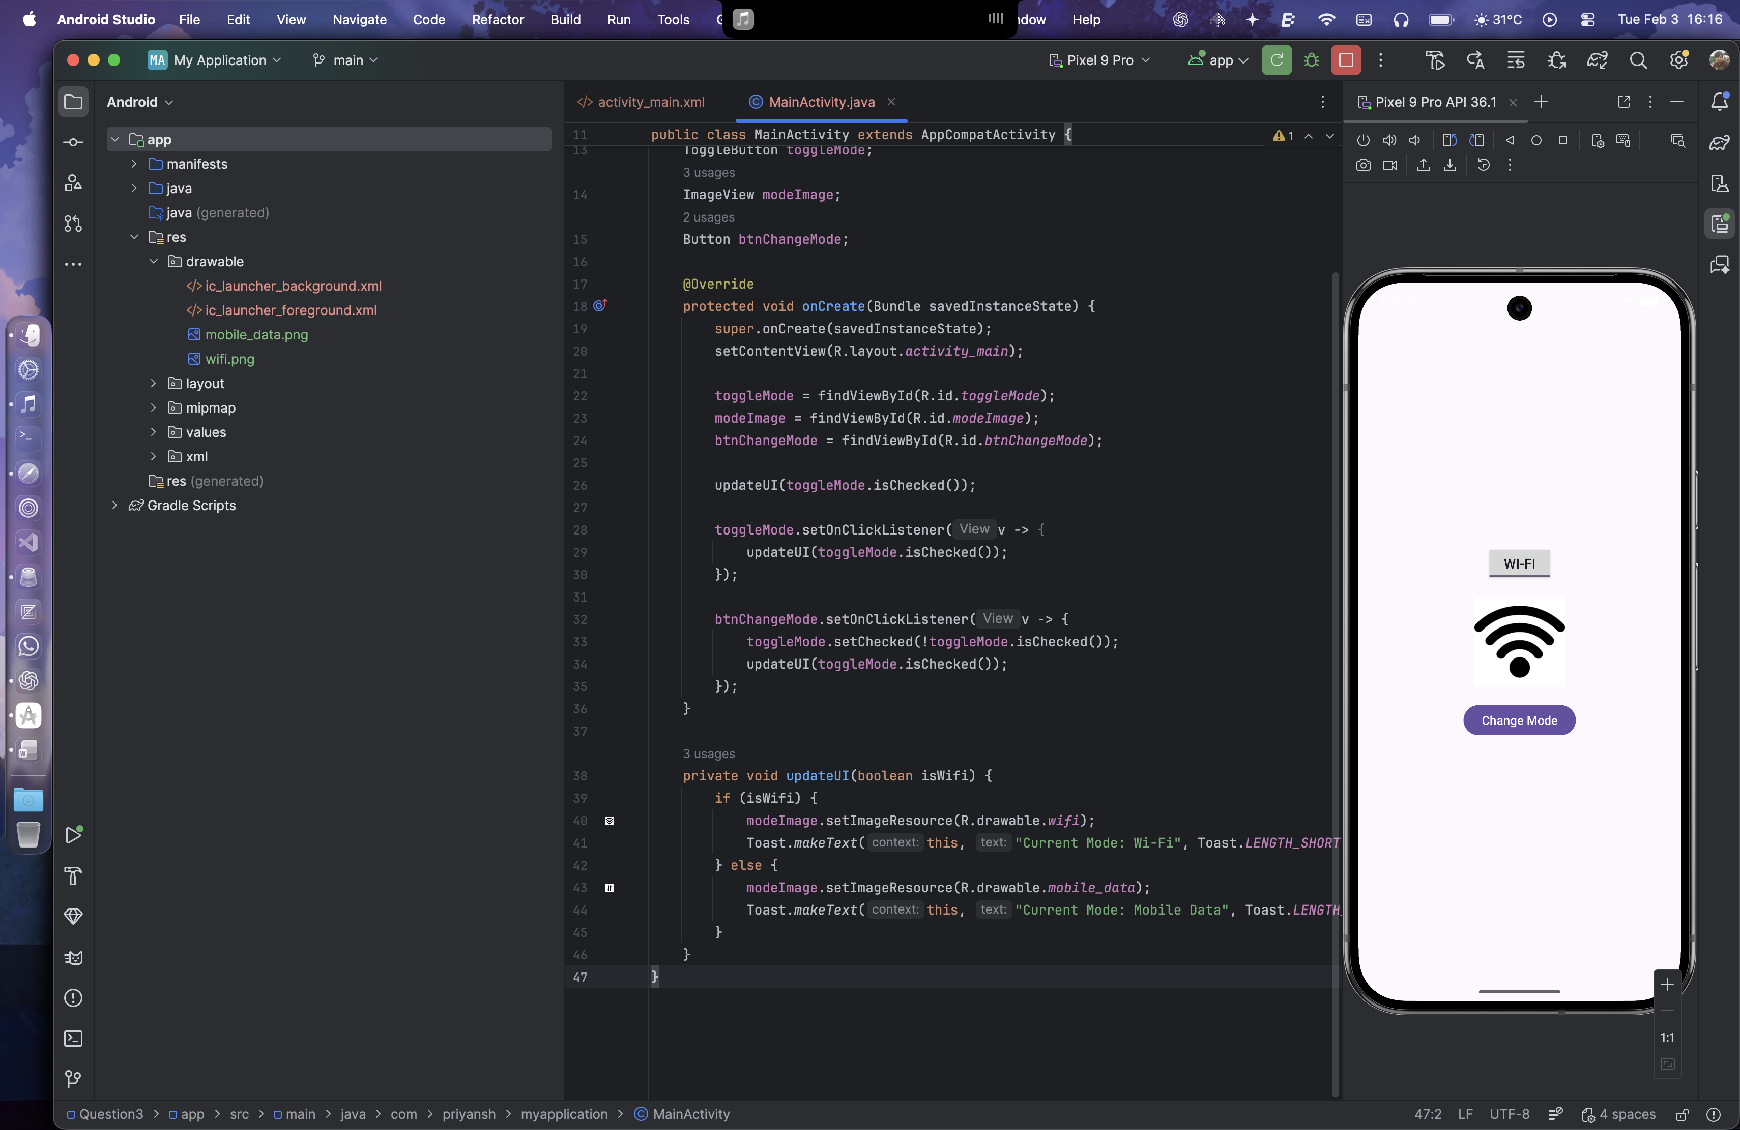 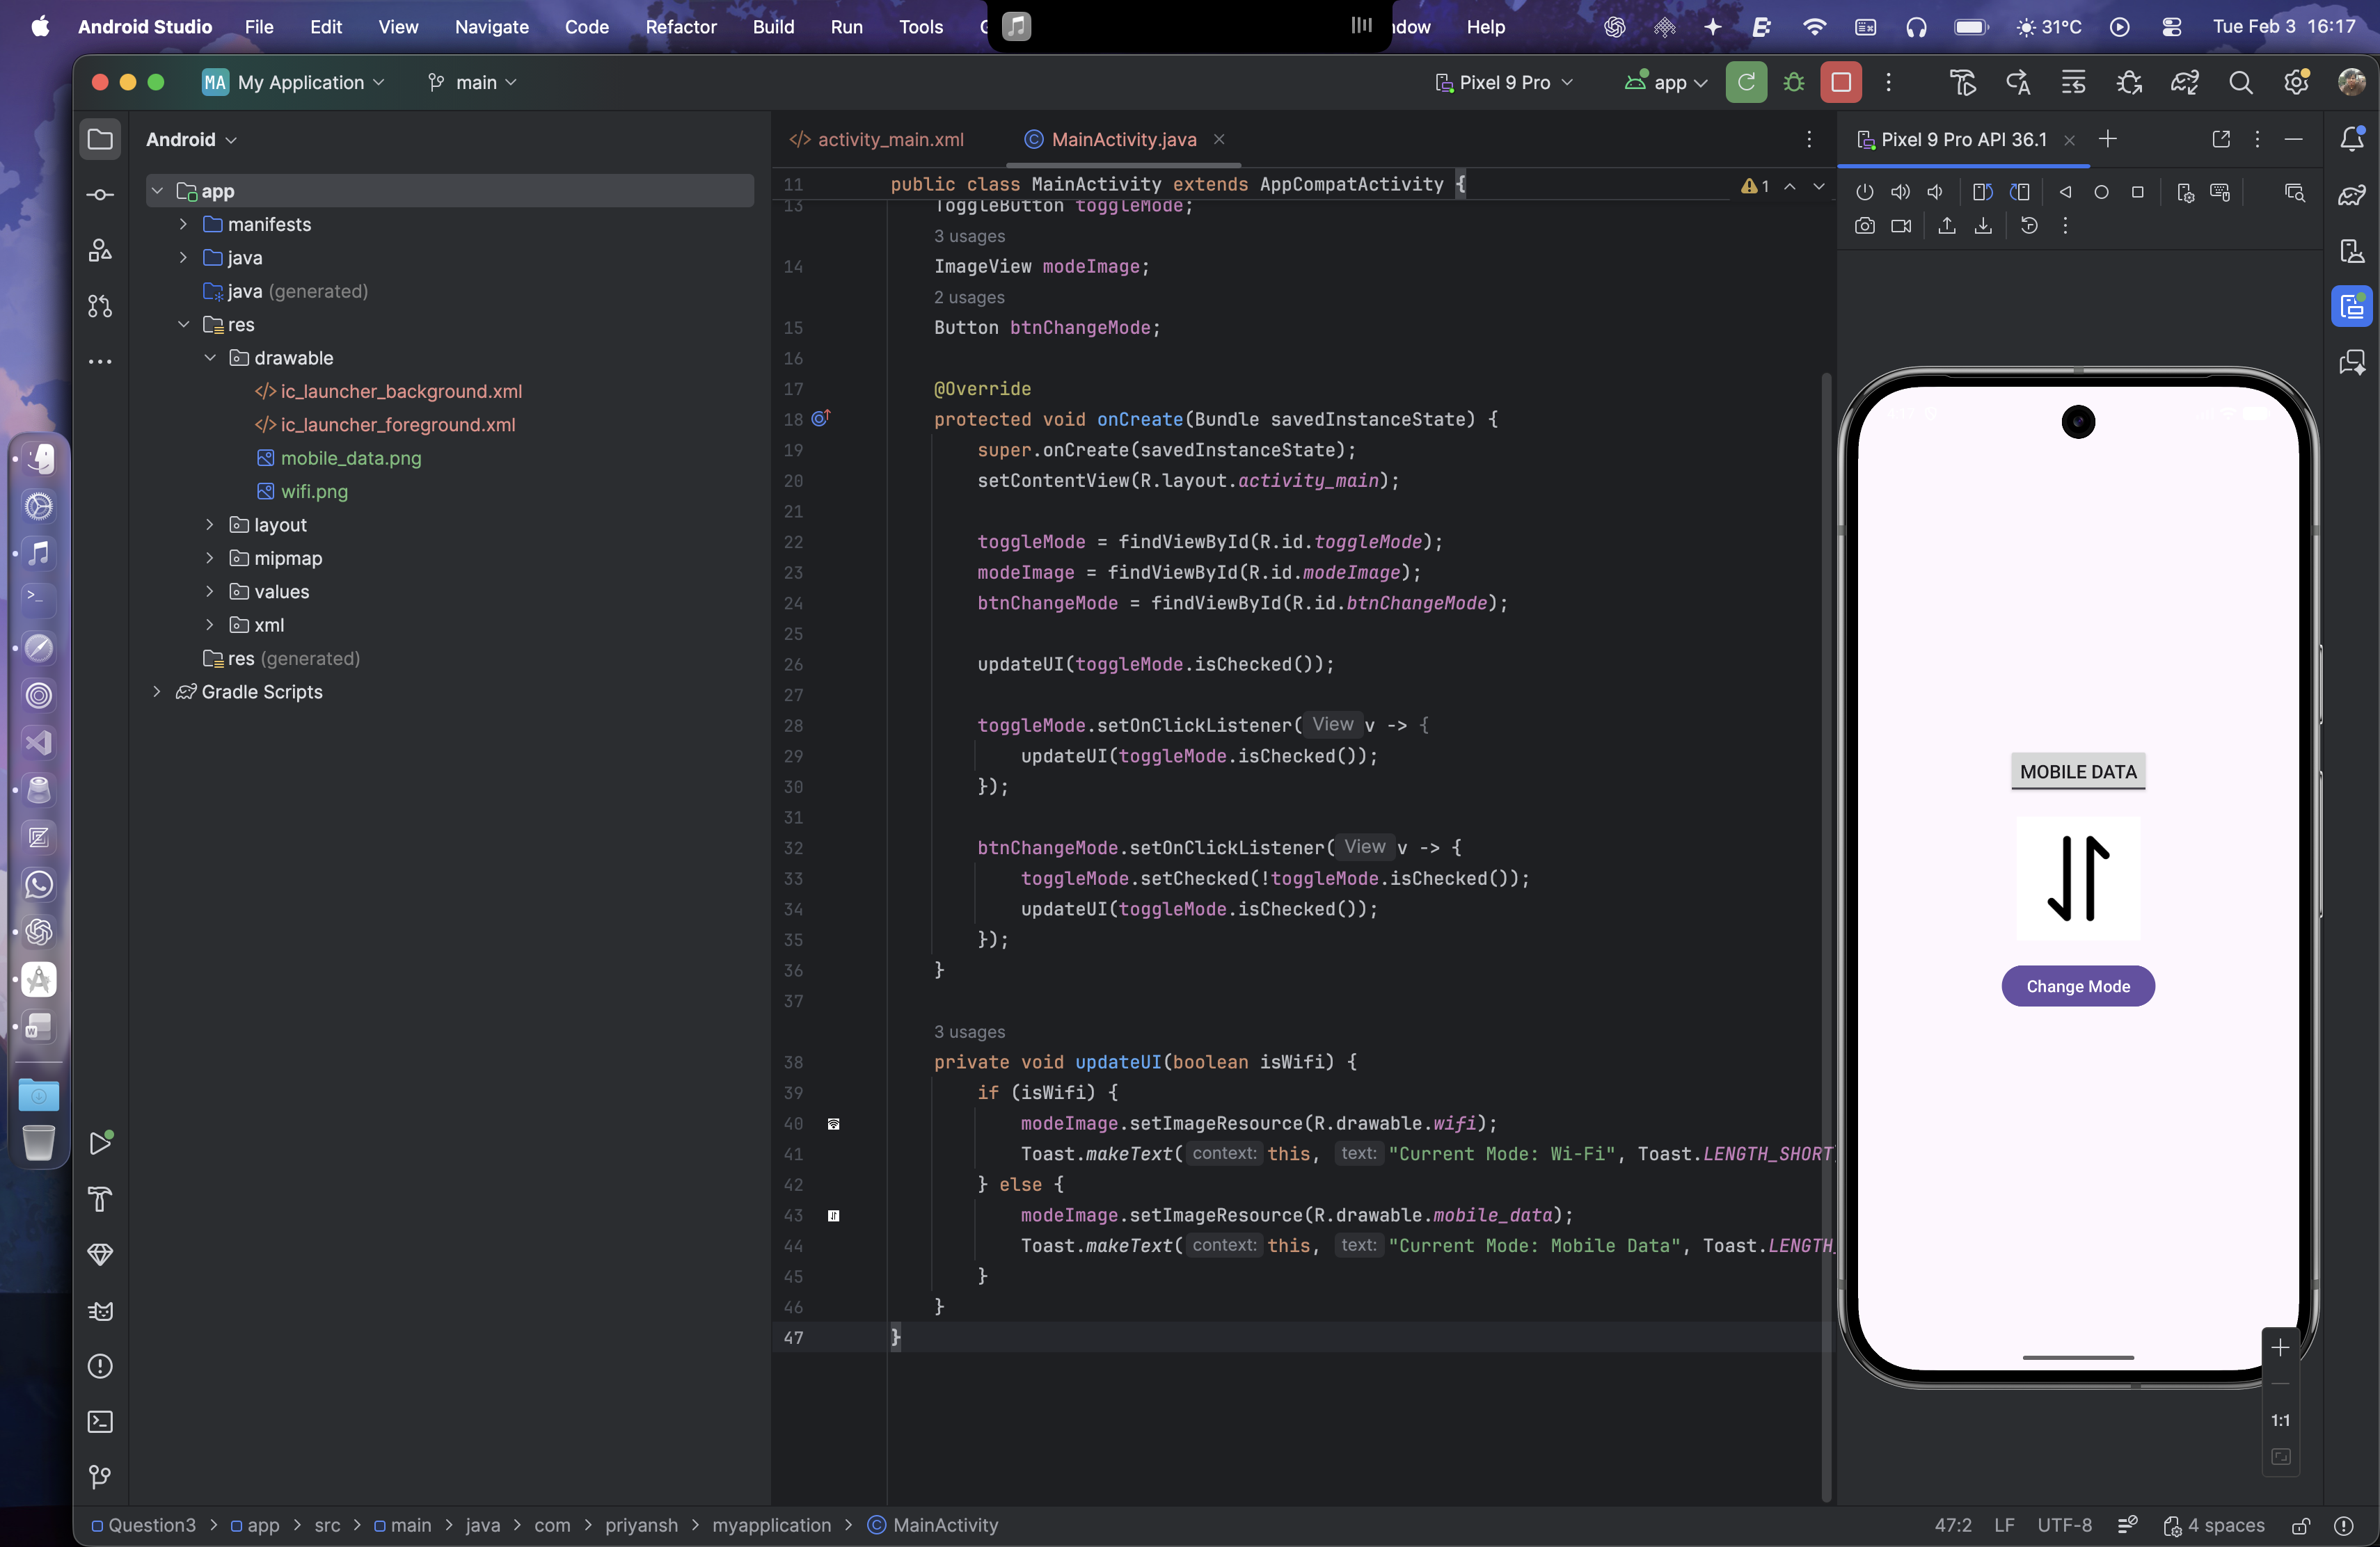

Question 4:

Create a “Food Ordering App” which lists food items with check boxes. Once the user checks/unchecks the item and click on the submit button display the items ordered along with cost of each item and total cost in a new activity. Once the user clicks on the submit button he/she should not be allowed to change the order i.e. he should not be allowed to change the state of the items checked.

Layout Design

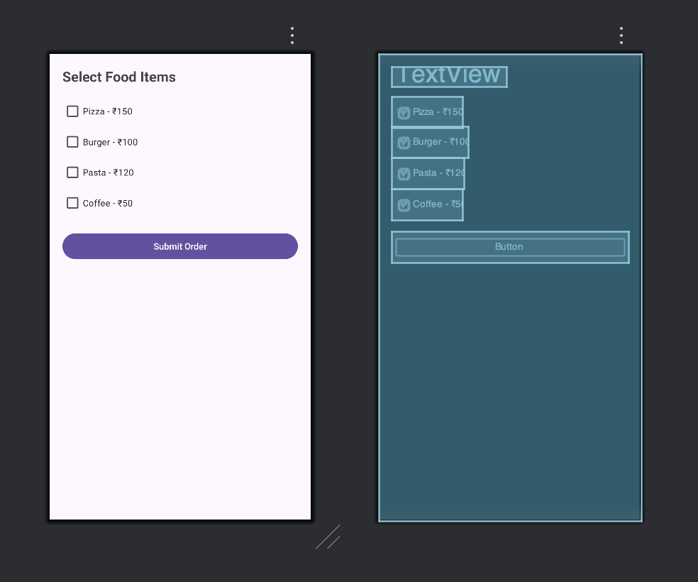

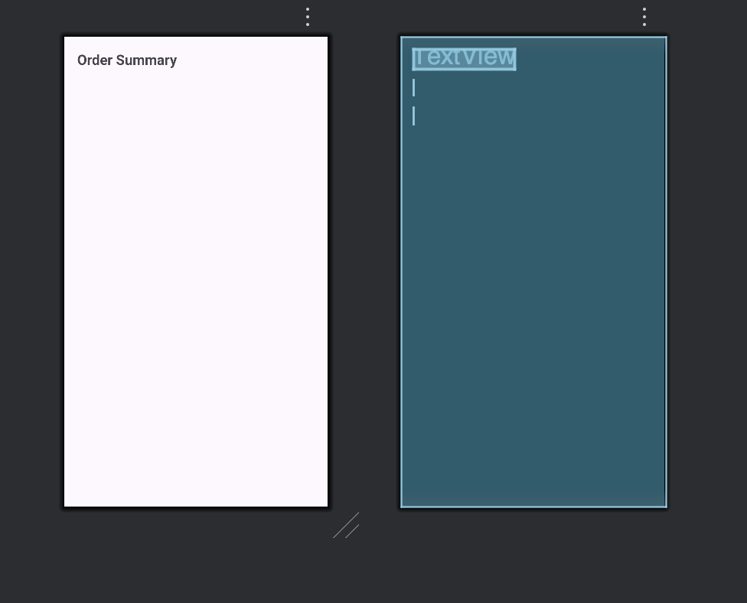

XML for activity_main.xml

<?xml version="1.0" encoding="utf-8"?>  
<LinearLayout xmlns:android="http://schemas.android.com/apk/res/android"  
 android:layout_width="match_parent"  
 android:layout_height="match_parent"  
 android:orientation="vertical"  
 android:padding="20dp">  
  
 <TextView  
 android:layout_width="wrap_content"  
 android:layout_height="wrap_content"  
 android:text="Select Food Items"  
 android:textSize="22sp"  
 android:textStyle="bold"  
 android:layout_marginBottom="16dp"/>  
  
 <CheckBox  
 android:id="@+id/cbPizza"  
 android:layout_width="wrap_content"  
 android:layout_height="wrap_content"  
 android:text="Pizza - ₹150"/>  
  
 <CheckBox  
 android:id="@+id/cbBurger"  
 android:layout_width="wrap_content"  
 android:layout_height="wrap_content"  
 android:text="Burger - ₹100"/>  
  
 <CheckBox  
 android:id="@+id/cbPasta"  
 android:layout_width="wrap_content"  
 android:layout_height="wrap_content"  
 android:text="Pasta - ₹120"/>  
  
 <CheckBox  
 android:id="@+id/cbCoffee"  
 android:layout_width="wrap_content"  
 android:layout_height="wrap_content"  
 android:text="Coffee - ₹50"/>  
  
 <Button  
 android:id="@+id/btnSubmit"  
 android:layout_width="match_parent"  
 android:layout_height="wrap_content"  
 android:text="Submit Order"  
 android:layout_marginTop="20dp"/>  
  
</LinearLayout>

XML for activity_order_summary.xml

<?xml version="1.0" encoding="utf-8"?>  
<LinearLayout xmlns:android="http://schemas.android.com/apk/res/android"  
 android:layout_width="match_parent"  
 android:layout_height="match_parent"  
 android:orientation="vertical"  
 android:padding="20dp">  
  
 <TextView  
 android:layout_width="wrap_content"  
 android:layout_height="wrap_content"  
 android:text="Order Summary"  
 android:textSize="22sp"  
 android:textStyle="bold"  
 android:layout_marginBottom="16dp"/>  
  
 <TextView  
 android:id="@+id/tvOrderDetails"  
 android:layout_width="wrap_content"  
 android:layout_height="wrap_content"  
 android:textSize="18sp"  
 android:layout_marginBottom="20dp"/>  
  
 <TextView  
 android:id="@+id/tvTotalCost"  
 android:layout_width="wrap_content"  
 android:layout_height="wrap_content"  
 android:textSize="20sp"  
 android:textStyle="bold"/>  
</LinearLayout>

Java Code:

MainActivity.java

public class MainActivity extends AppCompatActivity {  
  
 CheckBox cbPizza, cbBurger, cbPasta, cbCoffee;  
 Button btnSubmit;  
  
 @Override  
 protected void onCreate(Bundle savedInstanceState) {  
 super.onCreate(savedInstanceState);  
 setContentView(R.layout.*activity_main*);  
  
 cbPizza = findViewById(R.id.*cbPizza*);  
 cbBurger = findViewById(R.id.*cbBurger*);  
 cbPasta = findViewById(R.id.*cbPasta*);  
 cbCoffee = findViewById(R.id.*cbCoffee*);  
 btnSubmit = findViewById(R.id.*btnSubmit*);  
  
 btnSubmit.setOnClickListener(v -> {  
 StringBuilder orderDetails = new StringBuilder();  
 int totalCost = 0;  
  
 if (cbPizza.isChecked()) {  
 orderDetails.append("Pizza - ₹150\n");  
 totalCost += 150;  
 }  
 if (cbBurger.isChecked()) {  
 orderDetails.append("Burger - ₹100\n");  
 totalCost += 100;  
 }  
 if (cbPasta.isChecked()) {  
 orderDetails.append("Pasta - ₹120\n");  
 totalCost += 120;  
 }  
 if (cbCoffee.isChecked()) {  
 orderDetails.append("Coffee - ₹50\n");  
 totalCost += 50;  
 }  
  
 Intent intent = new Intent(MainActivity.this, activity_order_summary.class);  
 intent.putExtra("order", orderDetails.toString());  
 intent.putExtra("total", totalCost);  
 startActivity(intent);  
  
 disableInputs();  
 });  
 }  
  
 private void disableInputs() {  
 cbPizza.setEnabled(false);  
 cbBurger.setEnabled(false);  
 cbPasta.setEnabled(false);  
 cbCoffee.setEnabled(false);  
 btnSubmit.setEnabled(false);  
 }  
}

activity_order_summary.java

public class activity_order_summary extends AppCompatActivity {  
  
 @Override  
 protected void onCreate(Bundle savedInstanceState) {  
 super.onCreate(savedInstanceState);  
 setContentView(R.layout.*activity_order_summary*);  
  
 TextView tvOrderDetails = findViewById(R.id.*tvOrderDetails*);  
 TextView tvTotalCost = findViewById(R.id.*tvTotalCost*);  
  
 String order = getIntent().getStringExtra("order");  
 int total = getIntent().getIntExtra("total", 0);  
  
 tvOrderDetails.setText(order.isEmpty() ? "No items selected" : order);  
 tvTotalCost.setText("Total Cost: ₹" + total);  
 }  
}

Output:

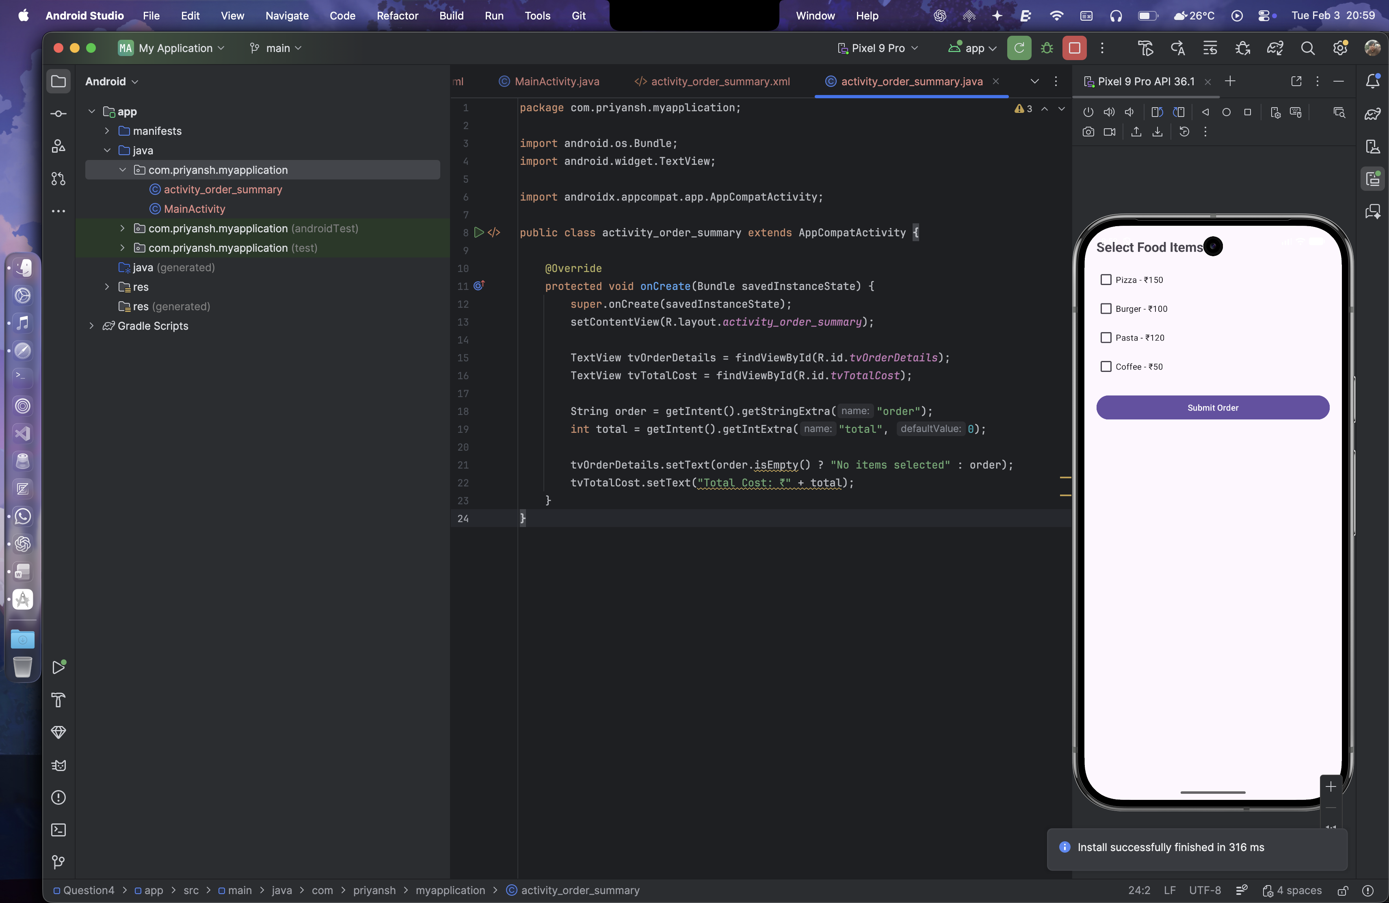 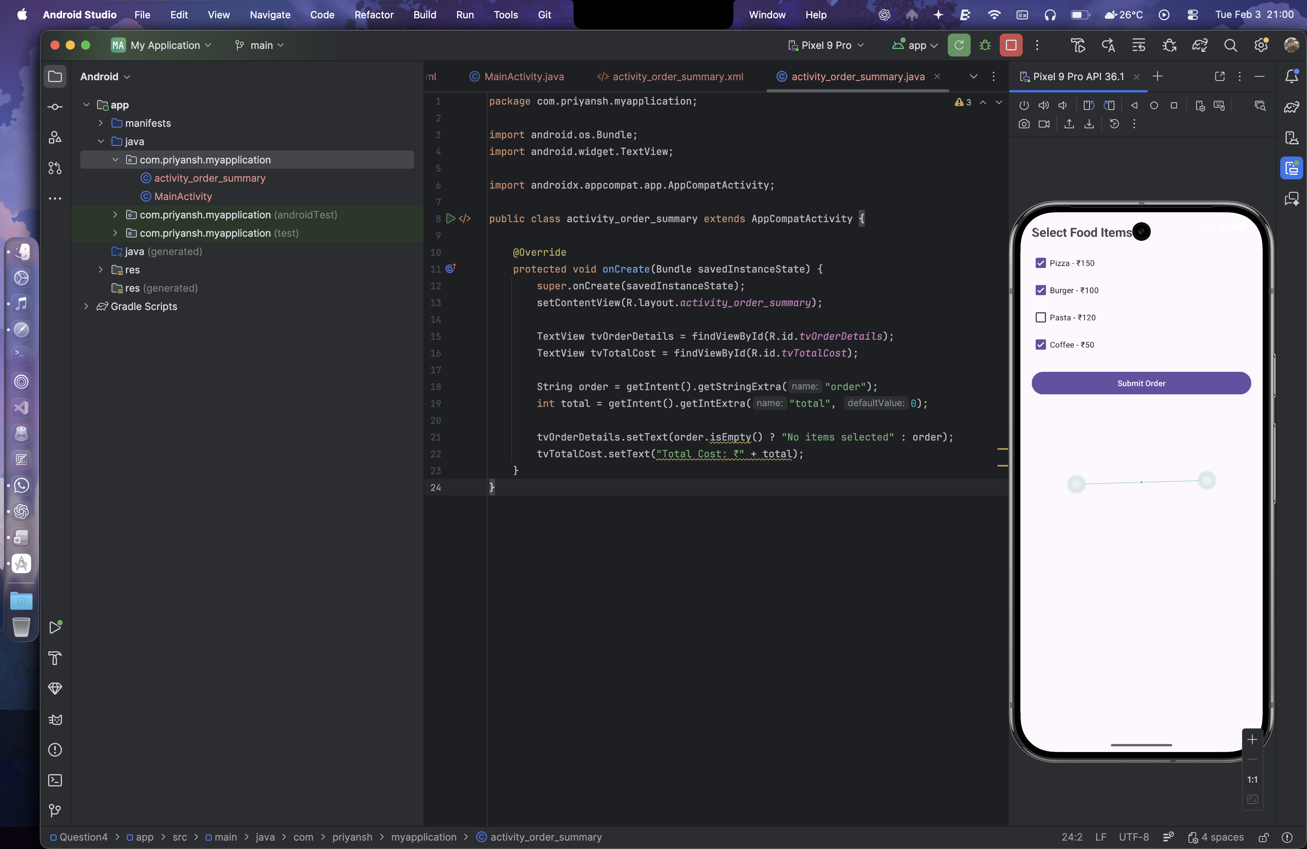 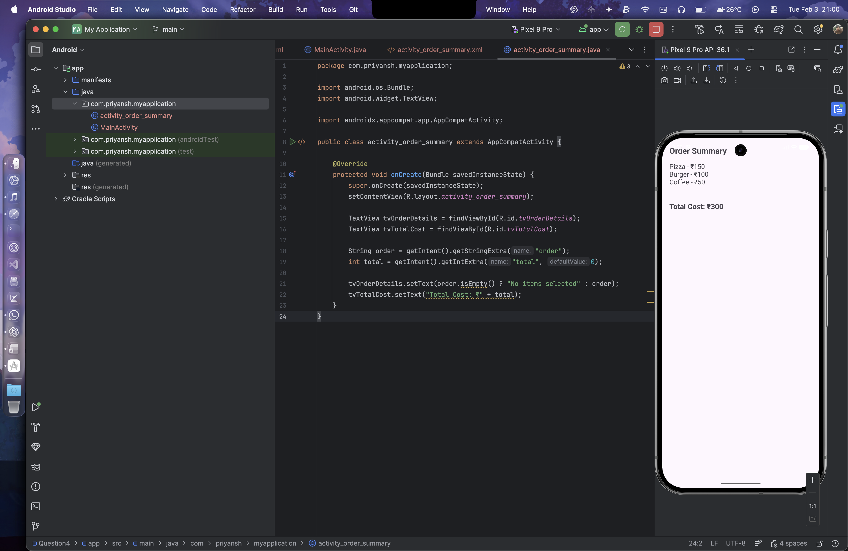

**Lab 5- Input Controls - Spinners and Pickers**

Question1:  
Develop an application named "Vehicle Parking Registration" where the user can register their vehicle for parking. The app should include a spinner that allows users to select the type of vehicle (e.g., car, bike, etc.) and text fields for entering the vehicle number and RC number. Upon clicking the submit button, the entered details should be displayed in a separate view, providing the user with options to either confirm the details or edit them. Once the user confirms the information, a toast message should appear showing a unique serial number to confirm the parking allotment

Layout Design:

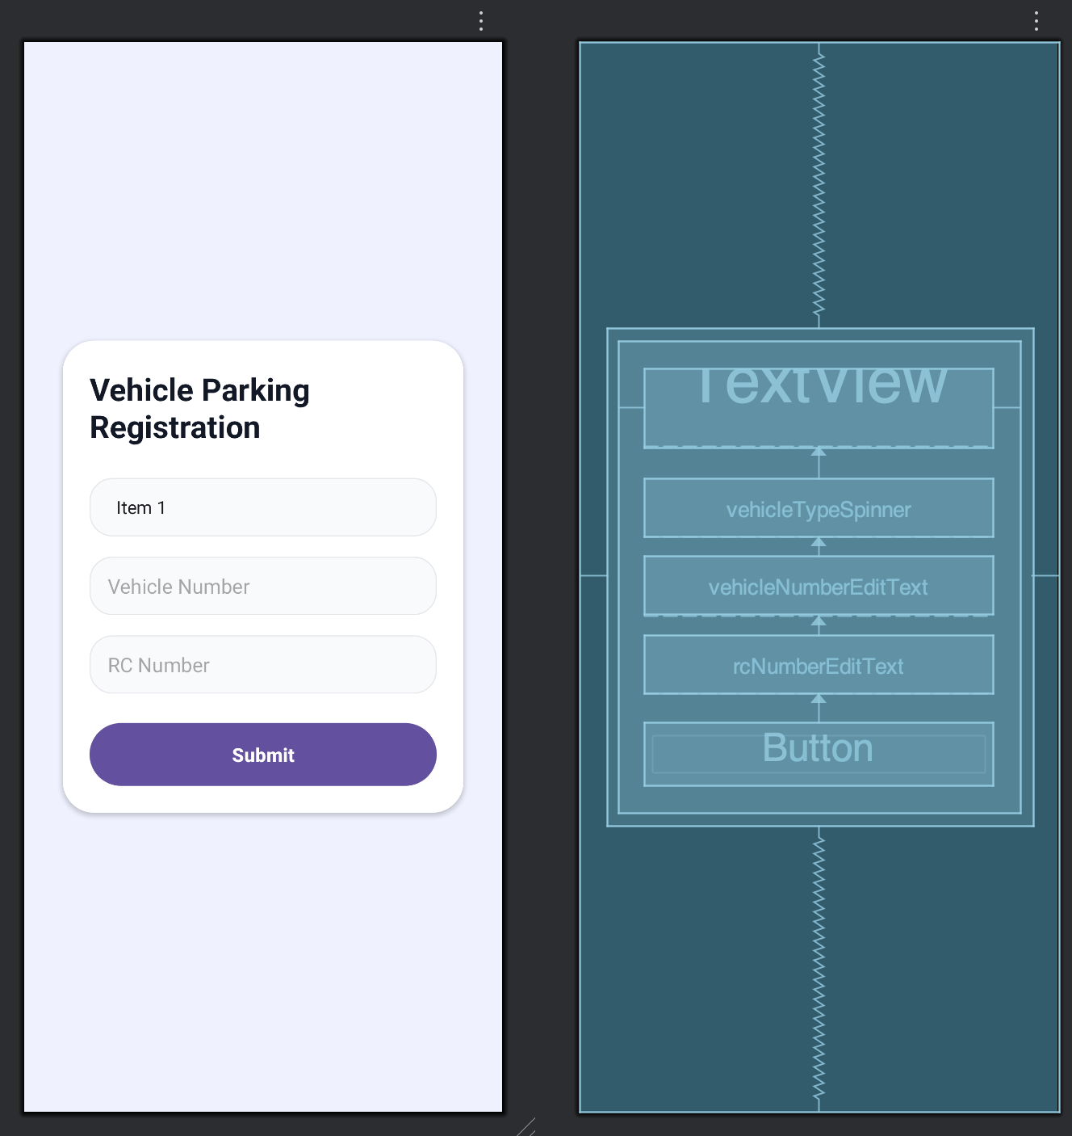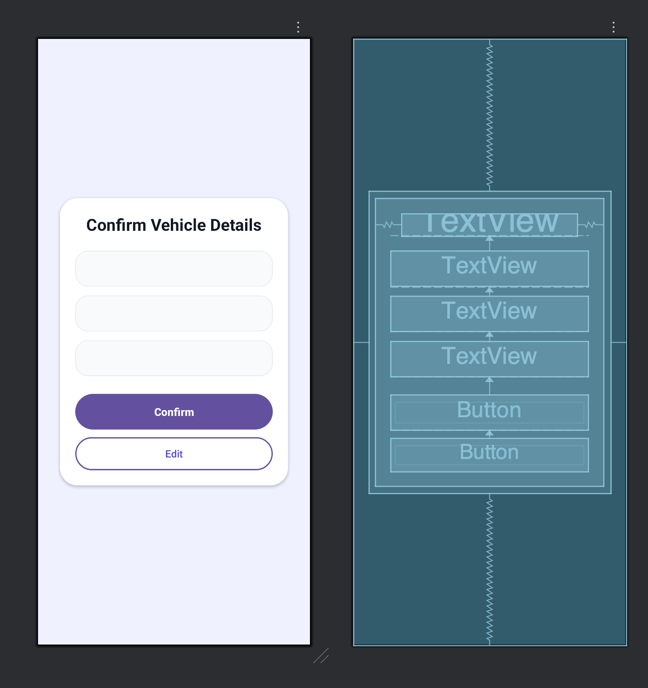

XML for activity_main.xml

<?xml version="1.0" encoding="utf-8"?>  
<RelativeLayout xmlns:android="http://schemas.android.com/apk/res/android"  
 xmlns:tools="http://schemas.android.com/tools"  
 xmlns:app="http://schemas.android.com/apk/res-auto"  
 android:id="@+id/main"  
 android:layout_width="match_parent"  
 android:layout_height="match_parent"  
 android:background="#EEF2FF"  
 android:padding="24dp"  
 tools:context=".MainActivity">  
  
 <androidx.cardview.widget.CardView  
 android:layout_width="match_parent"  
 android:layout_height="wrap_content"  
 android:layout_centerInParent="true"  
 android:elevation="10dp"  
 android:backgroundTint="@android:color/white"  
 app:cardCornerRadius="28dp"  
 app:cardUseCompatPadding="true">  
  
 <RelativeLayout  
 android:layout_width="match_parent"  
 android:layout_height="wrap_content"  
 android:padding="24dp">  
  
 <TextView  
 android:id="@+id/titleTextView"  
 android:layout_width="wrap_content"  
 android:layout_height="wrap_content"  
 android:text="@string/app_name"  
 android:textSize="28sp"  
 android:textStyle="bold"  
 android:textColor="#111827"  
 android:layout_centerHorizontal="true"  
 android:layout_marginBottom="28dp" />  
  
 <Spinner  
 android:id="@+id/vehicleTypeSpinner"  
 android:layout_width="match_parent"  
 android:layout_height="52dp"  
 android:layout_below="@id/titleTextView"  
 android:entries="@array/vehicle_types"  
 android:background="@drawable/bg_rounded_input"  
 android:paddingHorizontal="16dp"  
 android:layout_marginBottom="18dp" />  
  
 <EditText  
 android:id="@+id/vehicleNumberEditText"  
 android:layout_width="match_parent"  
 android:layout_height="52dp"  
 android:layout_below="@id/vehicleTypeSpinner"  
 android:hint="@string/vehicle_number_hint"  
 android:inputType="textCapCharacters"  
 android:background="@drawable/bg_rounded_input"  
 android:paddingHorizontal="16dp"  
 android:layout_marginBottom="18dp" />  
  
 <EditText  
 android:id="@+id/rcNumberEditText"  
 android:layout_width="match_parent"  
 android:layout_height="52dp"  
 android:layout_below="@id/vehicleNumberEditText"  
 android:hint="@string/rc_number_hint"  
 android:inputType="textCapCharacters"  
 android:background="@drawable/bg_rounded_input"  
 android:paddingHorizontal="16dp"  
 android:layout_marginBottom="26dp" />  
  
 <Button  
 android:id="@+id/submitButton"  
 android:layout_width="match_parent"  
 android:layout_height="56dp"  
 android:layout_below="@id/rcNumberEditText"  
 android:text="@string/submit_button_text"  
 android:textAllCaps="false"  
 android:textSize="17sp"  
 android:textStyle="bold"  
 android:background="@drawable/bg_rounded_button"  
 android:textColor="@android:color/white" />  
  
 </RelativeLayout>  
  
 </androidx.cardview.widget.CardView>  
  
</RelativeLayout>

XML for activity_show_details.xml

<?xml version="1.0" encoding="utf-8"?>  
<RelativeLayout xmlns:android="http://schemas.android.com/apk/res/android"  
 xmlns:app="http://schemas.android.com/apk/res-auto"  
 xmlns:tools="http://schemas.android.com/tools"  
 android:id="@+id/main"  
 android:layout_width="match_parent"  
 android:layout_height="match_parent"  
 android:background="#EEF2FF"  
 android:padding="24dp"  
 tools:context=".ShowDetails">  
  
 <androidx.cardview.widget.CardView  
 android:layout_width="match_parent"  
 android:layout_height="wrap_content"  
 android:layout_centerInParent="true"  
 android:elevation="10dp"  
 android:backgroundTint="@android:color/white"  
 app:cardCornerRadius="28dp"  
 app:cardUseCompatPadding="true">  
  
 <RelativeLayout  
 android:layout_width="match_parent"  
 android:layout_height="wrap_content"  
 android:padding="24dp">  
  
 <TextView  
 android:id="@+id/titleTextView"  
 android:layout_width="wrap_content"  
 android:layout_height="wrap_content"  
 android:text="Confirm Vehicle Details"  
 android:textSize="26sp"  
 android:textStyle="bold"  
 android:textColor="#111827"  
 android:layout_centerHorizontal="true"  
 android:layout_marginBottom="24dp" />  
  
 <TextView  
 android:id="@+id/vehicleTypeTextView"  
 android:layout_width="match_parent"  
 android:layout_height="wrap_content"  
 android:layout_below="@id/titleTextView"  
 android:background="@drawable/bg_rounded_input"  
 android:padding="16dp"  
 android:textSize="18sp"  
 android:textColor="#1F2937"  
 android:layout_marginBottom="14dp" />  
  
 <TextView  
 android:id="@+id/vehicleNumberTextView"  
 android:layout_width="match_parent"  
 android:layout_height="wrap_content"  
 android:layout_below="@id/vehicleTypeTextView"  
 android:background="@drawable/bg_rounded_input"  
 android:padding="16dp"  
 android:textSize="18sp"  
 android:textColor="#1F2937"  
 android:layout_marginBottom="14dp" />  
  
 <TextView  
 android:id="@+id/rcNumberTextView"  
 android:layout_width="match_parent"  
 android:layout_height="wrap_content"  
 android:layout_below="@id/vehicleNumberTextView"  
 android:background="@drawable/bg_rounded_input"  
 android:padding="16dp"  
 android:textSize="18sp"  
 android:textColor="#1F2937"  
 android:layout_marginBottom="28dp" />  
  
 <Button  
 android:id="@+id/confirmButton"  
 android:layout_width="match_parent"  
 android:layout_height="56dp"  
 android:layout_below="@id/rcNumberTextView"  
 android:text="Confirm"  
 android:textAllCaps="false"  
 android:textSize="17sp"  
 android:textStyle="bold"  
 android:background="@drawable/bg_rounded_button"  
 android:textColor="@android:color/white"  
 android:layout_marginBottom="12dp" />  
  
 <Button  
 android:id="@+id/editButton"  
 android:layout_width="match_parent"  
 android:layout_height="52dp"  
 android:layout_below="@id/confirmButton"  
 android:text="Edit"  
 android:textAllCaps="false"  
 android:textSize="16sp"  
 android:background="@drawable/bg_rounded_outline_button"  
 android:textColor="#4F46E5" />  
  
 </RelativeLayout>  
  
 </androidx.cardview.widget.CardView>  
  
</RelativeLayout>

XML for drawable

Bg_rounded_button.xml

<shape xmlns:android="http://schemas.android.com/apk/res/android">  
 <solid android:color="#6366F1" />  
 <corners android:radius="28dp" />  
</shape>

Bg_rounded_input.xml

<shape xmlns:android="http://schemas.android.com/apk/res/android">  
 <solid android:color="#F9FAFB" />  
 <corners android:radius="20dp" />  
 <stroke  
 android:width="1dp"  
 android:color="#E5E7EB" />  
</shape>

Bg_rounded_outline_button.xml

<shape xmlns:android="http://schemas.android.com/apk/res/android">  
 <solid android:color="@android:color/transparent" />  
 <corners android:radius="26dp" />  
 <stroke  
 android:width="2dp"  
 android:color="#6366F1" />  
</shape>

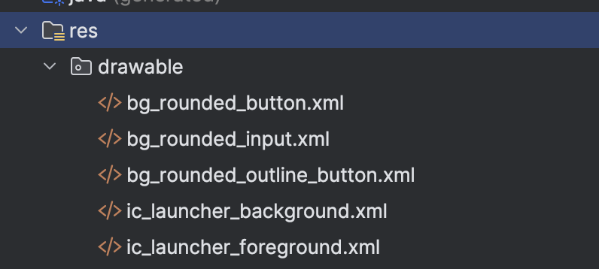

Java code:

MainActivity.java

public class MainActivity extends AppCompatActivity {  
  
 private Spinner vehicleTypeSpinner;  
 private EditText vehicleNumberEditText, rcNumberEditText;  
 private Button submitButton;  
  
 @Override  
 protected void onCreate(Bundle savedInstanceState) {  
 super.onCreate(savedInstanceState);  
 setContentView(R.layout.*activity_main*);  
  
 vehicleTypeSpinner = findViewById(R.id.*vehicleTypeSpinner*);  
 vehicleNumberEditText = findViewById(R.id.*vehicleNumberEditText*);  
 rcNumberEditText = findViewById(R.id.*rcNumberEditText*);  
 submitButton = findViewById(R.id.*submitButton*);  
  
 submitButton.setOnClickListener(new View.OnClickListener() {  
 @Override  
 public void onClick(View v) {  
 String vehicleType = vehicleTypeSpinner.getSelectedItem().toString();  
 String vehicleNumber = vehicleNumberEditText.getText().toString();  
 String rcNumber = rcNumberEditText.getText().toString();  
  
 Intent intent = new Intent(MainActivity.this, ShowDetails.class);  
 intent.putExtra("vehicleType", vehicleType);  
 intent.putExtra("vehicleNumber", vehicleNumber);  
 intent.putExtra("rcNumber", rcNumber);  
 startActivity(intent);  
 }  
 });  
 }  
}

ShowDetails.java

public class ShowDetails extends AppCompatActivity {  
  
 private TextView vehicleTypeTextView, vehicleNumberTextView, rcNumberTextView;  
 private Button confirmButton, editButton;  
  
 @Override  
 protected void onCreate(Bundle savedInstanceState) {  
 super.onCreate(savedInstanceState);  
 setContentView(R.layout.*activity_show_details*);  
  
 vehicleTypeTextView = findViewById(R.id.*vehicleTypeTextView*);  
 vehicleNumberTextView = findViewById(R.id.*vehicleNumberTextView*);  
 rcNumberTextView = findViewById(R.id.*rcNumberTextView*);  
 confirmButton = findViewById(R.id.*confirmButton*);  
 editButton = findViewById(R.id.*editButton*);  
  
 Intent intent = getIntent();  
 String vehicleType = intent.getStringExtra("vehicleType");  
 String vehicleNumber = intent.getStringExtra("vehicleNumber");  
 String rcNumber = intent.getStringExtra("rcNumber");  
  
 vehicleTypeTextView.setText("Vehicle Type: " + vehicleType);  
 vehicleNumberTextView.setText("Vehicle Number: " + vehicleNumber);  
 rcNumberTextView.setText("RC Number: " + rcNumber);  
  
 confirmButton.setOnClickListener(new View.OnClickListener() {  
 @Override  
 public void onClick(View v) {  
 String serialNumber = UUID.*randomUUID*().toString();  
 Toast.*makeText*(ShowDetails.this, "Parking Confirmed! Serial Number: " + serialNumber, Toast.*LENGTH_LONG*).show();  
 }  
 });  
  
 editButton.setOnClickListener(new View.OnClickListener() {  
 @Override  
 public void onClick(View v) {  
 finish();  
 }  
 });  
 }  
}

Output:

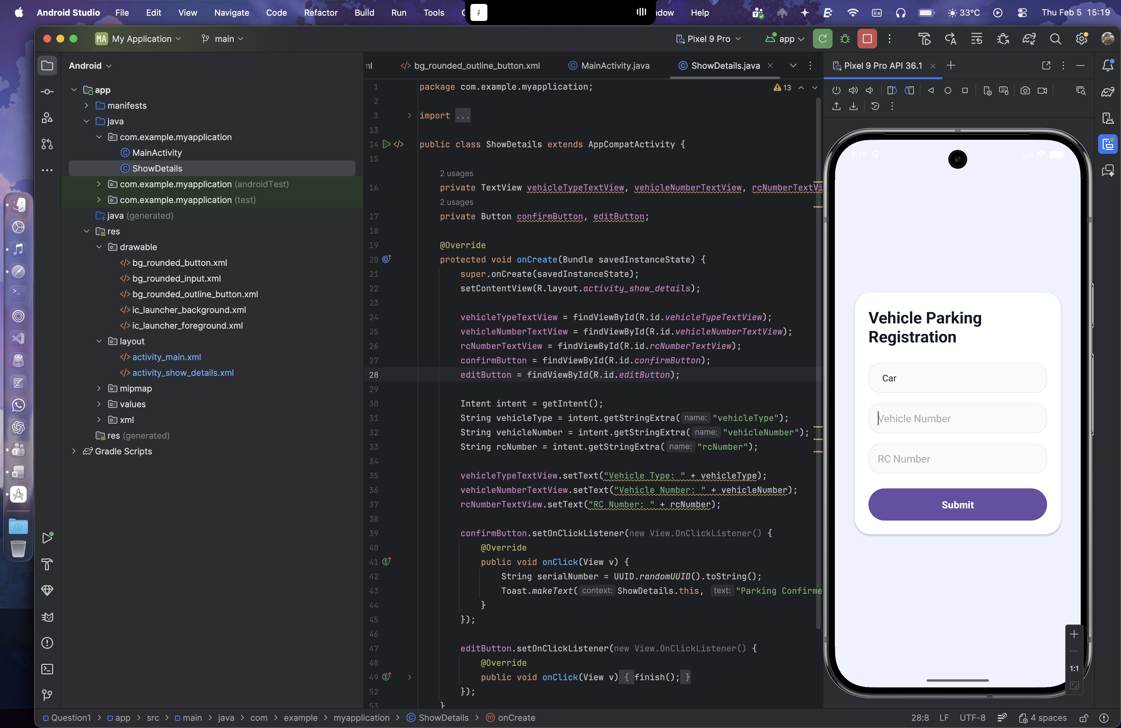 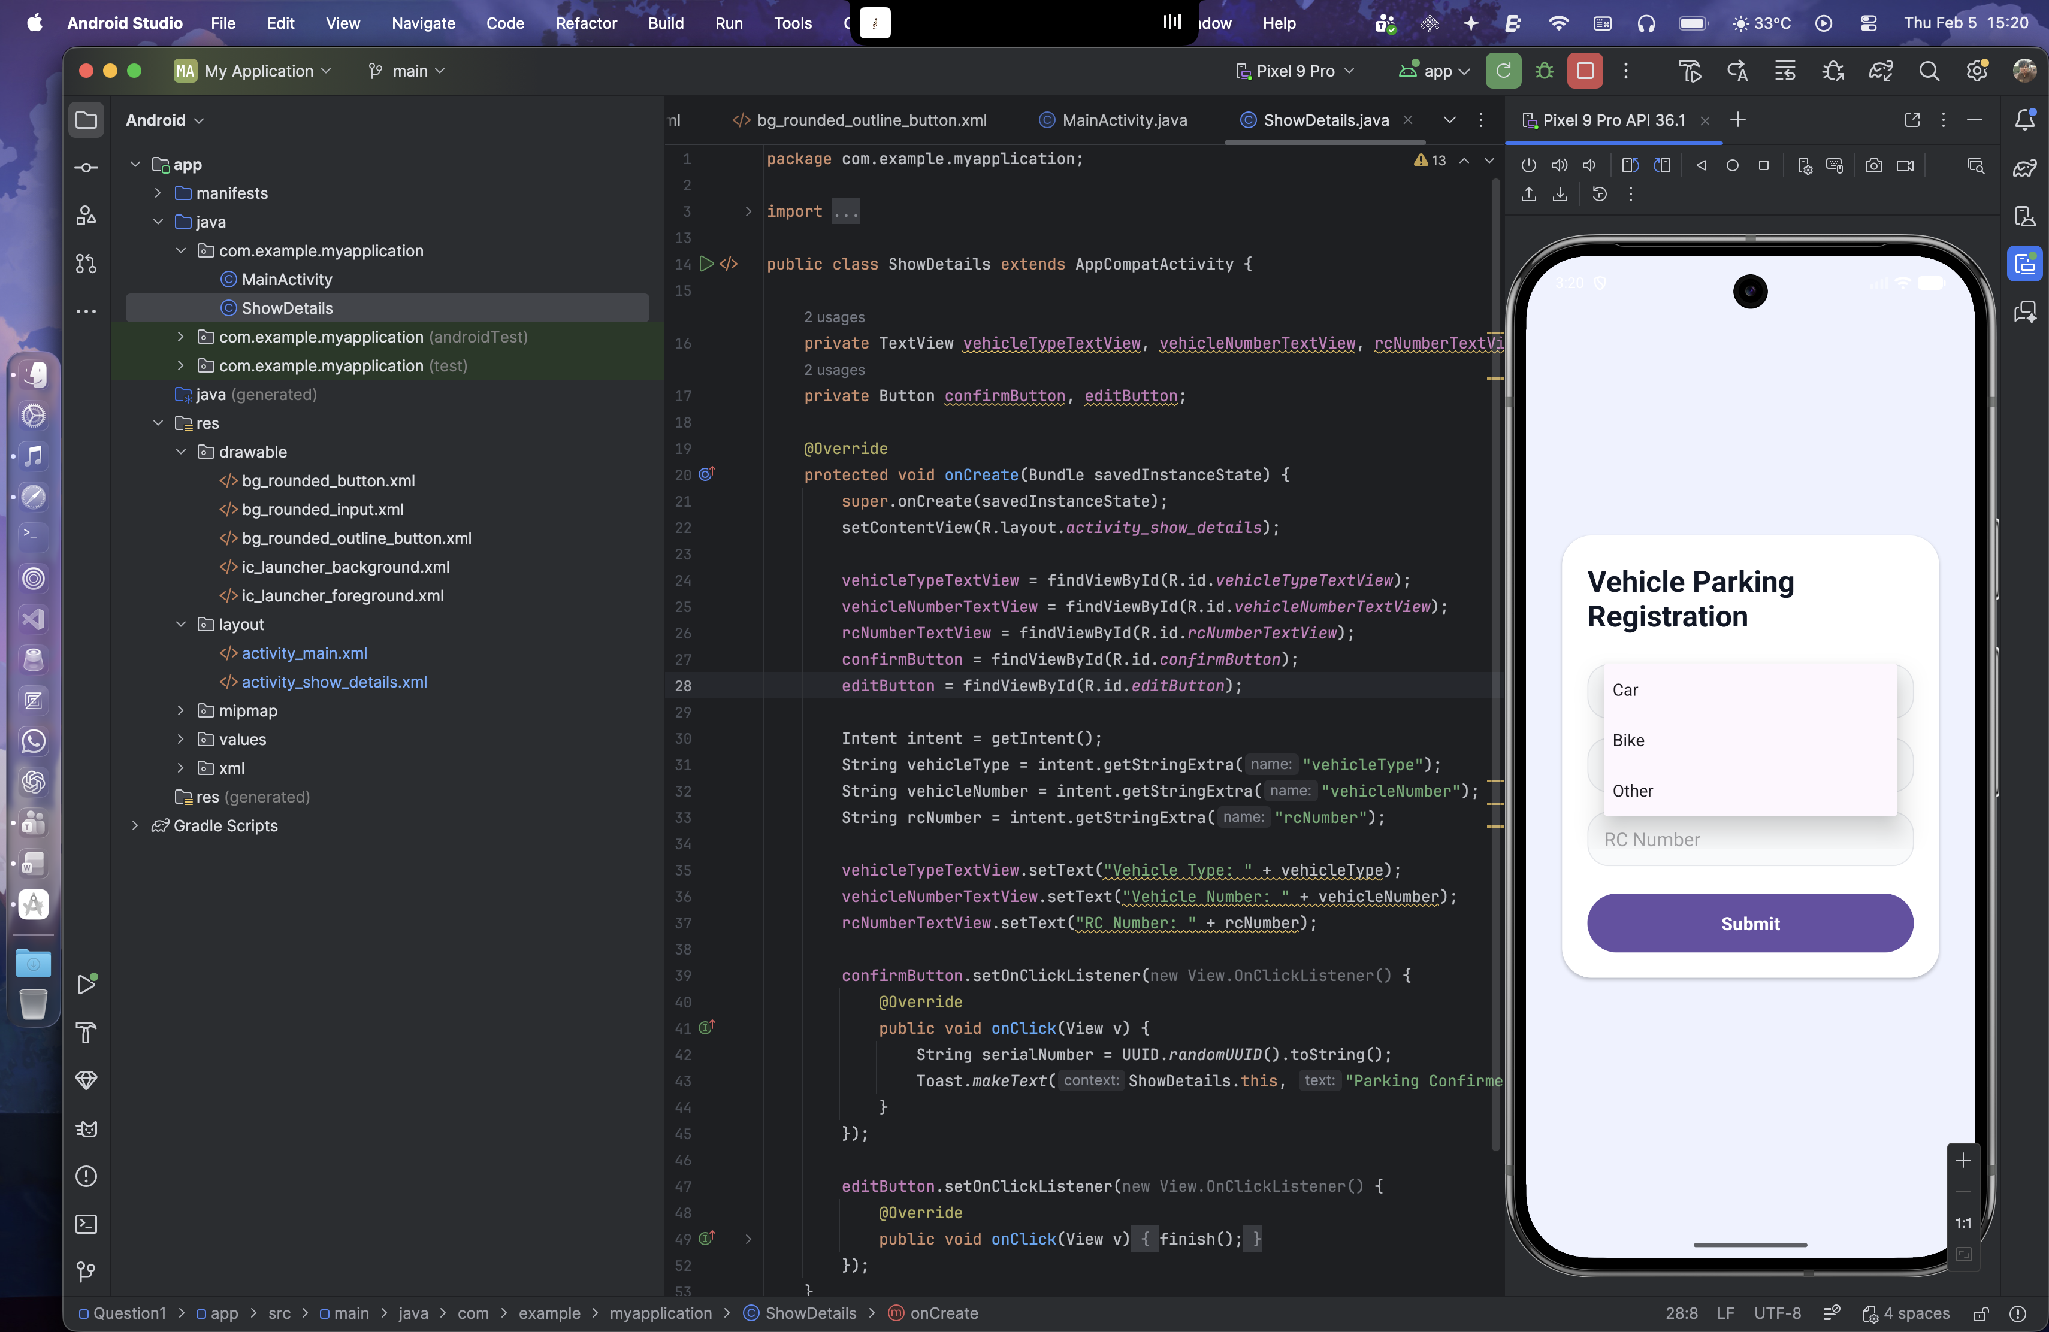 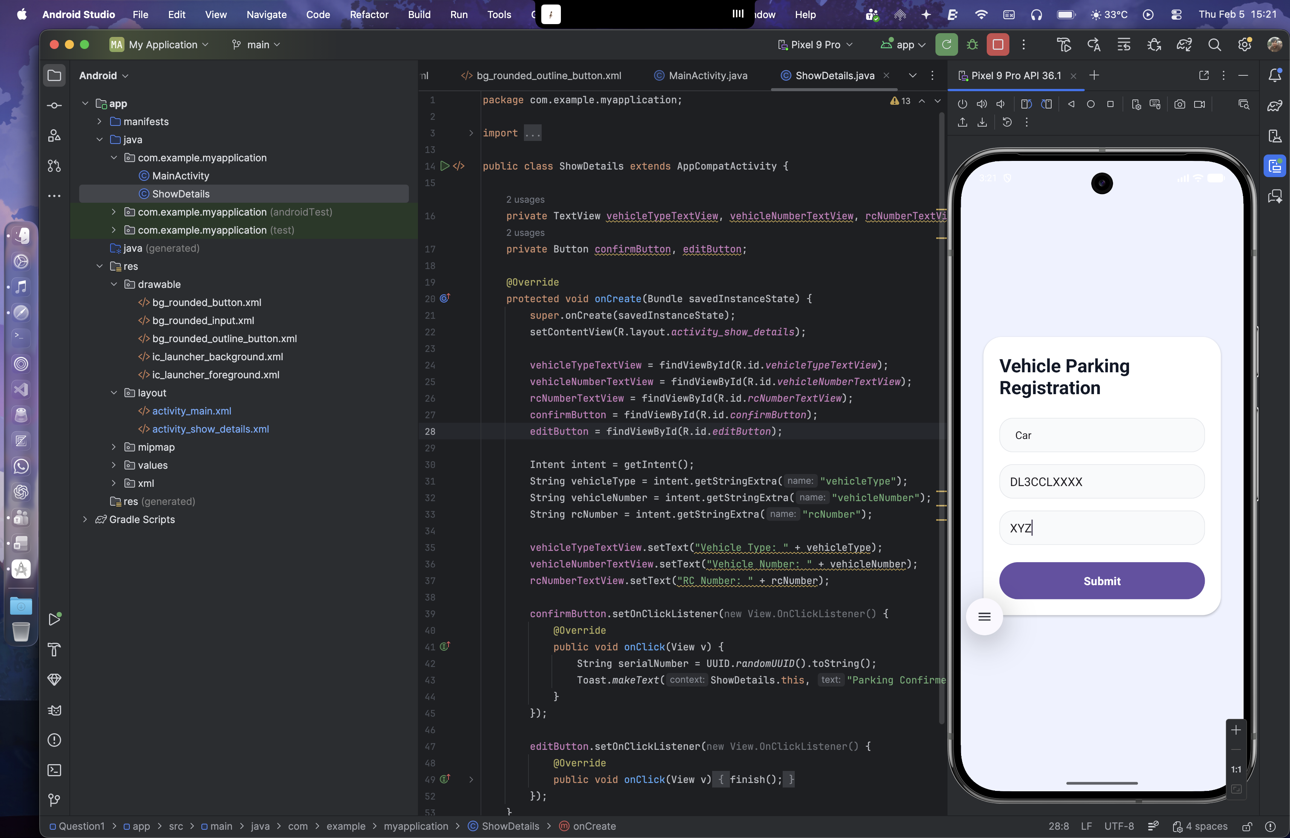 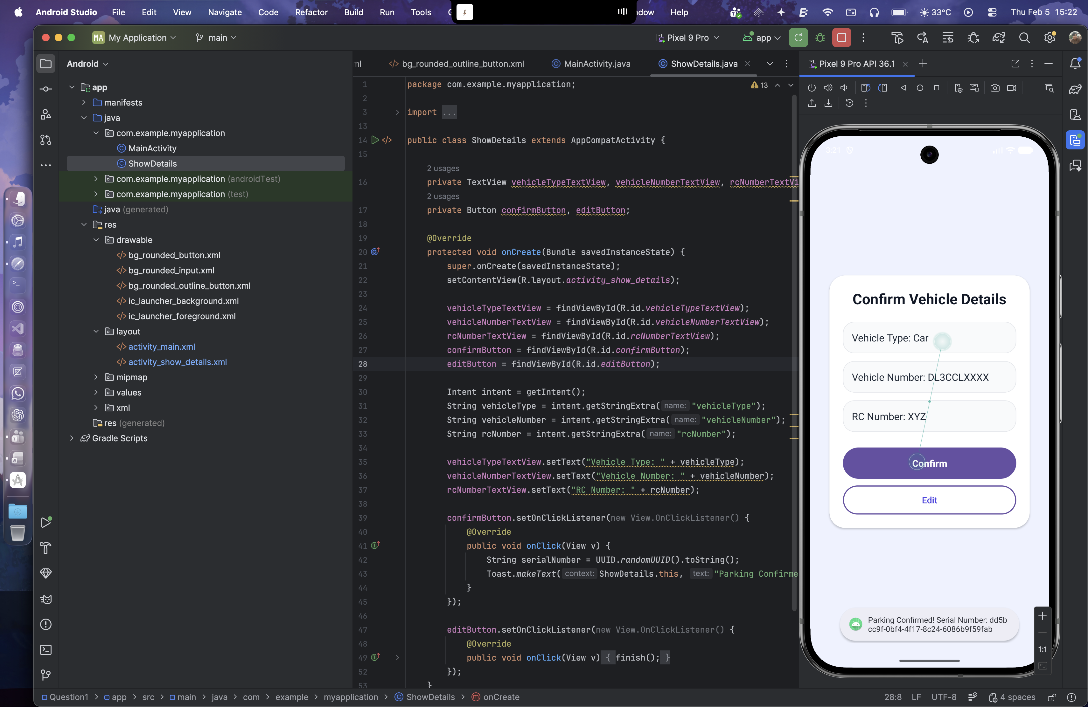

Question 2:

Design and develop a "Travel Ticket Booking" app where users can book tickets by selecting the source and destination from dropdown lists (spinners) and choosing the date of travel using a date picker. Include a toggle button to let users specify whether they want a one-way ticket or a round-trip ticket. The app should have "Submit" and "Reset" buttons. When the "Submit" button is clicked, display the entered details on a new screen in a structured format. The "Reset" button should clear all input fields and set the date picker to the current system date and time.

Layout Design:

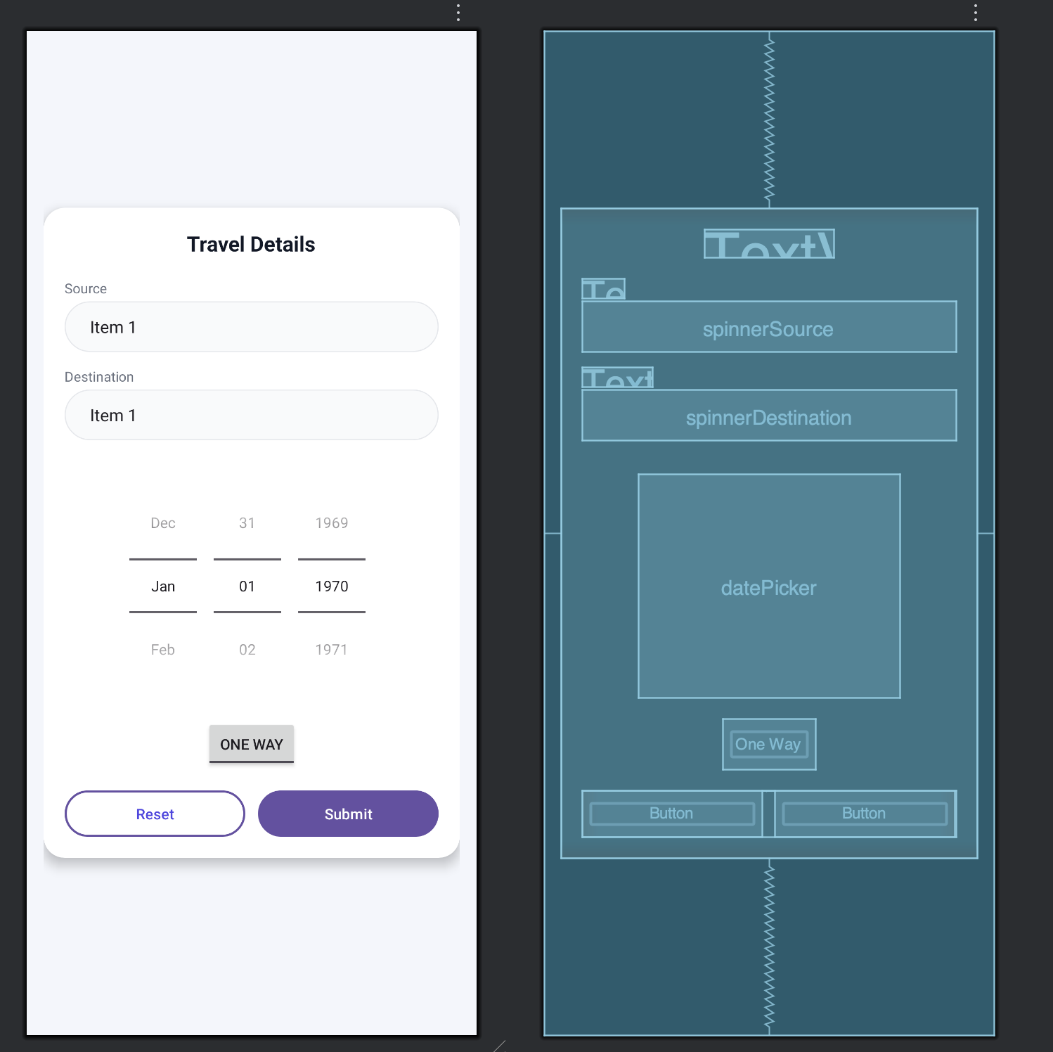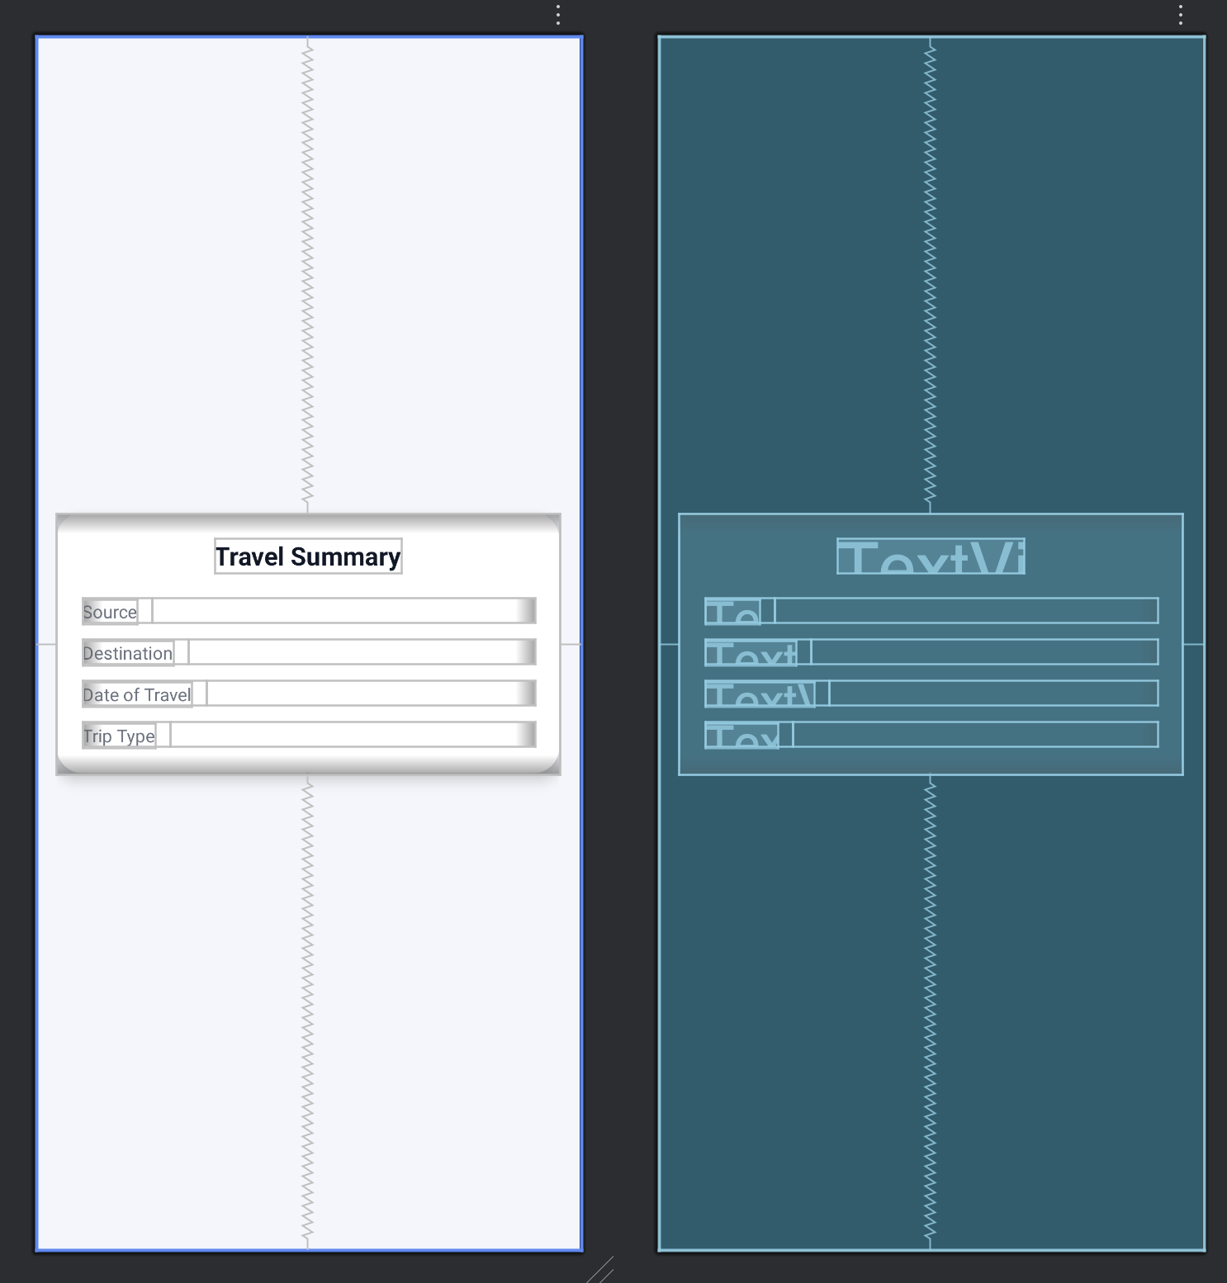

XML for activity_main.xml

<?xml version="1.0" encoding="utf-8"?>  
<RelativeLayout xmlns:android="http://schemas.android.com/apk/res/android"  
 xmlns:app="http://schemas.android.com/apk/res-auto"  
 xmlns:tools="http://schemas.android.com/tools"  
 android:id="@+id/main"  
 android:layout_width="match_parent"  
 android:layout_height="match_parent"  
 android:background="#F4F6FB"  
 android:padding="16dp"  
 tools:context=".MainActivity">  
  
 <androidx.cardview.widget.CardView  
 android:layout_width="match_parent"  
 android:layout_height="wrap_content"  
 android:layout_centerInParent="true"  
 app:cardCornerRadius="20dp"  
 app:cardElevation="6dp"  
 android:backgroundTint="@android:color/white">  
  
 <LinearLayout  
 android:layout_width="match_parent"  
 android:layout_height="wrap_content"  
 android:orientation="vertical"  
 android:padding="20dp">  
  
 <TextView  
 android:layout_width="wrap_content"  
 android:layout_height="wrap_content"  
 android:text="Travel Details"  
 android:textSize="20sp"  
 android:textStyle="bold"  
 android:textColor="#111827"  
 android:layout_gravity="center_horizontal"  
 android:layout_marginBottom="20dp" />  
  
 <TextView  
 android:id="@+id/textViewSource"  
 android:layout_width="wrap_content"  
 android:layout_height="wrap_content"  
 android:text="Source"  
 android:textColor="#6B7280"  
 android:textSize="13sp"  
 android:layout_marginBottom="4dp" />  
  
 <Spinner  
 android:id="@+id/spinnerSource"  
 android:layout_width="match_parent"  
 android:layout_height="48dp"  
 android:background="@drawable/bg_pill_input"  
 android:paddingHorizontal="16dp"  
 android:layout_marginBottom="14dp" />  
  
 <TextView  
 android:id="@+id/textViewDestination"  
 android:layout_width="wrap_content"  
 android:layout_height="wrap_content"  
 android:text="Destination"  
 android:textColor="#6B7280"  
 android:textSize="13sp"  
 android:layout_marginBottom="4dp" />  
  
 <Spinner  
 android:id="@+id/spinnerDestination"  
 android:layout_width="match_parent"  
 android:layout_height="48dp"  
 android:background="@drawable/bg_pill_input"  
 android:paddingHorizontal="16dp"  
 android:layout_marginBottom="16dp" />  
  
 <DatePicker  
 android:id="@+id/datePicker"  
 android:layout_width="wrap_content"  
 android:layout_height="wrap_content"  
 android:layout_gravity="center_horizontal"  
 android:datePickerMode="spinner"  
 android:calendarViewShown="false"  
 android:layout_marginTop="16dp"  
 android:layout_marginBottom="20dp" />  
  
  
 <ToggleButton  
 android:id="@+id/toggleButton"  
 android:layout_width="wrap_content"  
 android:layout_height="wrap_content"  
 android:layout_gravity="center_horizontal"  
 android:textOff="One Way"  
 android:textOn="Round Trip"  
 android:layout_marginBottom="20dp" />  
  
 <LinearLayout  
 android:layout_width="match_parent"  
 android:layout_height="wrap_content"  
 android:orientation="horizontal">  
  
 <Button  
 android:id="@+id/buttonReset"  
 android:layout_width="0dp"  
 android:layout_height="44dp"  
 android:layout_weight="1"  
 android:text="Reset"  
 android:textAllCaps="false"  
 android:background="@drawable/bg_pill_outline"  
 android:textColor="#4F46E5" />  
  
 <Space  
 android:layout_width="12dp"  
 android:layout_height="wrap_content" />  
  
 <Button  
 android:id="@+id/buttonSubmit"  
 android:layout_width="0dp"  
 android:layout_height="44dp"  
 android:layout_weight="1"  
 android:text="Submit"  
 android:textAllCaps="false"  
 android:background="@drawable/bg_pill_primary"  
 android:textColor="@android:color/white" />  
 </LinearLayout>  
  
 </LinearLayout>  
 </androidx.cardview.widget.CardView>  
  
</RelativeLayout>

XML for activity_show_details.xml

<?xml version="1.0" encoding="utf-8"?>  
<RelativeLayout xmlns:android="http://schemas.android.com/apk/res/android"  
 xmlns:app="http://schemas.android.com/apk/res-auto"  
 xmlns:tools="http://schemas.android.com/tools"  
 android:id="@+id/main"  
 android:layout_width="match_parent"  
 android:layout_height="match_parent"  
 android:background="#F4F6FB"  
 android:padding="16dp"  
 tools:context=".showDetails">  
  
 <androidx.cardview.widget.CardView  
 android:layout_width="match_parent"  
 android:layout_height="wrap_content"  
 android:layout_centerInParent="true"  
 app:cardCornerRadius="20dp"  
 app:cardElevation="6dp"  
 android:backgroundTint="@android:color/white">  
  
 <LinearLayout  
 android:layout_width="match_parent"  
 android:layout_height="wrap_content"  
 android:orientation="vertical"  
 android:padding="20dp">  
  
 <TextView  
 android:layout_width="wrap_content"  
 android:layout_height="wrap_content"  
 android:text="Travel Summary"  
 android:textSize="20sp"  
 android:textStyle="bold"  
 android:textColor="#111827"  
 android:layout_gravity="center_horizontal"  
 android:layout_marginBottom="20dp" />  
  
 <LinearLayout  
 android:layout_width="match_parent"  
 android:layout_height="wrap_content"  
 android:orientation="horizontal"  
 android:layout_marginBottom="12dp">  
  
 <TextView  
 android:id="@+id/textViewSourceLabel"  
 android:layout_width="wrap_content"  
 android:layout_height="wrap_content"  
 android:text="Source"  
 android:textColor="#6B7280"  
 android:textSize="14sp" />  
  
 <TextView  
 android:id="@+id/textViewSourceValue"  
 android:layout_width="wrap_content"  
 android:layout_height="wrap_content"  
 android:layout_marginStart="12dp"  
 android:textColor="#111827"  
 android:textSize="15sp"  
 android:textStyle="bold" />  
 </LinearLayout>  
  
 <LinearLayout  
 android:layout_width="match_parent"  
 android:layout_height="wrap_content"  
 android:orientation="horizontal"  
 android:layout_marginBottom="12dp">  
  
 <TextView  
 android:id="@+id/textViewDestinationLabel"  
 android:layout_width="wrap_content"  
 android:layout_height="wrap_content"  
 android:text="Destination"  
 android:textColor="#6B7280"  
 android:textSize="14sp" />  
  
 <TextView  
 android:id="@+id/textViewDestinationValue"  
 android:layout_width="wrap_content"  
 android:layout_height="wrap_content"  
 android:layout_marginStart="12dp"  
 android:textColor="#111827"  
 android:textSize="15sp"  
 android:textStyle="bold" />  
 </LinearLayout>  
  
 <LinearLayout  
 android:layout_width="match_parent"  
 android:layout_height="wrap_content"  
 android:orientation="horizontal"  
 android:layout_marginBottom="12dp">  
  
 <TextView  
 android:id="@+id/textViewDateLabel"  
 android:layout_width="wrap_content"  
 android:layout_height="wrap_content"  
 android:text="Date of Travel"  
 android:textColor="#6B7280"  
 android:textSize="14sp" />  
  
 <TextView  
 android:id="@+id/textViewDateValue"  
 android:layout_width="wrap_content"  
 android:layout_height="wrap_content"  
 android:layout_marginStart="12dp"  
 android:textColor="#111827"  
 android:textSize="15sp"  
 android:textStyle="bold" />  
 </LinearLayout>  
  
 <LinearLayout  
 android:layout_width="match_parent"  
 android:layout_height="wrap_content"  
 android:orientation="horizontal">  
  
 <TextView  
 android:id="@+id/textViewTripTypeLabel"  
 android:layout_width="wrap_content"  
 android:layout_height="wrap_content"  
 android:text="Trip Type"  
 android:textColor="#6B7280"  
 android:textSize="14sp" />  
  
 <TextView  
 android:id="@+id/textViewTripTypeValue"  
 android:layout_width="wrap_content"  
 android:layout_height="wrap_content"  
 android:layout_marginStart="12dp"  
 android:textColor="#111827"  
 android:textSize="15sp"  
 android:textStyle="bold" />  
 </LinearLayout>  
  
 </LinearLayout>  
  
 </androidx.cardview.widget.CardView>  
  
</RelativeLayout>

XML for drawable:

Bg_pill_input.xml

<shape xmlns:android="http://schemas.android.com/apk/res/android">  
 <solid android:color="#F9FAFB"/>  
 <corners android:radius="24dp"/>  
 <stroke android:width="1dp" android:color="#E5E7EB"/>  
</shape>

Bg_pill_outline.xml

<shape xmlns:android="http://schemas.android.com/apk/res/android">  
 <solid android:color="#F9FAFB"/>  
 <corners android:radius="24dp"/>  
 <stroke android:width="1dp" android:color="#E5E7EB"/>  
</shape>

Bg_pill_primary.xml

<shape xmlns:android="http://schemas.android.com/apk/res/android">  
 <solid android:color="#4F46E5"/>  
 <corners android:radius="24dp"/>  
</shape>

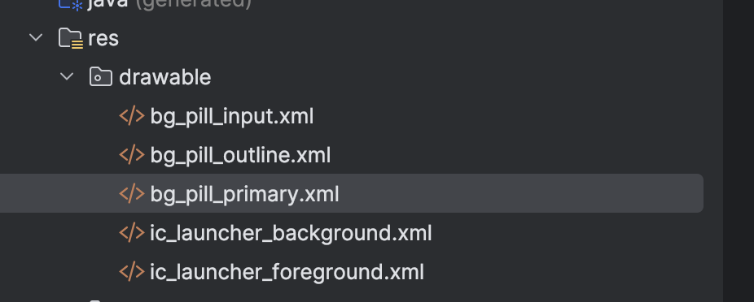

Java Code:

MainActivity.java

public class MainActivity extends AppCompatActivity {  
  
 private Spinner spinnerSource, spinnerDestination;  
 private DatePicker datePicker;  
 private ToggleButton toggleButton;  
 private Button buttonSubmit, buttonReset;  
  
 @Override  
 protected void onCreate(Bundle savedInstanceState) {  
 super.onCreate(savedInstanceState);  
 setContentView(R.layout.*activity_main*);  
  
 spinnerSource = findViewById(R.id.*spinnerSource*);  
 spinnerDestination = findViewById(R.id.*spinnerDestination*);  
 datePicker = findViewById(R.id.*datePicker*);  
 toggleButton = findViewById(R.id.*toggleButton*);  
 buttonSubmit = findViewById(R.id.*buttonSubmit*);  
 buttonReset = findViewById(R.id.*buttonReset*);  
  
 String[] locations = {"Delhi", "Mumbai", "Bangalore", "London", "Tokyo", "Paris", "Sydney"};  
 ArrayAdapter<String> adapter = new ArrayAdapter<>(this, android.R.layout.*simple_spinner_dropdown_item*, locations);  
 spinnerSource.setAdapter(adapter);  
 spinnerDestination.setAdapter(adapter);  
  
 buttonReset.setOnClickListener(new View.OnClickListener() {  
 @Override  
 public void onClick(View v) {  
 resetFields();  
 }  
 });  
  
 buttonSubmit.setOnClickListener(new View.OnClickListener() {  
 @Override  
 public void onClick(View v) {  
 String source = spinnerSource.getSelectedItem().toString();  
 String destination = spinnerDestination.getSelectedItem().toString();  
 int day = datePicker.getDayOfMonth();  
 int month = datePicker.getMonth();  
 int year = datePicker.getYear();  
 String tripType = toggleButton.isChecked() ? "Round Trip" : "One Way";  
  
 Intent intent = new Intent(MainActivity.this, showDetails.class);  
 intent.putExtra("source", source);  
 intent.putExtra("destination", destination);  
 intent.putExtra("date", day + "/" + (month + 1) + "/" + year);  
 intent.putExtra("tripType", tripType);  
 startActivity(intent);  
 }  
 });  
 }  
  
 private void resetFields() {  
 spinnerSource.setSelection(0);  
 spinnerDestination.setSelection(0);  
 toggleButton.setChecked(false);  
  
 final Calendar c = Calendar.*getInstance*();  
 int year = c.get(Calendar.*YEAR*);  
 int month = c.get(Calendar.*MONTH*);  
 int day = c.get(Calendar.*DAY_OF_MONTH*);  
 datePicker.updateDate(year, month, day);  
 }  
}

showDetails.java

public class showDetails extends AppCompatActivity {  
  
 @Override  
 protected void onCreate(Bundle savedInstanceState) {  
 super.onCreate(savedInstanceState);  
 setContentView(R.layout.*activity_show_details*);  
  
 TextView textViewSourceValue = findViewById(R.id.*textViewSourceValue*);  
 TextView textViewDestinationValue = findViewById(R.id.*textViewDestinationValue*);  
 TextView textViewDateValue = findViewById(R.id.*textViewDateValue*);  
 TextView textViewTripTypeValue = findViewById(R.id.*textViewTripTypeValue*);  
  
 Bundle extras = getIntent().getExtras();  
 if (extras != null) {  
 textViewSourceValue.setText(extras.getString("source"));  
 textViewDestinationValue.setText(extras.getString("destination"));  
 textViewDateValue.setText(extras.getString("date"));  
 textViewTripTypeValue.setText(extras.getString("tripType"));  
 }  
 }  
}

Output:

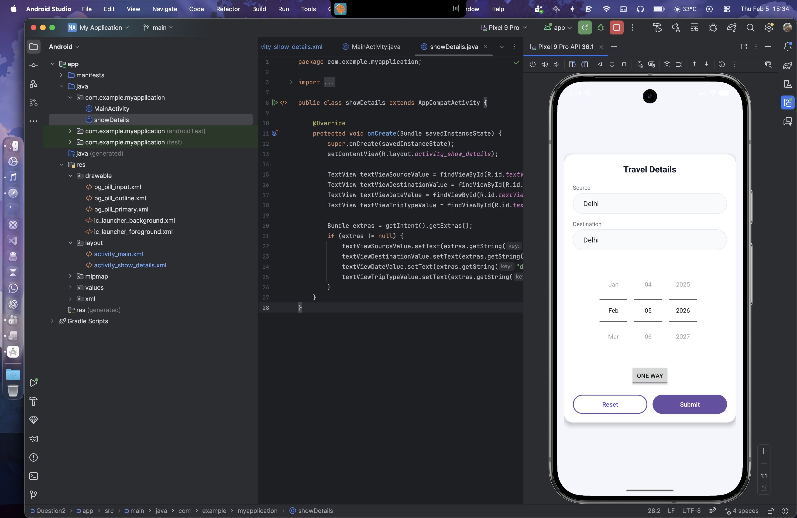 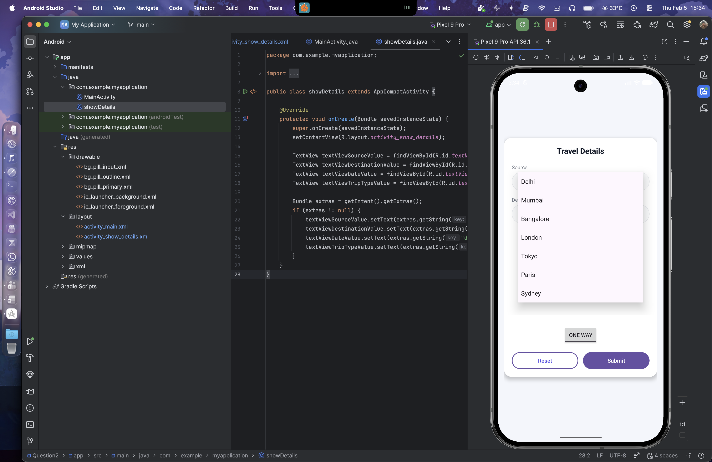 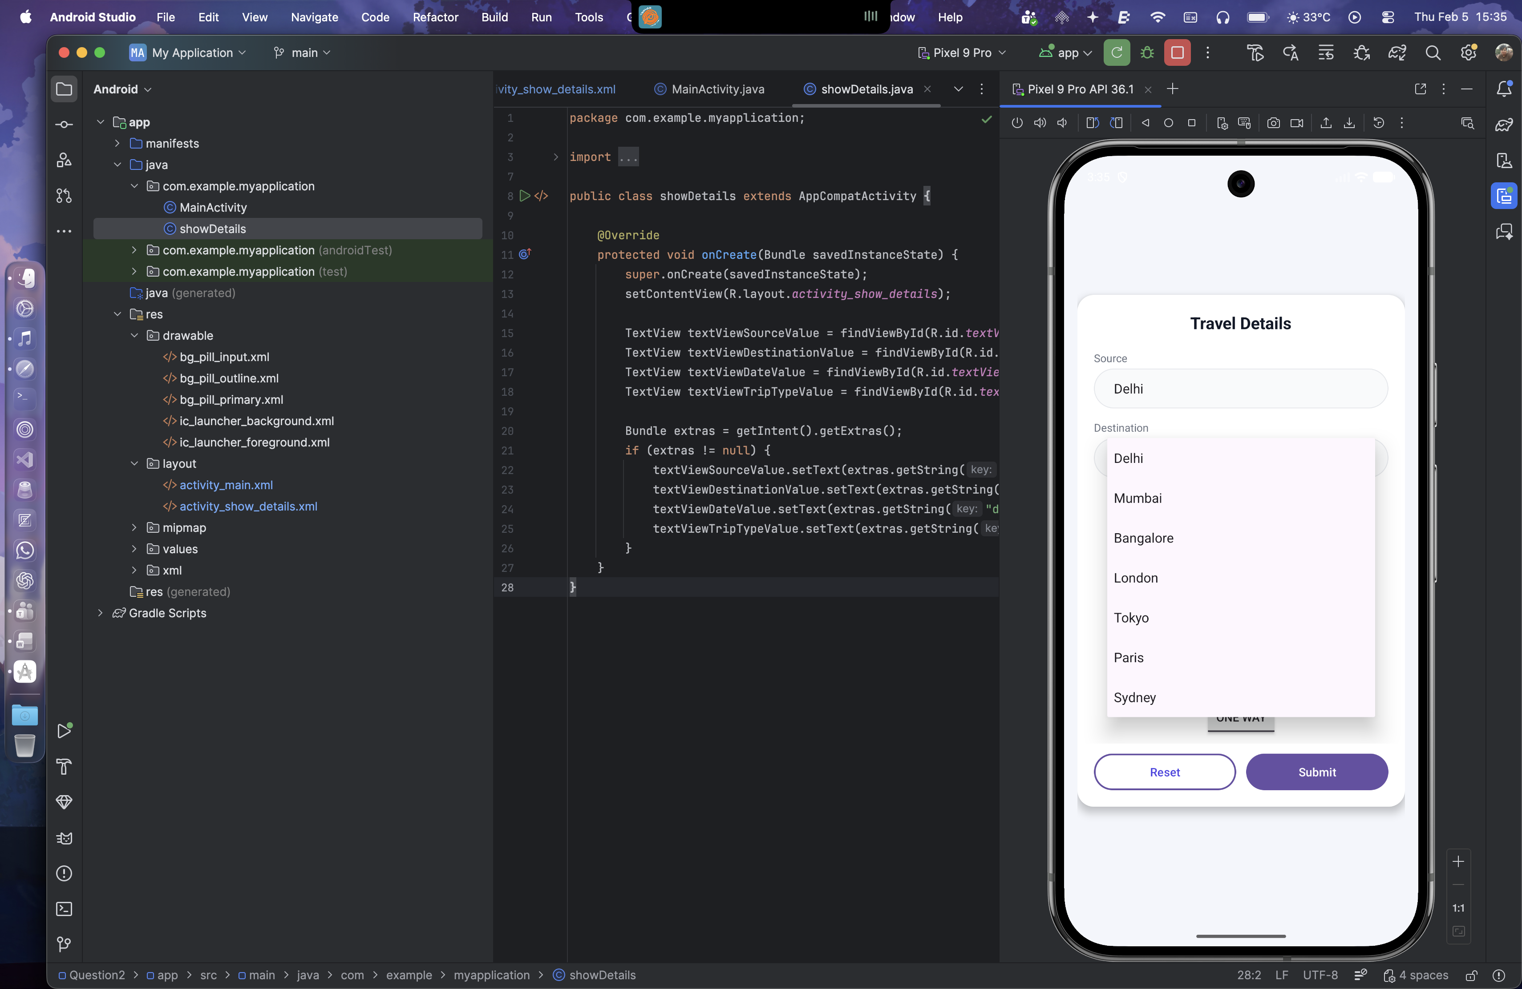

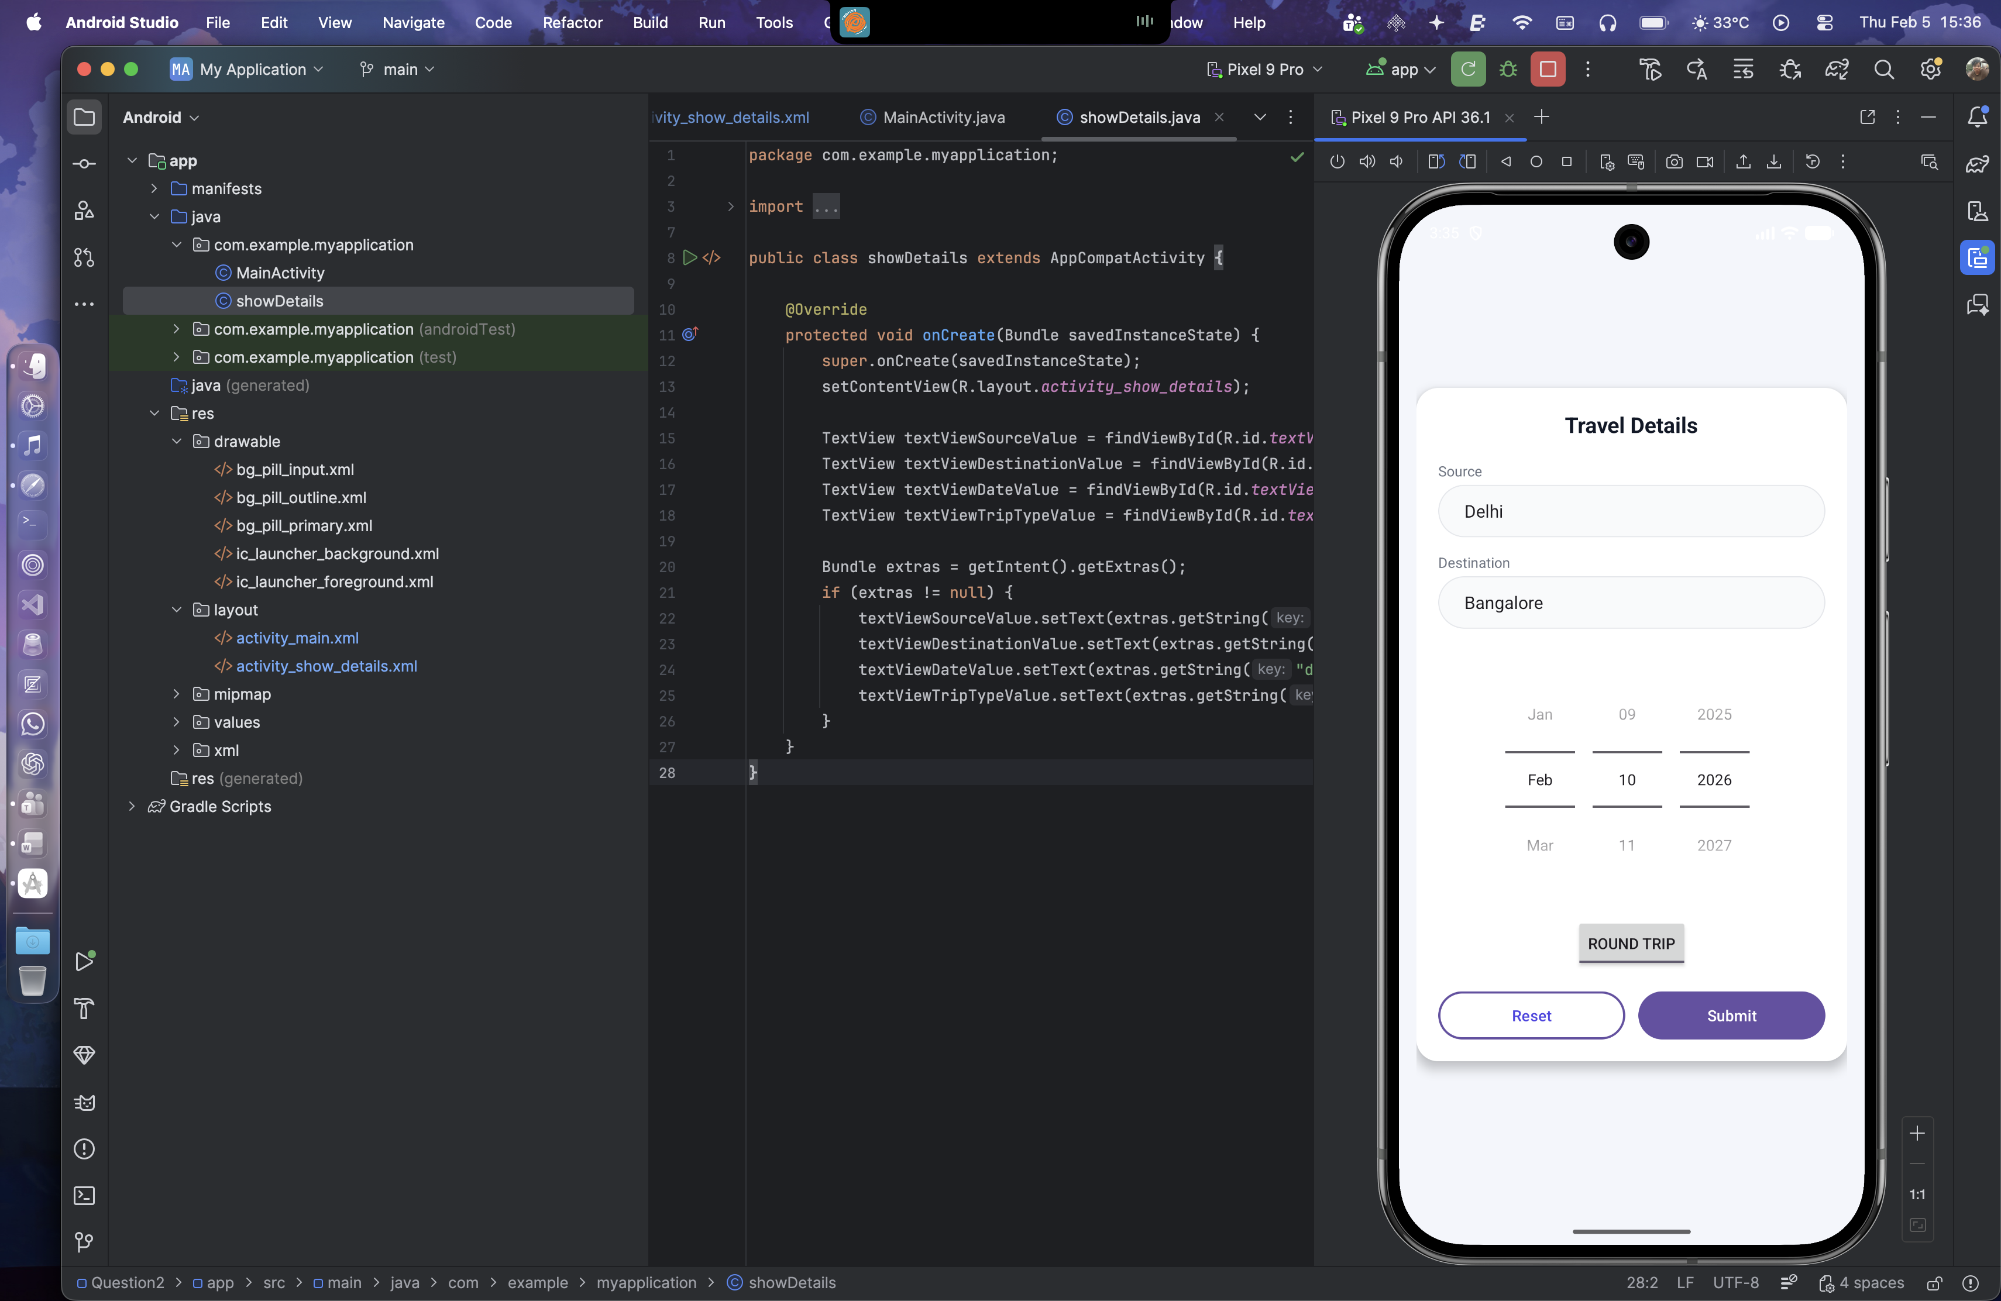 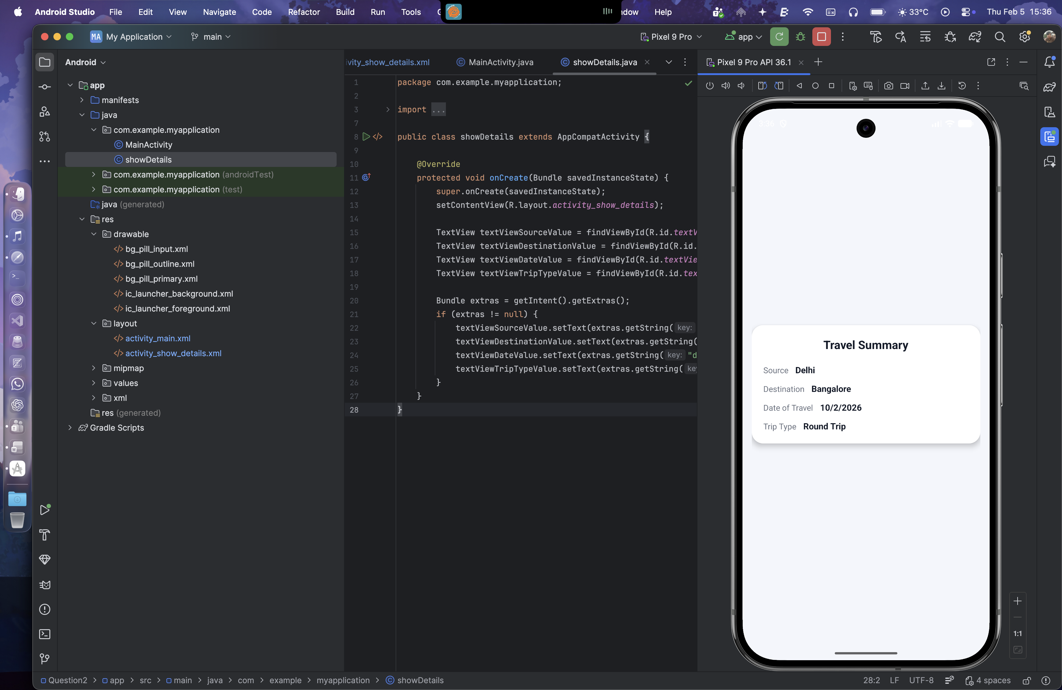

Question 3:

Design and develop a "Movie Ticket Booking" app where users can book tickets by selecting the movie and theatre from dropdown menus (spinners), the date of the show using a date picker, and the preferred showtime using a time picker. Include a toggle button to let users choose between a standard ticket or a premium ticket. If the "premium" option is selected, ensure the "Submit" button becomes clickable only after 12:00 PM. The app should have "Book Now" and "Reset" buttons. When the user clicks "Book Now," display the entered details along with available seats for the selected show in a new screen in a well-organized format. The "Reset" button should clear all fields and reset the date picker to the current system date. Validate all inputs to ensure correct data entry.

Layout Design:

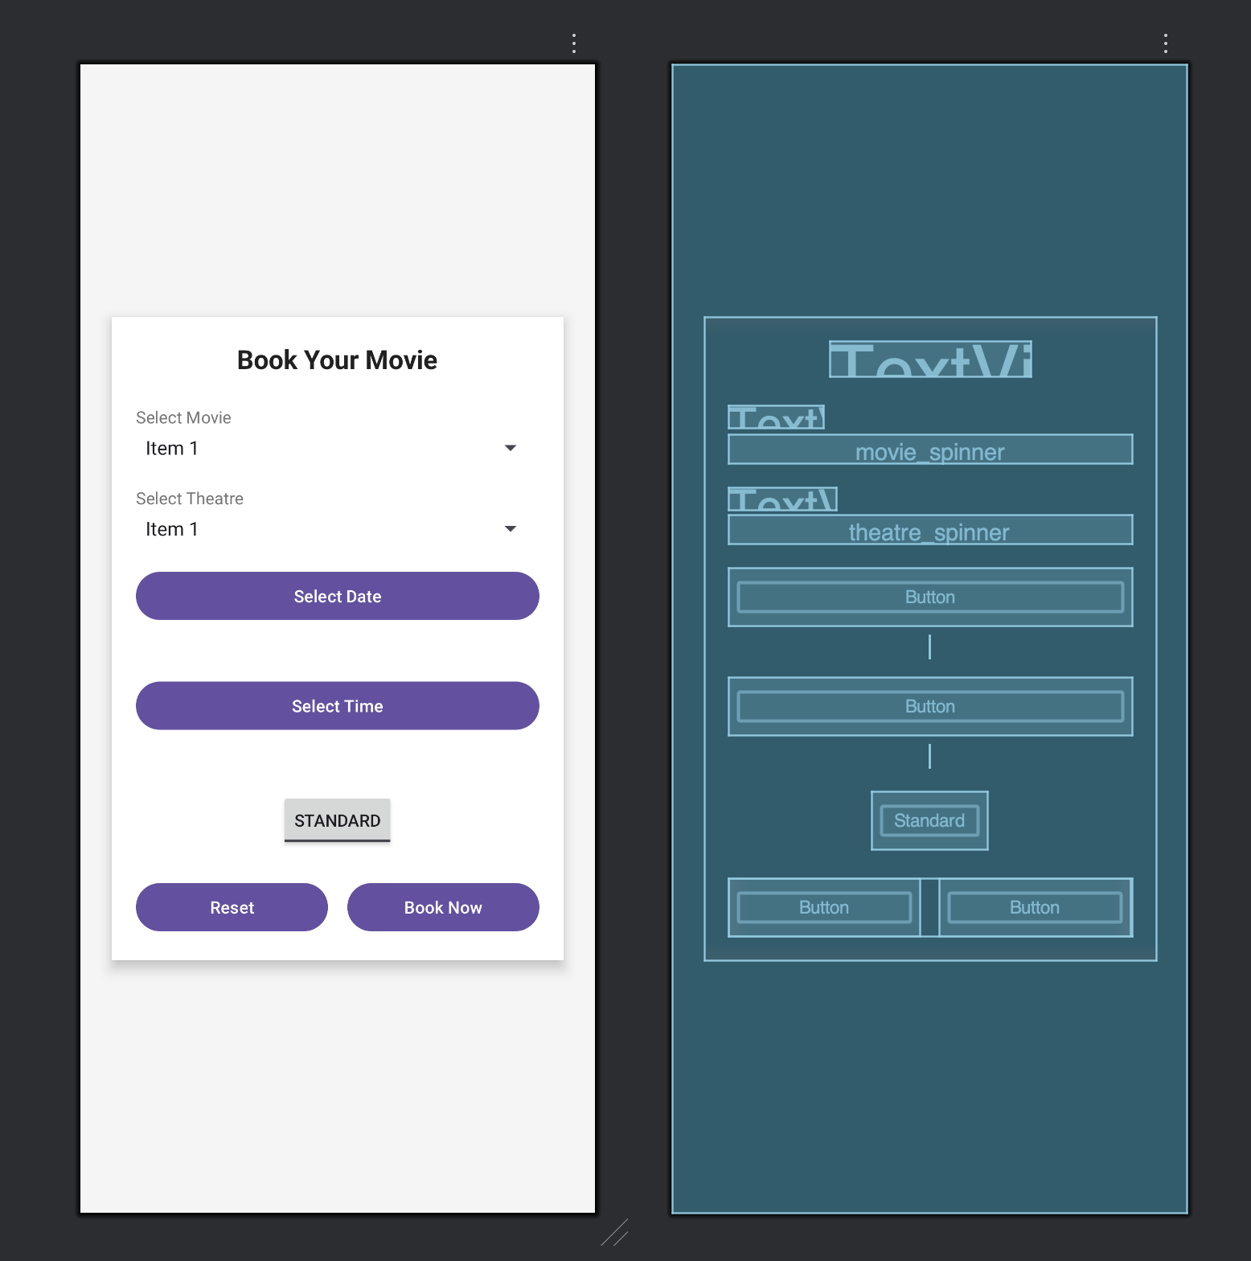 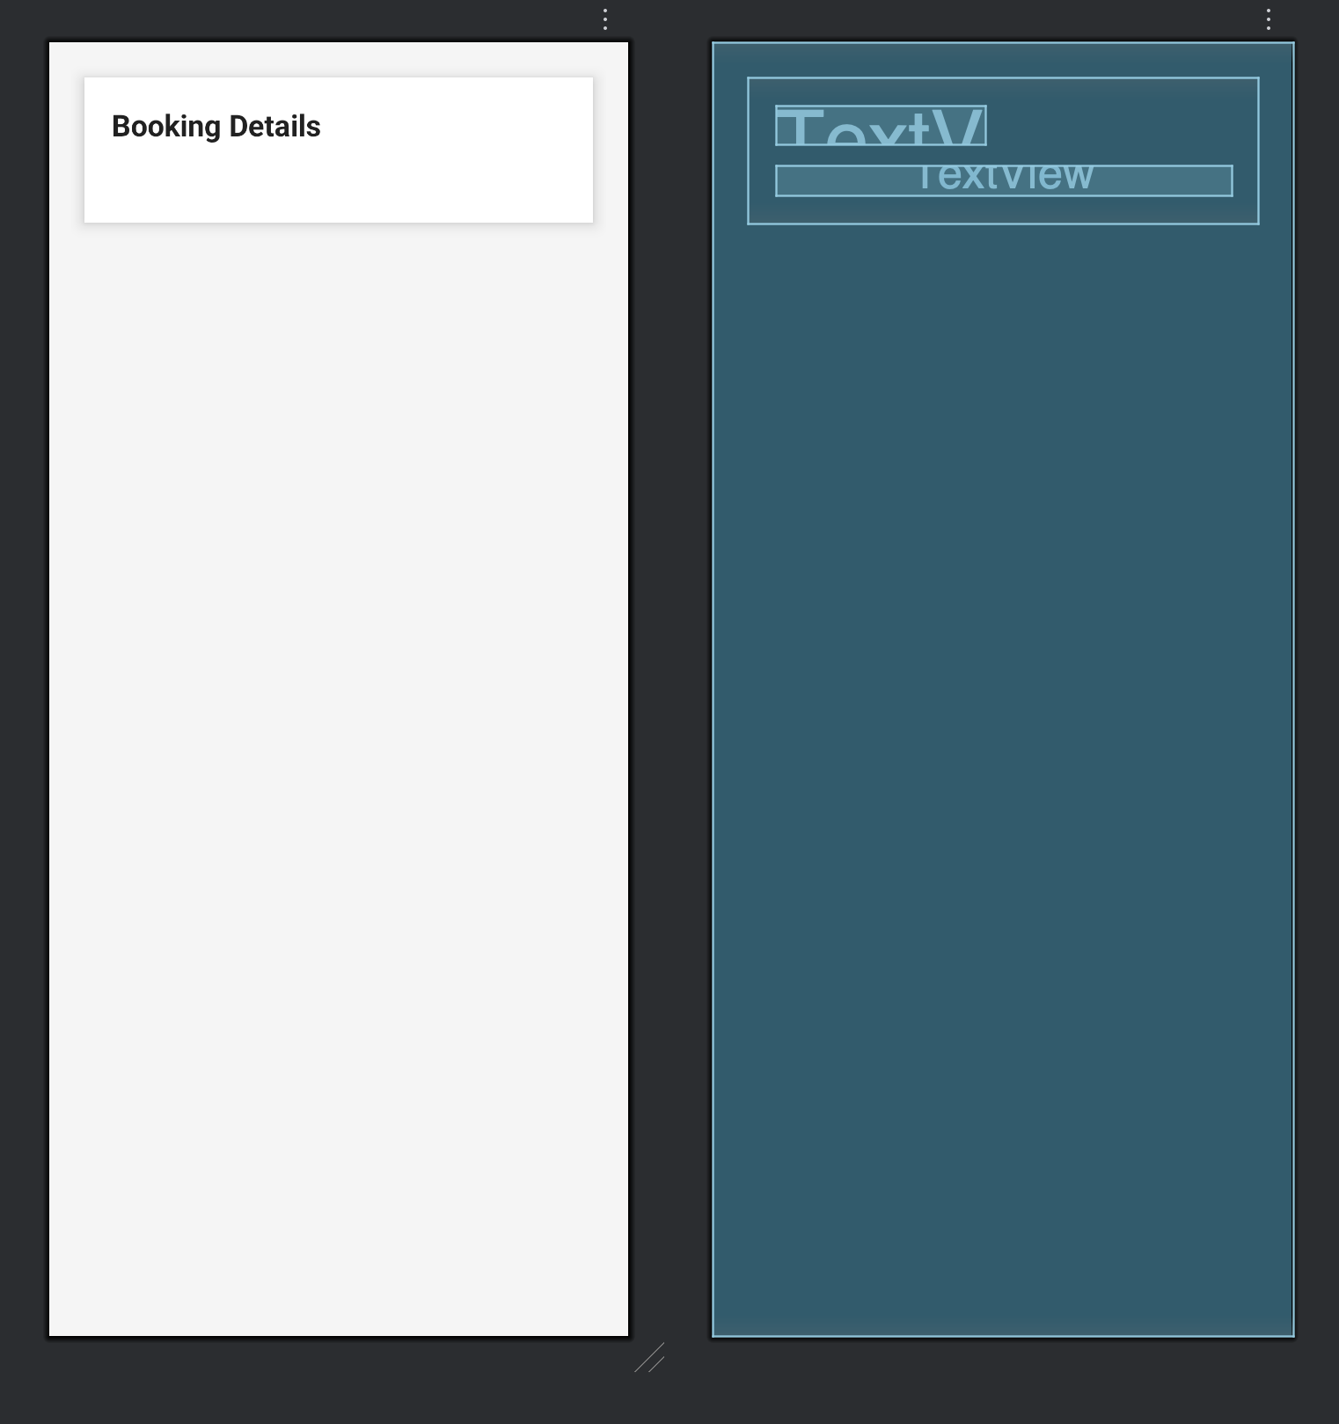

XML for activity_main.xml

<?xml version="1.0" encoding="utf-8"?>  
<ScrollView xmlns:android="http://schemas.android.com/apk/res/android"  
 xmlns:app="http://schemas.android.com/apk/res-auto"  
 xmlns:tools="http://schemas.android.com/tools"  
 android:layout_width="match_parent"  
 android:layout_height="match_parent"  
 android:background="#F5F5F5"  
 android:padding="16dp"  
 tools:context=".MainActivity">  
  
 <LinearLayout  
 android:id="@+id/main"  
 android:layout_width="match_parent"  
 android:layout_height="wrap_content"  
 android:orientation="vertical"  
 android:padding="20dp"  
 android:background="@android:color/white"  
 android:elevation="6dp"  
 android:layout_margin="10dp"  
 android:layout_gravity="center">  
  
 <TextView  
 android:layout_width="wrap_content"  
 android:layout_height="wrap_content"  
 android:text="Book Your Movie"  
 android:textSize="22sp"  
 android:textStyle="bold"  
 android:textColor="#212121"  
 android:layout_gravity="center_horizontal"  
 android:layout_marginBottom="24dp" />  
  
 <TextView  
 android:layout_width="wrap_content"  
 android:layout_height="wrap_content"  
 android:text="Select Movie"  
 android:textSize="14sp"  
 android:textColor="#757575"  
 android:layout_marginBottom="4dp" />  
  
 <Spinner  
 android:id="@+id/movie_spinner"  
 android:layout_width="match_parent"  
 android:layout_height="wrap_content"  
 android:layout_marginBottom="20dp" />  
  
 <TextView  
 android:layout_width="wrap_content"  
 android:layout_height="wrap_content"  
 android:text="Select Theatre"  
 android:textSize="14sp"  
 android:textColor="#757575"  
 android:layout_marginBottom="4dp" />  
  
 <Spinner  
 android:id="@+id/theatre_spinner"  
 android:layout_width="match_parent"  
 android:layout_height="wrap_content"  
 android:layout_marginBottom="20dp" />  
  
 <Button  
 android:id="@+id/date_picker_button"  
 android:layout_width="match_parent"  
 android:layout_height="48dp"  
 android:text="Select Date"  
 android:textAllCaps="false"  
 android:layout_marginBottom="8dp" />  
  
 <TextView  
 android:id="@+id/selected_date_textview"  
 android:layout_width="wrap_content"  
 android:layout_height="wrap_content"  
 android:layout_gravity="center_horizontal"  
 android:textSize="14sp"  
 android:textColor="#424242"  
 android:layout_marginBottom="16dp" />  
  
 <Button  
 android:id="@+id/time_picker_button"  
 android:layout_width="match_parent"  
 android:layout_height="48dp"  
 android:text="Select Time"  
 android:textAllCaps="false"  
 android:layout_marginBottom="8dp" />  
  
 <TextView  
 android:id="@+id/selected_time_textview"  
 android:layout_width="wrap_content"  
 android:layout_height="wrap_content"  
 android:layout_gravity="center_horizontal"  
 android:textSize="14sp"  
 android:textColor="#424242"  
 android:layout_marginBottom="20dp" />  
  
 <ToggleButton  
 android:id="@+id/ticket_type_toggle"  
 android:layout_width="wrap_content"  
 android:layout_height="wrap_content"  
 android:layout_gravity="center_horizontal"  
 android:textOff="Standard"  
 android:textOn="Premium"  
 android:layout_marginBottom="24dp" />  
  
 <LinearLayout  
 android:layout_width="match_parent"  
 android:layout_height="wrap_content"  
 android:orientation="horizontal">  
  
 <Button  
 android:id="@+id/reset_button"  
 android:layout_width="0dp"  
 android:layout_height="48dp"  
 android:layout_weight="1"  
 android:text="Reset"  
 android:textAllCaps="false"  
 android:layout_marginEnd="8dp" />  
  
 <Button  
 android:id="@+id/book_now_button"  
 android:layout_width="0dp"  
 android:layout_height="48dp"  
 android:layout_weight="1"  
 android:text="Book Now"  
 android:textAllCaps="false"  
 android:layout_marginStart="8dp" />  
 </LinearLayout>  
  
 </LinearLayout>  
  
</ScrollView>

XML for activity_booking_details.xml

<?xml version="1.0" encoding="utf-8"?>  
<LinearLayout xmlns:android="http://schemas.android.com/apk/res/android"  
 xmlns:tools="http://schemas.android.com/tools"  
 android:layout_width="match_parent"  
 android:layout_height="match_parent"  
 android:orientation="vertical"  
 android:background="#F5F5F5"  
 android:padding="16dp"  
 tools:context=".BookingDetailsActivity">  
  
 <LinearLayout  
 android:layout_width="match_parent"  
 android:layout_height="wrap_content"  
 android:layout_gravity="center"  
 android:layout_margin="10dp"  
 android:layout_marginTop="240dp"  
 android:background="@android:color/white"  
 android:elevation="6dp"  
 android:orientation="vertical"  
 android:padding="20dp">  
  
 <TextView  
 android:layout_width="wrap_content"  
 android:layout_height="wrap_content"  
 android:layout_marginBottom="16dp"  
 android:text="Booking Details"  
 android:textColor="#212121"  
 android:textSize="22sp"  
 android:textStyle="bold" />  
  
 <TextView  
 android:id="@+id/booking_details_textview"  
 android:layout_width="match_parent"  
 android:layout_height="wrap_content"  
 android:lineSpacingExtra="6dp"  
 android:textColor="#424242"  
 android:textSize="16sp" />  
  
 </LinearLayout>  
  
</LinearLayout>

Java Code:

MainActivity.java

public class MainActivity extends AppCompatActivity {  
  
 private Spinner movieSpinner, theatreSpinner;  
 private Button datePickerButton, timePickerButton, bookNowButton, resetButton;  
 private TextView selectedDateTextView, selectedTimeTextView;  
 private ToggleButton ticketTypeToggle;  
  
 private int year, month, day, hour, minute;  
  
 @Override  
 protected void onCreate(Bundle savedInstanceState) {  
 super.onCreate(savedInstanceState);  
 setContentView(R.layout.*activity_main*);  
  
 movieSpinner = findViewById(R.id.*movie_spinner*);  
 theatreSpinner = findViewById(R.id.*theatre_spinner*);  
 datePickerButton = findViewById(R.id.*date_picker_button*);  
 timePickerButton = findViewById(R.id.*time_picker_button*);  
 bookNowButton = findViewById(R.id.*book_now_button*);  
 resetButton = findViewById(R.id.*reset_button*);  
 selectedDateTextView = findViewById(R.id.*selected_date_textview*);  
 selectedTimeTextView = findViewById(R.id.*selected_time_textview*);  
 ticketTypeToggle = findViewById(R.id.*ticket_type_toggle*);  
  
 ArrayAdapter<CharSequence> movieAdapter = ArrayAdapter.*createFromResource*(this,  
 R.array.*movies_array*, android.R.layout.*simple_spinner_item*);  
 movieAdapter.setDropDownViewResource(android.R.layout.*simple_spinner_dropdown_item*);  
 movieSpinner.setAdapter(movieAdapter);  
  
 ArrayAdapter<CharSequence> theatreAdapter = ArrayAdapter.*createFromResource*(this,  
 R.array.*theatres_array*, android.R.layout.*simple_spinner_item*);  
 theatreAdapter.setDropDownViewResource(android.R.layout.*simple_spinner_dropdown_item*);  
 theatreSpinner.setAdapter(theatreAdapter);  
  
 final Calendar c = Calendar.*getInstance*();  
 year = c.get(Calendar.*YEAR*);  
 month = c.get(Calendar.*MONTH*);  
 day = c.get(Calendar.*DAY_OF_MONTH*);  
 selectedDateTextView.setText(day + "-" + (month + 1) + "-" + year);  
  
 datePickerButton.setOnClickListener(v -> {  
 DatePickerDialog datePickerDialog = new DatePickerDialog(MainActivity.this,  
 (view, year, monthOfYear, dayOfMonth) -> {  
 selectedDateTextView.setText(dayOfMonth + "-" + (monthOfYear + 1) + "-" + year);  
 MainActivity.this.year = year;  
 MainActivity.this.month = monthOfYear;  
 MainActivity.this.day = dayOfMonth;  
 }, year, month, day);  
 datePickerDialog.show();  
 });  
  
 timePickerButton.setOnClickListener(v -> {  
 TimePickerDialog timePickerDialog = new TimePickerDialog(MainActivity.this,  
 (view, hourOfDay, minute) -> {  
 selectedTimeTextView.setText(hourOfDay + ":" + minute);  
 MainActivity.this.hour = hourOfDay;  
 MainActivity.this.minute = minute;  
 updateSubmitButtonState();  
 }, hour, minute, false);  
 timePickerDialog.show();  
 });  
  
 ticketTypeToggle.setOnCheckedChangeListener((buttonView, isChecked) -> {  
 updateSubmitButtonState();  
 });  
  
 bookNowButton.setOnClickListener(v -> {  
 if (validateInputs()) {  
 Intent intent = new Intent(MainActivity.this, BookingDetailsActivity.class);  
 intent.putExtra("movie", movieSpinner.getSelectedItem().toString());  
 intent.putExtra("theatre", theatreSpinner.getSelectedItem().toString());  
 intent.putExtra("date", selectedDateTextView.getText().toString());  
 intent.putExtra("time", selectedTimeTextView.getText().toString());  
 intent.putExtra("ticketType", ticketTypeToggle.isChecked() ? "Premium" : "Standard");  
 intent.putExtra("availableSeats", (int) (Math.*random*() * 100)); // Dummy data  
 startActivity(intent);  
 }  
 });  
  
 resetButton.setOnClickListener(v -> {  
 movieSpinner.setSelection(0);  
 theatreSpinner.setSelection(0);  
 final Calendar cal = Calendar.*getInstance*();  
 year = cal.get(Calendar.*YEAR*);  
 month = cal.get(Calendar.*MONTH*);  
 day = cal.get(Calendar.*DAY_OF_MONTH*);  
 selectedDateTextView.setText(day + "-" + (month + 1) + "-" + year);  
 selectedTimeTextView.setText("");  
 ticketTypeToggle.setChecked(false);  
 updateSubmitButtonState();  
 });  
  
 updateSubmitButtonState();  
 }  
  
 private void updateSubmitButtonState() {  
 if (ticketTypeToggle.isChecked()) {  
 bookNowButton.setEnabled(hour >= 12);  
 } else {  
 bookNowButton.setEnabled(true);  
 }  
 }  
  
 private boolean validateInputs() {  
 if (movieSpinner.getSelectedItemPosition() == 0) {  
 Toast.*makeText*(this, "Please select a movie", Toast.*LENGTH_SHORT*).show();  
 return false;  
 }  
 if (theatreSpinner.getSelectedItemPosition() == 0) {  
 Toast.*makeText*(this, "Please select a theatre", Toast.*LENGTH_SHORT*).show();  
 return false;  
 }  
 if (selectedTimeTextView.getText().toString().isEmpty()) {  
 Toast.*makeText*(this, "Please select a time", Toast.*LENGTH_SHORT*).show();  
 return false;  
 }  
 return true;  
 }  
}

BookingDetailsActivity.java

public class BookingDetailsActivity extends AppCompatActivity {  
  
 @Override  
 protected void onCreate(Bundle savedInstanceState) {  
 super.onCreate(savedInstanceState);  
 setContentView(R.layout.*activity_booking_details*);  
  
 TextView bookingDetailsTextView = findViewById(R.id.*booking_details_textview*);  
  
 Bundle extras = getIntent().getExtras();  
 if (extras != null) {  
 String movie = extras.getString("movie");  
 String theatre = extras.getString("theatre");  
 String date = extras.getString("date");  
 String time = extras.getString("time");  
 String ticketType = extras.getString("ticketType");  
 int availableSeats = extras.getInt("availableSeats");  
  
 String details = "Movie: " + movie + "\n"  
 + "Theatre: " + theatre + "\n"  
 + "Date: " + date + "\n"  
 + "Time: " + time + "\n"  
 + "Ticket Type: " + ticketType + "\n"  
 + "Available Seats: " + availableSeats;  
  
 bookingDetailsTextView.setText(details);  
 }  
 }  
}

Output:

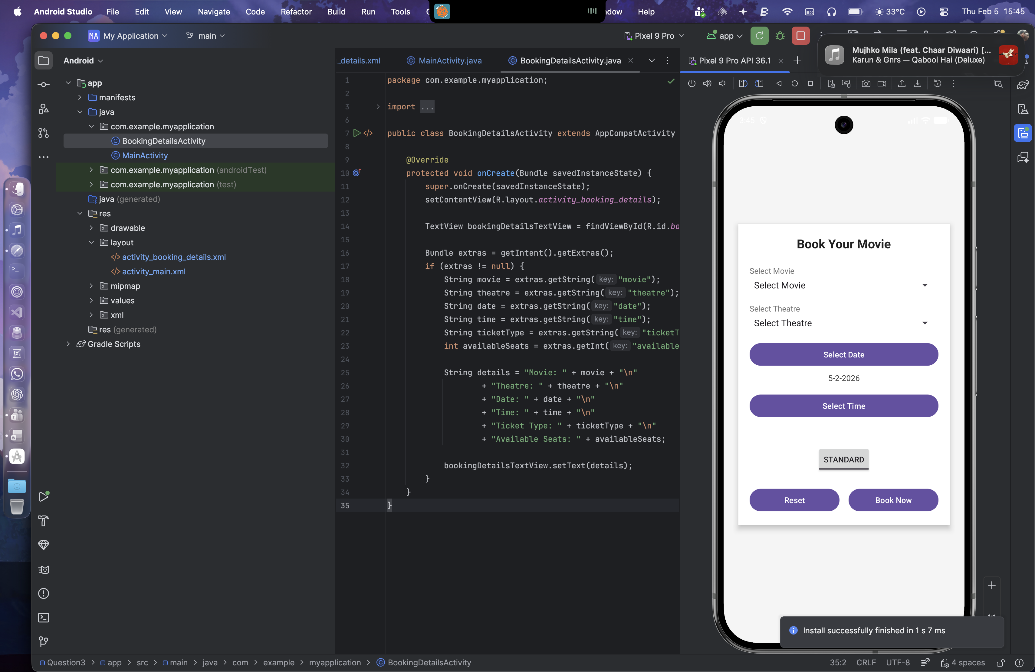 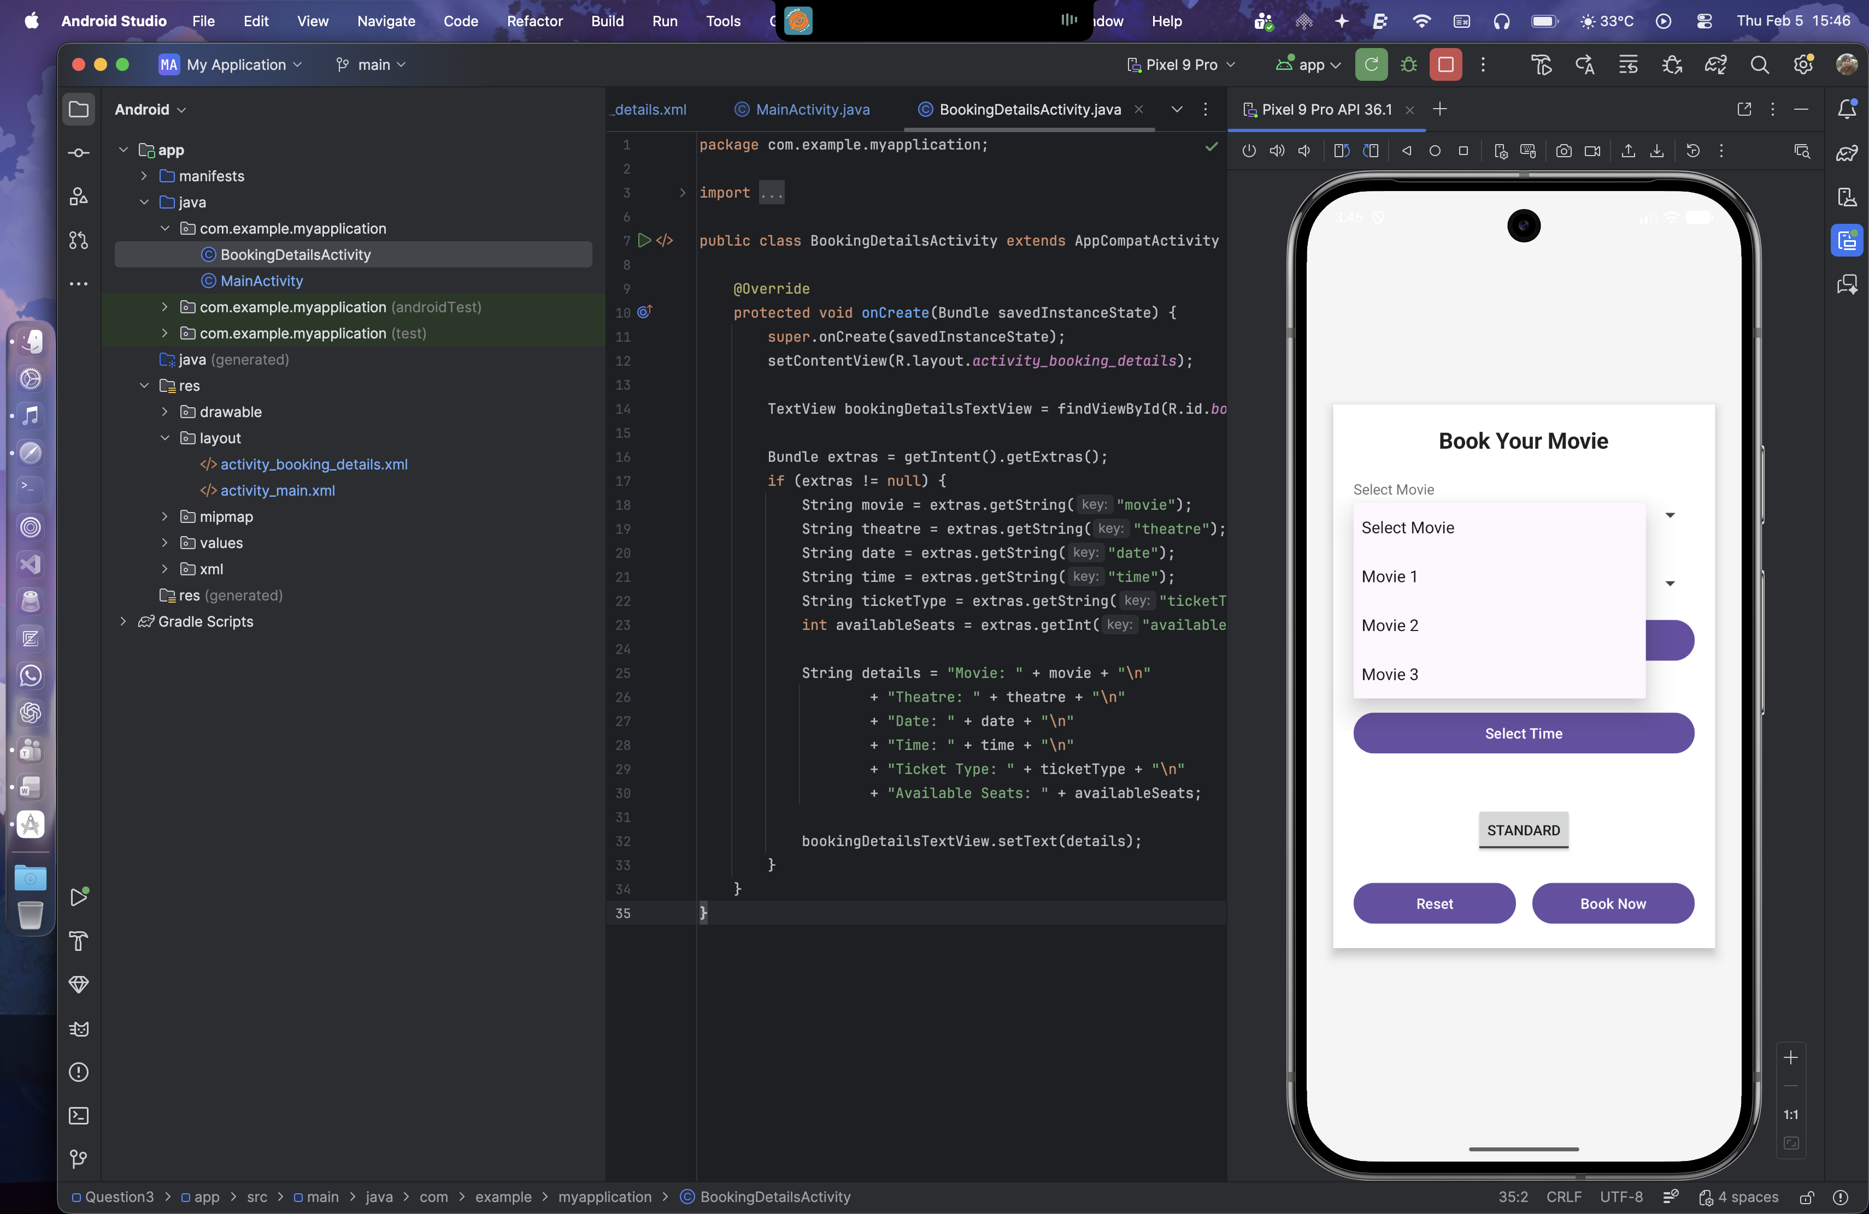 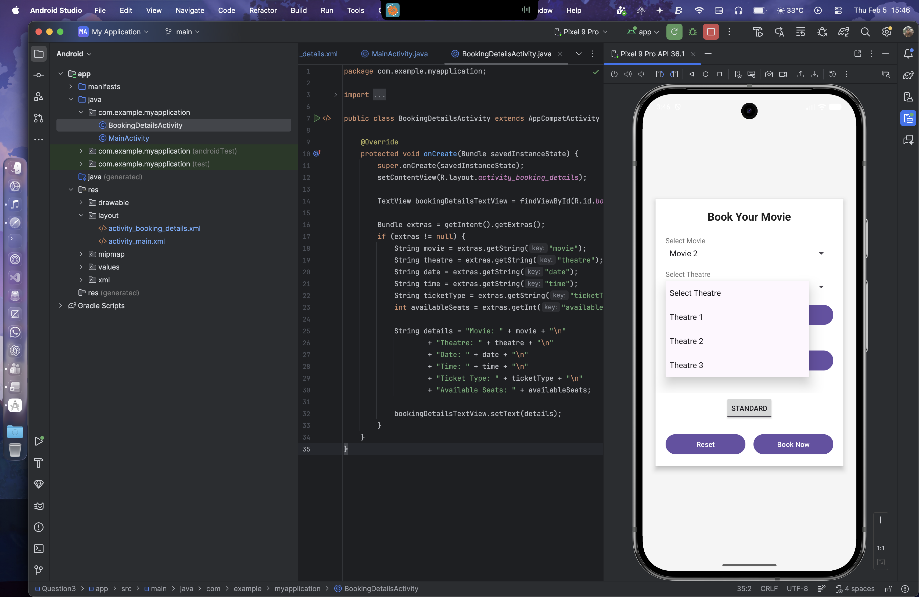

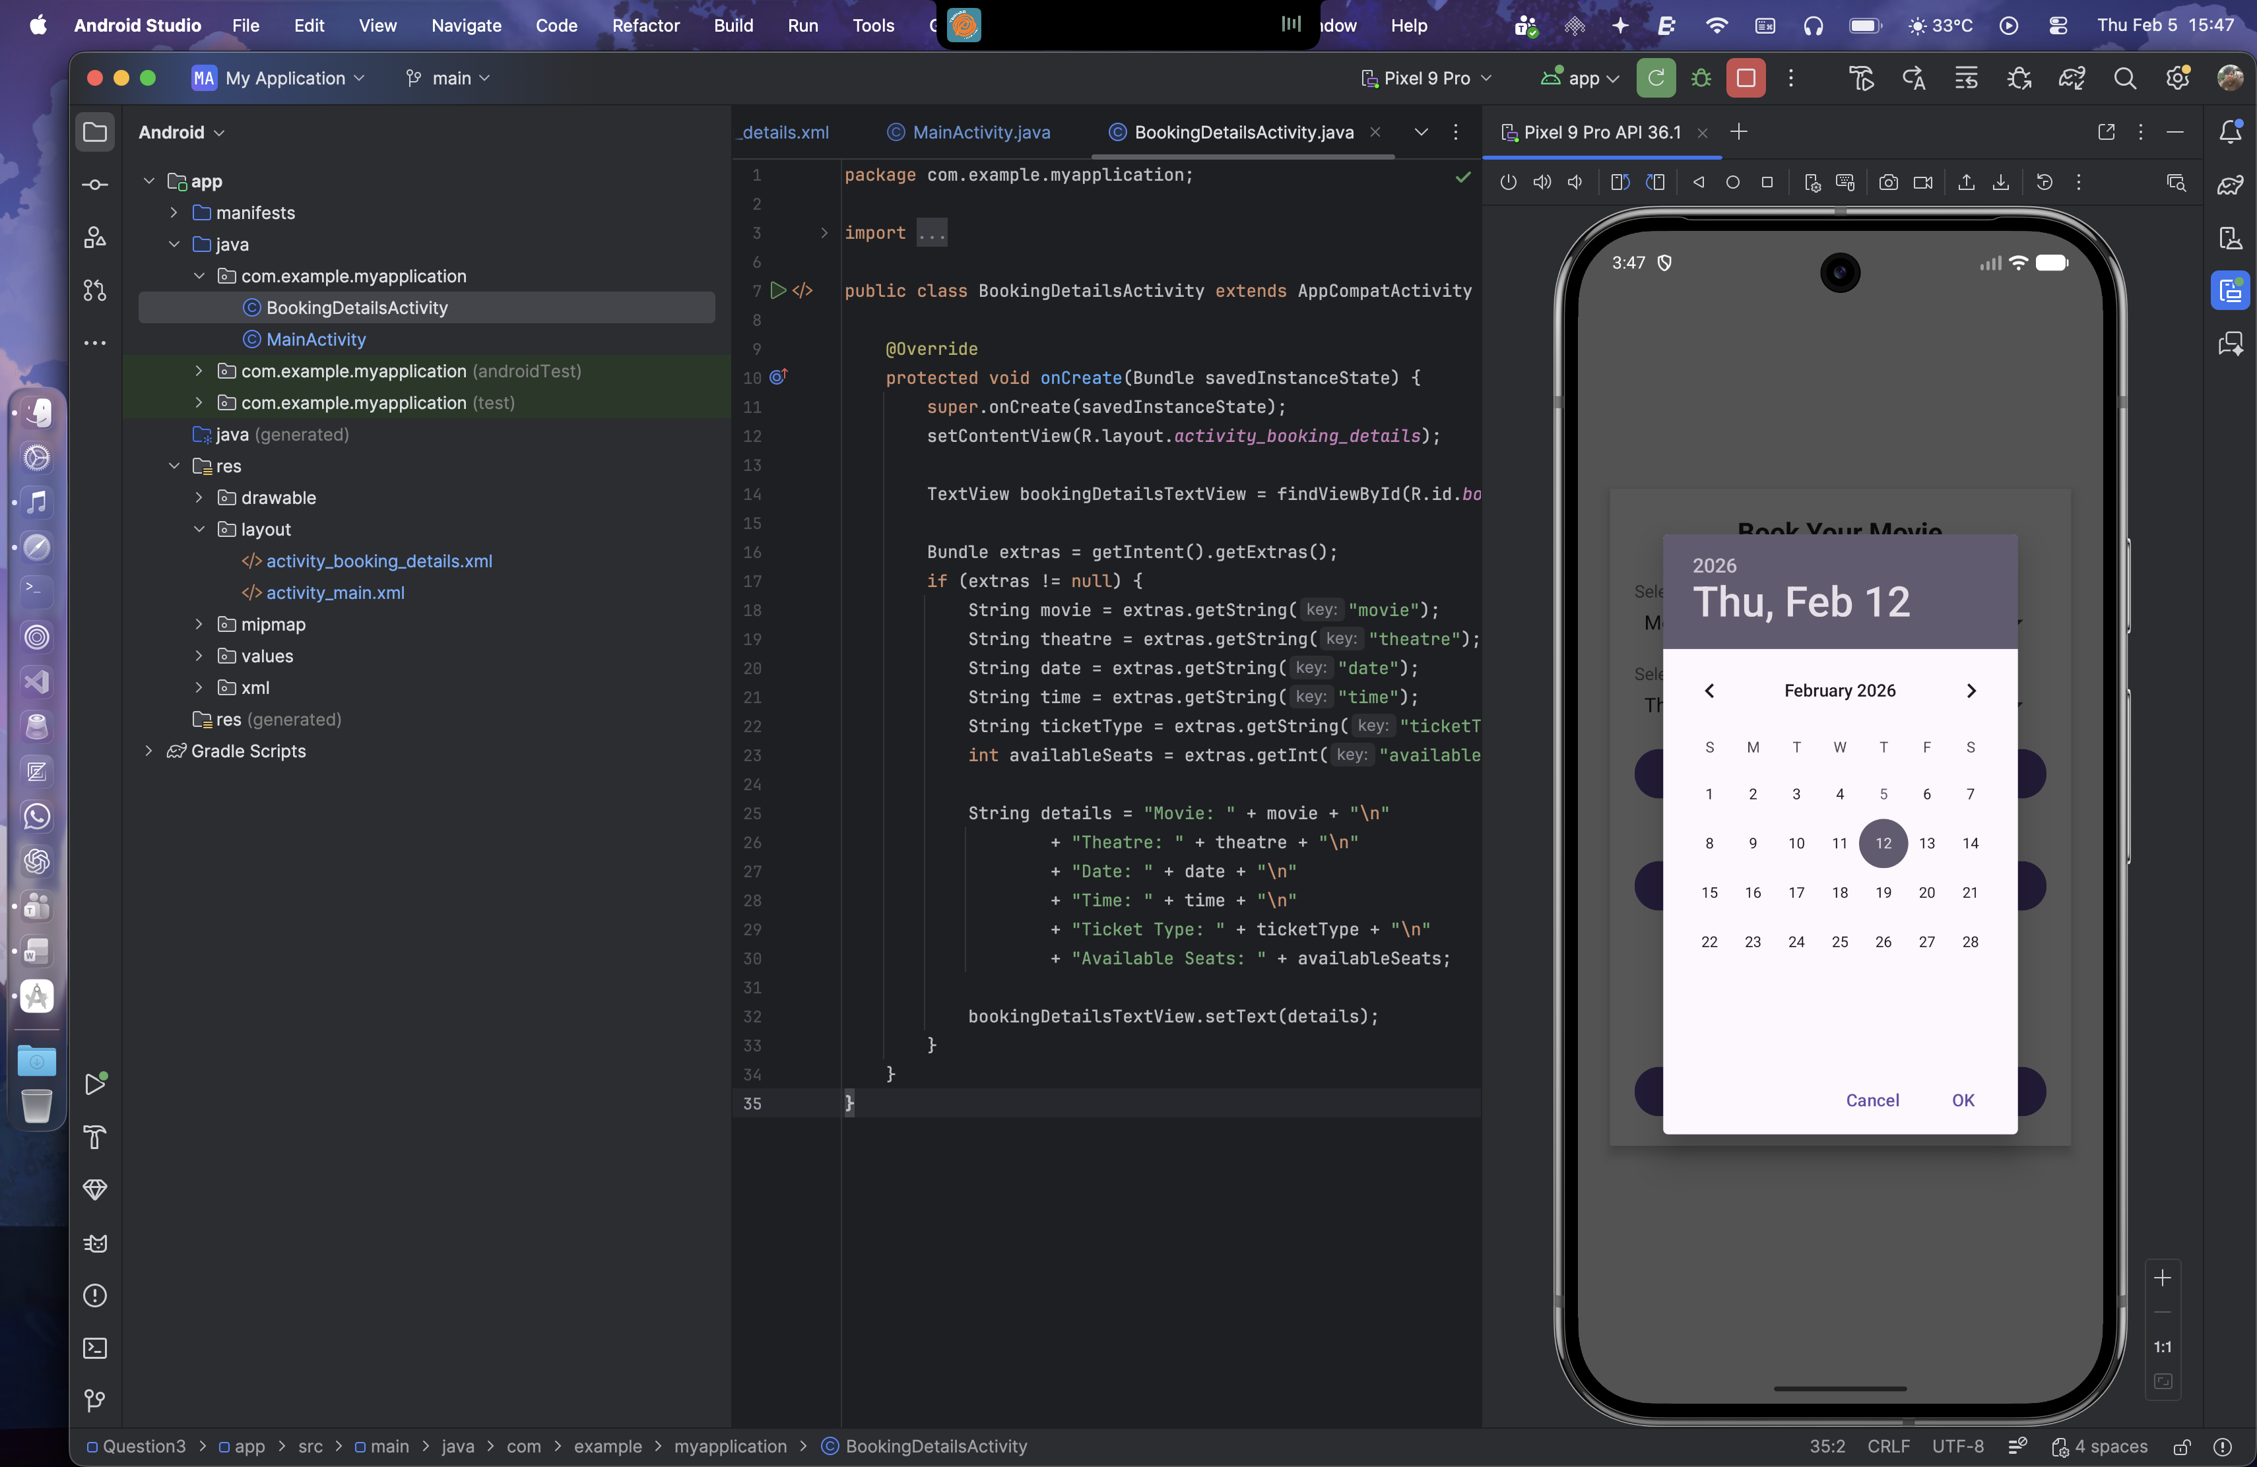 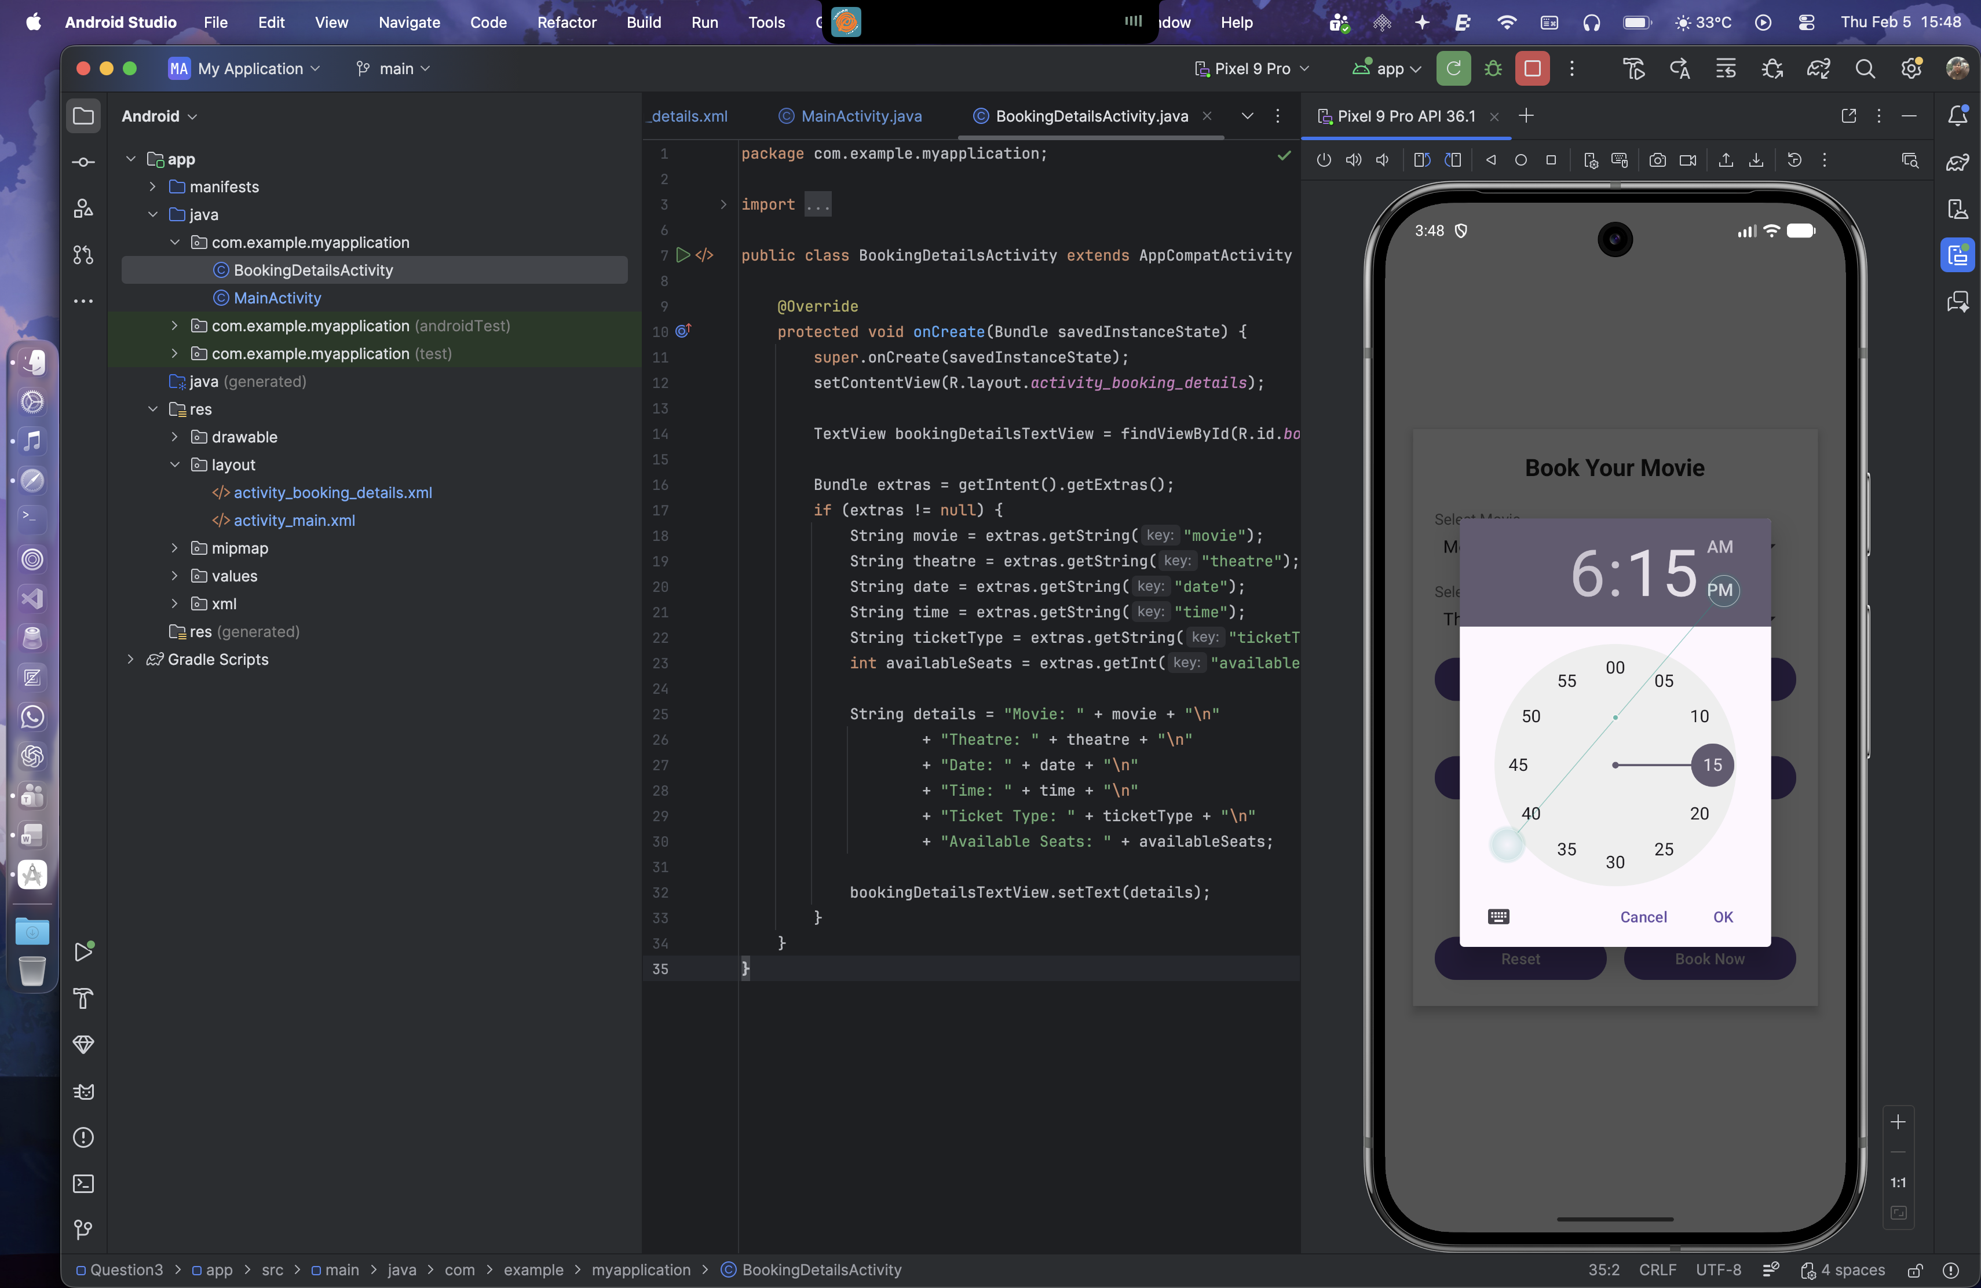 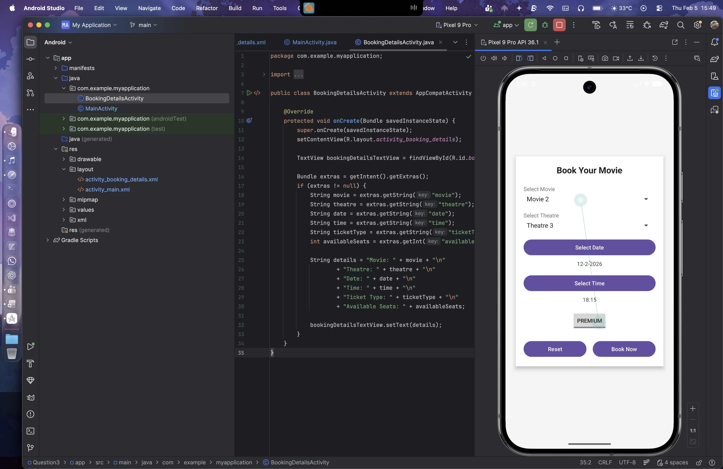

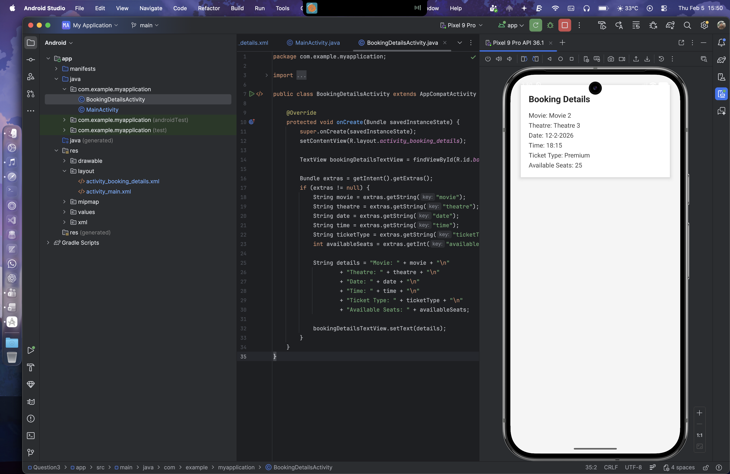

**Lab 6- Introduction to Menu**

Question 1:

* 1. Design a home page for the "XYZ Fitness Center" using an Options Menu with the following Requirements.

1. Create a simple option menus where in once you click the “menu options”, the option items should get displayed which are "Workout Plans," "Trainers," "Membership". "Workout Plans" should display the list of workout programs (e.g., Weight Loss, Cardio). "Trainers" should display the names and specializations of trainers with their photos. "Membership" should show the membership packages with pricing details.
2. This option menu uses images/icons instead of textual content. This textual content should represent “Contact US”, “About Us”,” Homepage”. Once the user clicks on the corresponding icons it should display corresponding content.

Layout Design:

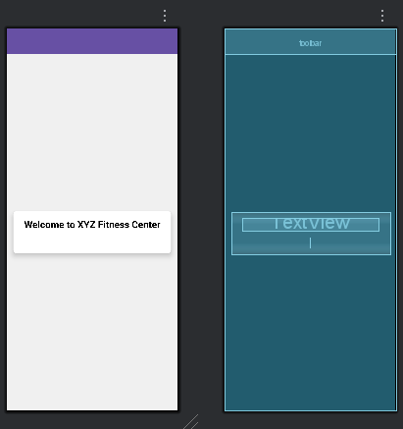 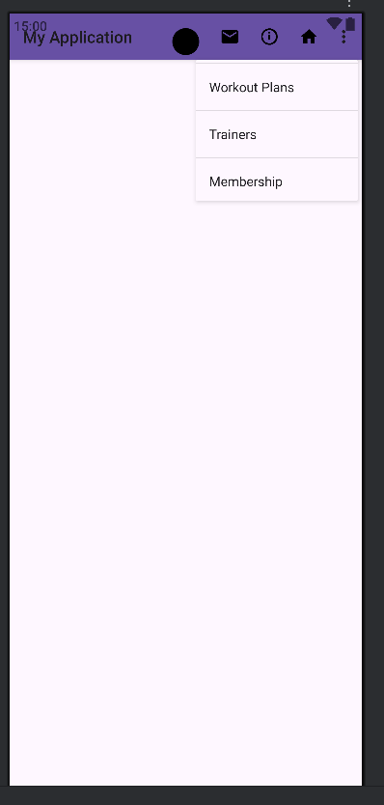

XML for activity_main.xml

<?xml version="1.0" encoding="utf-8"?>  
<androidx.constraintlayout.widget.ConstraintLayout xmlns:android="http://schemas.android.com/apk/res/android"  
 xmlns:app="http://schemas.android.com/apk/res-auto"  
 xmlns:tools="http://schemas.android.com/tools"  
 android:id="@+id/main"  
 android:layout_width="match_parent"  
 android:layout_height="match_parent"  
 android:background="#F0F0F0"  
 tools:context=".MainActivity">  
  
 <androidx.appcompat.widget.Toolbar  
 android:id="@+id/toolbar"  
 android:layout_width="match_parent"  
 android:layout_height="?attr/actionBarSize"  
 android:background="?attr/colorPrimary"  
 android:elevation="4dp"  
 android:theme="@style/ThemeOverlay.AppCompat.ActionBar"  
 app:layout_constraintTop_toTopOf="parent"  
 app:popupTheme="@style/ThemeOverlay.AppCompat.Light" />  
  
 <androidx.cardview.widget.CardView  
 android:layout_width="match_parent"  
 android:layout_height="wrap_content"  
 android:layout_margin="16dp"  
 app:cardCornerRadius="8dp"  
 app:cardElevation="8dp"  
 app:layout_constraintBottom_toBottomOf="parent"  
 app:layout_constraintEnd_toEndOf="parent"  
 app:layout_constraintStart_toStartOf="parent"  
 app:layout_constraintTop_toBottomOf="@+id/toolbar">  
  
 <LinearLayout  
 android:layout_width="match_parent"  
 android:layout_height="wrap_content"  
 android:orientation="vertical"  
 android:padding="16dp">  
  
 <TextView  
 android:id="@+id/welcome_text"  
 android:layout_width="wrap_content"  
 android:layout_height="wrap_content"  
 android:layout_gravity="center_horizontal"  
 android:text="Welcome to XYZ Fitness Center"  
 android:textAlignment="center"  
 android:textColor="@android:color/black"  
 android:textSize="24sp"  
 android:textStyle="bold" />  
  
 <TextView  
 android:id="@+id/content_text"  
 android:layout_width="wrap_content"  
 android:layout_height="wrap_content"  
 android:layout_gravity="center_horizontal"  
 android:layout_marginTop="16dp"  
 android:text=""  
 android:textAlignment="center"  
 android:textColor="@android:color/black"  
 android:textSize="18sp" />  
  
 </LinearLayout>  
 </androidx.cardview.widget.CardView>  
  
</androidx.constraintlayout.widget.ConstraintLayout>

XML for main_menu.xml

<?xml version="1.0" encoding="utf-8"?>  
<menu xmlns:android="http://schemas.android.com/apk/res/android"  
 xmlns:app="http://schemas.android.com/apk/res-auto">  
  
 <item  
 android:id="@+id/workout_plans"  
 android:title="Workout Plans"  
 app:showAsAction="ifRoom" />  
  
 <item  
 android:id="@+id/trainers"  
 android:title="Trainers"  
 app:showAsAction="ifRoom" />  
  
 <item  
 android:id="@+id/membership"  
 android:title="Membership"  
 app:showAsAction="ifRoom" />  
  
 <item  
 android:id="@+id/action_contact"  
 android:icon="@drawable/ic_contact_mail"  
 android:title="Contact US"  
 app:showAsAction="always" />  
  
 <item  
 android:id="@+id/action_about"  
 android:icon="@drawable/ic_about_us"  
 android:title="About Us"  
 app:showAsAction="always" />  
  
 <item  
 android:id="@+id/action_homepage"  
 android:icon="@drawable/ic_home"  
 android:title="Homepage"  
 app:showAsAction="always" />  
  
</menu>

Included Drawables:

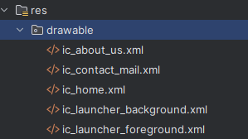

Java Code:

package com.example.myapplication;  
  
public class MainActivity extends AppCompatActivity {  
  
 private TextView contentText;  
  
 @Override  
 protected void onCreate(Bundle savedInstanceState) {  
 super.onCreate(savedInstanceState);  
 EdgeToEdge.*enable*(this);  
 setContentView(R.layout.*activity_main*);  
  
 Toolbar toolbar = findViewById(R.id.*toolbar*);  
 setSupportActionBar(toolbar);  
  
 contentText = findViewById(R.id.*content_text*);  
  
 ViewCompat.*setOnApplyWindowInsetsListener*(findViewById(R.id.*main*), (v, insets) -> {  
 Insets systemBars = insets.getInsets(WindowInsetsCompat.Type.*systemBars*());  
 v.setPadding(systemBars.left, systemBars.top, systemBars.right, systemBars.bottom);  
 return insets;  
 });  
 }  
  
 @Override  
 public boolean onCreateOptionsMenu(Menu menu) {  
 MenuInflater inflater = getMenuInflater();  
 inflater.inflate(R.menu.*main_menu*, menu);  
 return true;  
 }  
  
 @Override  
 public boolean onOptionsItemSelected(MenuItem item) {  
 int itemId = item.getItemId();  
 if (itemId == R.id.*workout_plans*) {  
 contentText.setText("Workout Plans:\n- Weight Loss\n- Cardio");  
 return true;  
 } else if (itemId == R.id.*trainers*) {  
 contentText.setText("Trainers:\n- John Doe (Weightlifting)\n- Jane Smith (Yoga)");  
 return true;  
 } else if (itemId == R.id.*membership*) {  
 contentText.setText("Membership Packages:\n- Basic: 1500/month\n- Premium: 2500/month");  
 return true;  
 } else if (itemId == R.id.*action_contact*) {  
 contentText.setText("Contact Us:\nEmail: contact@xyzfitness.com\nPhone: 123-456-7890");  
 return true;  
 } else if (itemId == R.id.*action_about*) {  
 contentText.setText("About Us:\nXYZ Fitness Center is dedicated to helping you achieve your fitness goals.");  
 return true;  
 } else if (itemId == R.id.*action_homepage*) {  
 contentText.setText("");  
 return true;  
 }  
 return super.onOptionsItemSelected(item);  
 }  
}

Output:

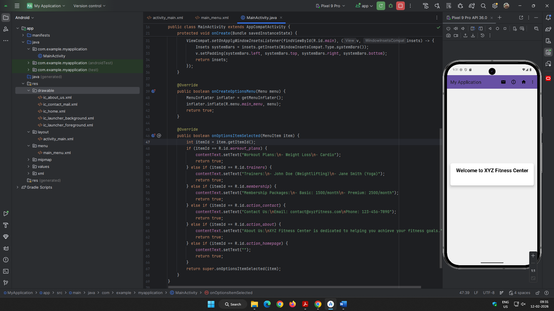 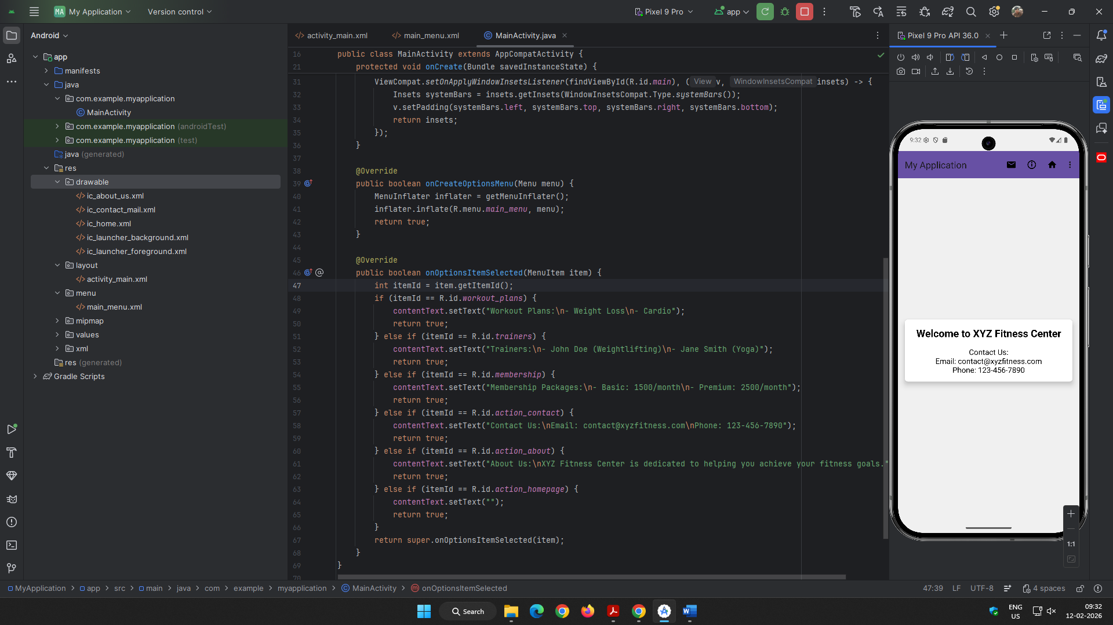 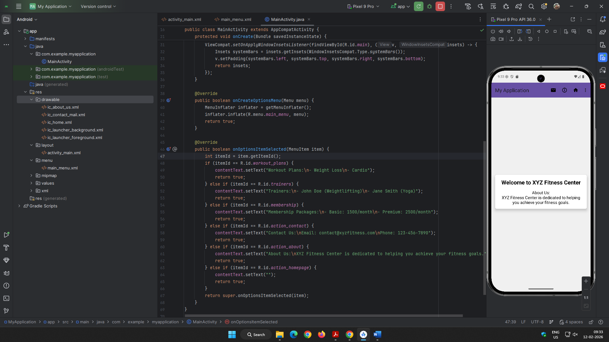 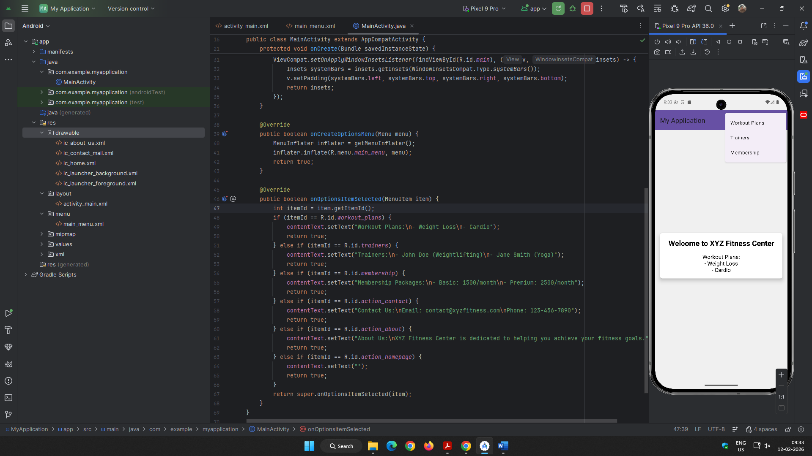 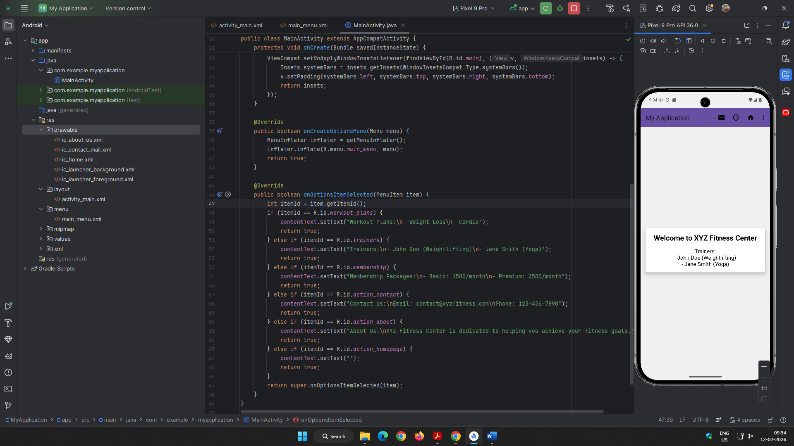

**Lab 7: Creating Contextual and Pop-Up Menus**

Question 1:

Design and develop an application that displays a list of installed applications on your device. On long press of any application, display the following options:

1. Show whether the application is a system app or user-installed.
2. Provide options to open the app, uninstall it, or view its details (e.g., version, storage usage).
3. Indicate whether the app has special permissions enabled, like location or camera access.

When an option like **"View Details"** is selected, navigate to a detailed view showing the app's permissions, size, and version. For the **"Uninstall"** option, prompt the user for confirmation before proceeding.

Layout Design:

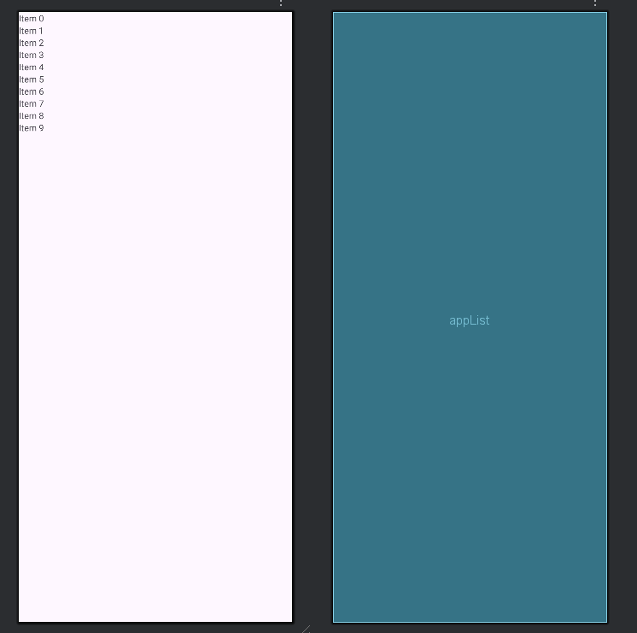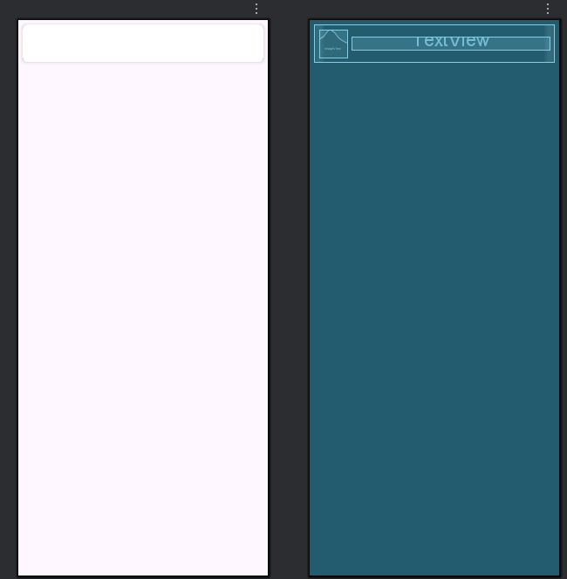

XML for activity_main.xml

<?xml version="1.0" encoding="utf-8"?>  
<androidx.constraintlayout.widget.ConstraintLayout xmlns:android="http://schemas.android.com/apk/res/android"  
 xmlns:app="http://schemas.android.com/apk/res-auto"  
 xmlns:tools="http://schemas.android.com/tools"

android:id="@+id/main"  
 android:layout_width="match_parent"  
 android:layout_height="match_parent"  
 tools:context=".MainActivity">  
  
 <androidx.recyclerview.widget.RecyclerView  
 android:id="@+id/appList"  
 android:layout_width="0dp"  
 android:layout_height="0dp"  
 app:layout_constraintBottom_toBottomOf="parent"  
 app:layout_constraintEnd_toEndOf="parent"  
 app:layout_constraintStart_toStartOf="parent"  
 app:layout_constraintTop_toTopOf="parent" />  
  
</androidx.constraintlayout.widget.ConstraintLayout>

XML for app_list_item.xml

<?xml version="1.0" encoding="utf-8"?>  
<androidx.cardview.widget.CardView xmlns:android="http://schemas.android.com/apk/res/android"  
 xmlns:app="http://schemas.android.com/apk/res-auto"  
 android:layout_width="match_parent"  
 android:layout_height="wrap_content"  
 android:layout_margin="8dp"  
 app:cardCornerRadius="8dp"  
 app:cardElevation="4dp">  
  
 <LinearLayout  
 android:layout_width="match_parent"  
 android:layout_height="wrap_content"  
 android:orientation="horizontal"  
 android:padding="8dp">  
  
 <ImageView  
 android:id="@+id/appIcon"  
 android:layout_width="48dp"  
 android:layout_height="48dp"  
 android:contentDescription="@string/app_icon" />  
  
 <TextView  
 android:id="@+id/appName"  
 android:layout_width="0dp"  
 android:layout_height="wrap_content"  
 android:layout_gravity="center_vertical"  
 android:layout_marginStart="8dp"  
 android:layout_weight="1"  
 android:textSize="16sp" />  
  
 </LinearLayout>  
  
</androidx.cardview.widget.CardView>

Java Code:

MainActivity.java

import java.util.List;  
  
public class MainActivity extends AppCompatActivity implements AppAdapter.OnItemLongClickListener {  
  
 private RecyclerView appList;  
 private AppAdapter appAdapter;  
 private List<ApplicationInfo> installedApps;  
  
 @Override  
 protected void onCreate(Bundle savedInstanceState) {  
 super.onCreate(savedInstanceState);  
 setContentView(R.layout.*activity_main*);  
  
 appList = findViewById(R.id.*appList*);  
 appList.setLayoutManager(new LinearLayoutManager(this));  
  
 installedApps = getInstalledApps();  
 appAdapter = new AppAdapter(this, installedApps, this);  
 appList.setAdapter(appAdapter);  
 }  
  
 private List<ApplicationInfo> getInstalledApps() {  
 PackageManager pm = getPackageManager();  
 return pm.getInstalledApplications(PackageManager.*GET_META_DATA*);  
 }  
  
 @Override  
 public void onItemLongClick(ApplicationInfo appInfo) {  
 final CharSequence[] items = {  
 "Is System App: " + isSystemApp(appInfo),  
 "Open App",  
 "Uninstall App",  
 "View Details",  
 "Has Special Permissions: " + hasSpecialPermissions(appInfo)  
 };  
  
 AlertDialog.Builder builder = new AlertDialog.Builder(this);  
 builder.setTitle(appInfo.loadLabel(getPackageManager()));  
 builder.setItems(items, (dialog, item) -> {  
 switch (item) {  
 case 1: // Open App  
 Intent launchIntent = getPackageManager().getLaunchIntentForPackage(appInfo.packageName);  
 if (launchIntent != null) {  
 startActivity(launchIntent);  
 } else {  
 Toast.*makeText*(MainActivity.this, "Cannot open this app", Toast.*LENGTH_SHORT*).show();  
 }  
 break;  
 case 2: // Uninstall App  
 uninstallApp(appInfo.packageName);  
 break;  
 case 3: // View Details  
 viewAppDetails(appInfo.packageName);  
 break;  
 }  
 });  
 builder.show();  
 }  
  
 private boolean isSystemApp(ApplicationInfo appInfo) {  
 return (appInfo.flags & ApplicationInfo.*FLAG_SYSTEM*) != 0;  
 }  
  
 private boolean hasSpecialPermissions(ApplicationInfo appInfo) {  
 PackageManager pm = getPackageManager();  
 return pm.checkPermission(android.Manifest.permission.*ACCESS_FINE_LOCATION*, appInfo.packageName) == PackageManager.*PERMISSION_GRANTED* ||  
 pm.checkPermission(android.Manifest.permission.*CAMERA*, appInfo.packageName) == PackageManager.*PERMISSION_GRANTED*;  
 }  
  
 private void uninstallApp(String packageName) {  
 new AlertDialog.Builder(this)  
 .setTitle("Uninstall App")  
 .setMessage("Are you sure you want to uninstall this app?")  
 .setPositiveButton("Yes", (dialog, which) -> {  
 Intent intent = new Intent(Intent.*ACTION_DELETE*);  
 intent.setData(Uri.*parse*("package:" + packageName));  
 startActivity(intent);  
 })  
 .setNegativeButton("No", null)  
 .show();  
 }  
  
 private void viewAppDetails(String packageName) {  
 Intent intent = new Intent(Settings.*ACTION_APPLICATION_DETAILS_SETTINGS*);  
 intent.setData(Uri.*parse*("package:" + packageName));  
 startActivity(intent);  
 }  
}

AppAdapter.java

package com.example.myapplication;  
  
public class AppAdapter extends RecyclerView.Adapter<AppAdapter.ViewHolder> {  
  
 private final Context context;  
 private final List<ApplicationInfo> appList;  
 private final OnItemLongClickListener longClickListener;  
  
 public interface OnItemLongClickListener {  
 void onItemLongClick(ApplicationInfo appInfo);  
 }  
  
 public AppAdapter(Context context, List<ApplicationInfo> appList, OnItemLongClickListener longClickListener) {  
 this.context = context;  
 this.appList = appList;  
 this.longClickListener = longClickListener;  
 }  
  
 @NonNull  
 @Override  
 public ViewHolder onCreateViewHolder(@NonNull ViewGroup parent, int viewType) {  
 View view = LayoutInflater.*from*(context).inflate(R.layout.*app_list_item*, parent, false);  
 return new ViewHolder(view);  
 }  
  
 @Override  
 public void onBindViewHolder(@NonNull ViewHolder holder, int position) {  
 ApplicationInfo appInfo = appList.get(position);  
 PackageManager pm = context.getPackageManager();  
  
 holder.appName.setText(appInfo.loadLabel(pm));  
 holder.appIcon.setImageDrawable(appInfo.loadIcon(pm));  
  
 holder.itemView.setOnLongClickListener(v -> {  
 if (longClickListener != null) {  
 longClickListener.onItemLongClick(appInfo);  
 }  
 return true;  
 });  
 }  
  
 @Override  
 public int getItemCount() {  
 return appList.size();  
 }  
  
 public static class ViewHolder extends RecyclerView.ViewHolder {  
 ImageView appIcon;  
 TextView appName;  
  
 public ViewHolder(@NonNull View itemView) {  
 super(itemView);  
 appIcon = itemView.findViewById(R.id.*appIcon*);  
 appName = itemView.findViewById(R.id.*appName*);  
 }  
 }  
}

Output:

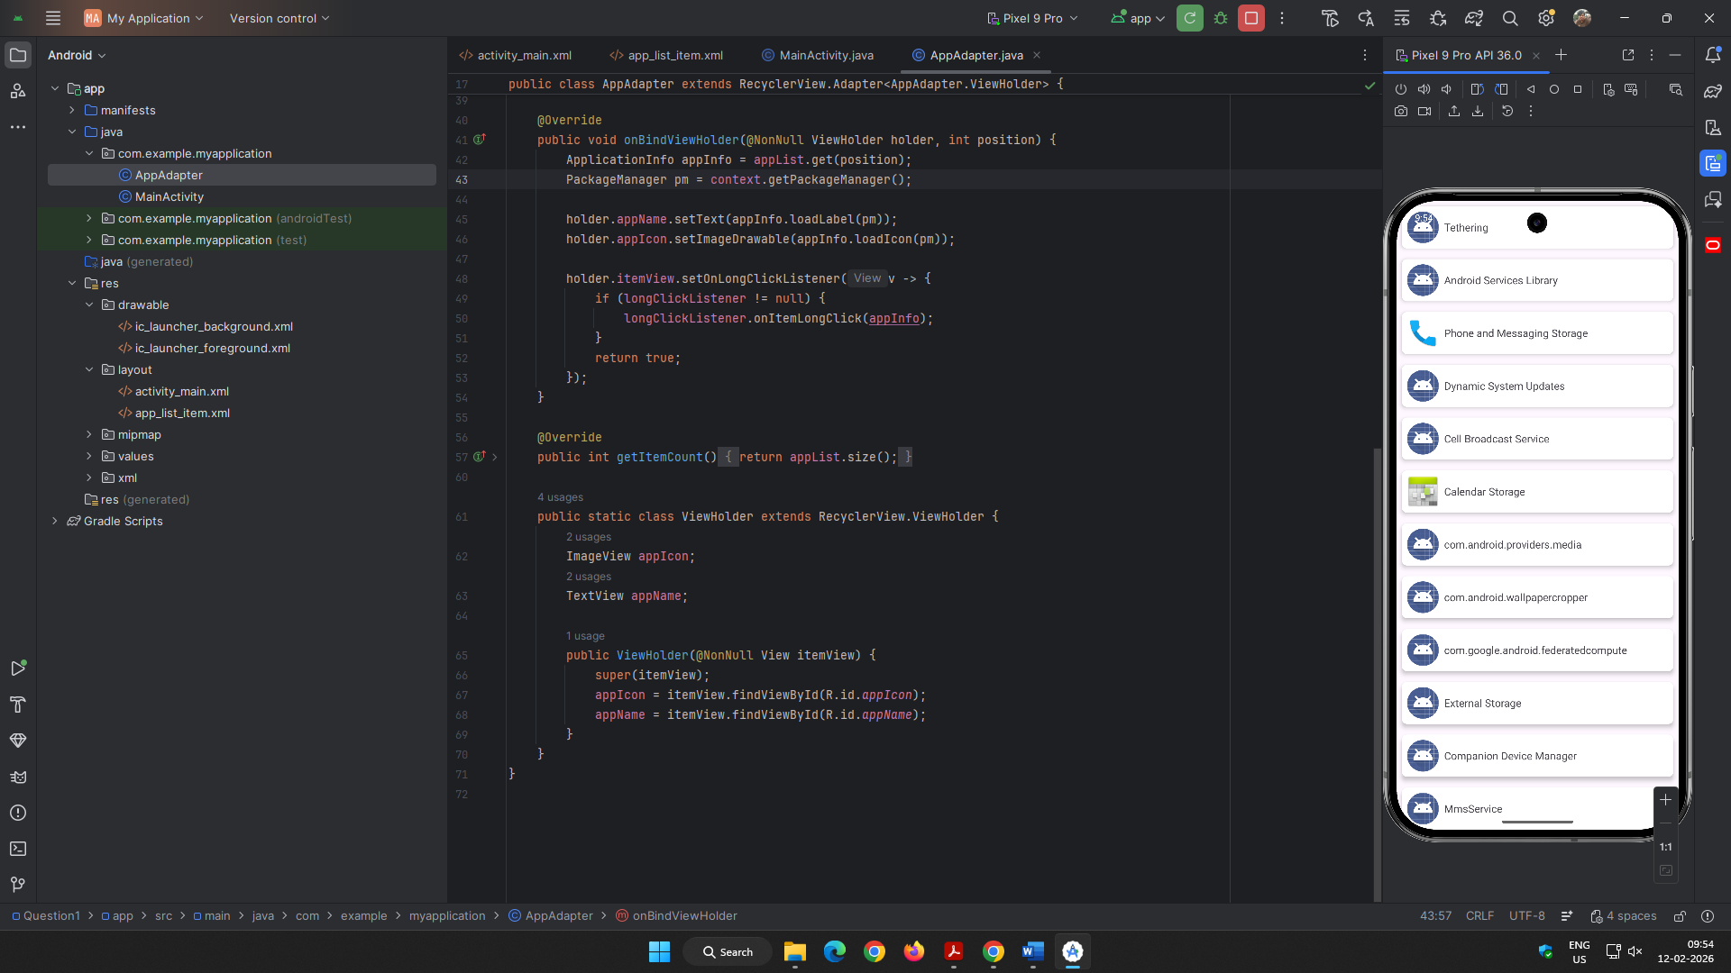 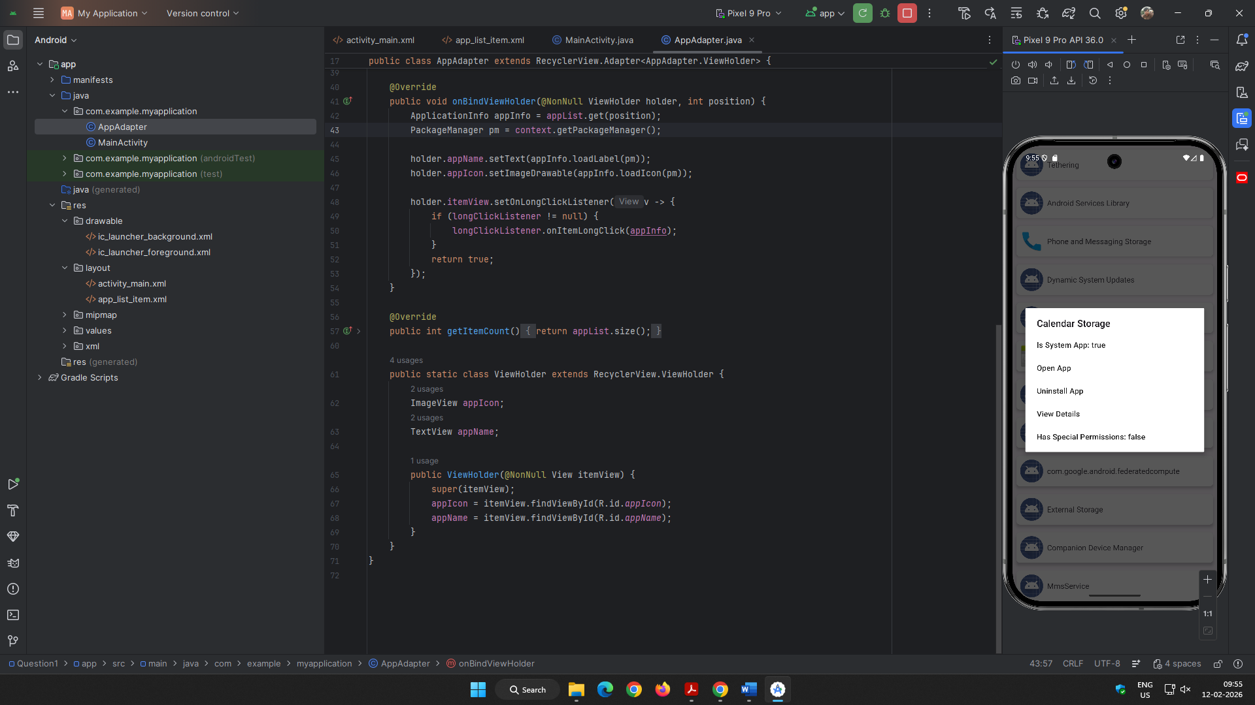 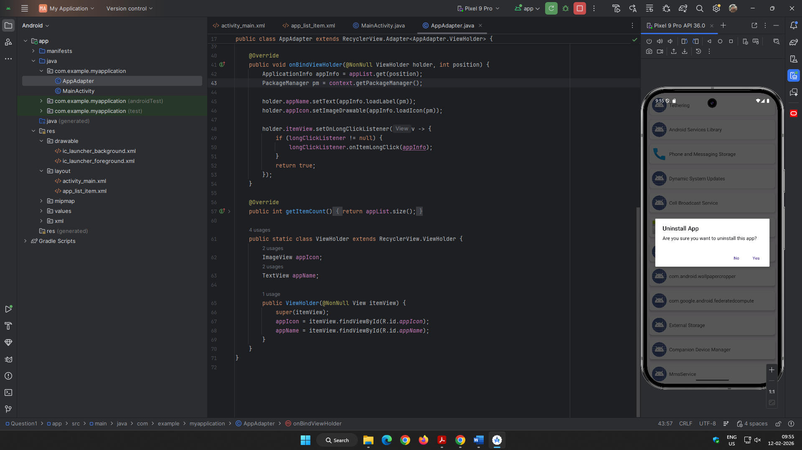

Question 2:

Create a View with the name “My Menu ” which contains an image as an icon. On click of that icon it shows a submenu as ”Image -1”,”Image -2” .On click of each item that particular image should be displayed with the corresponding content in the Toast.

Layout Design:

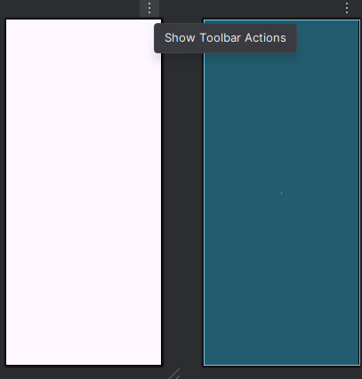 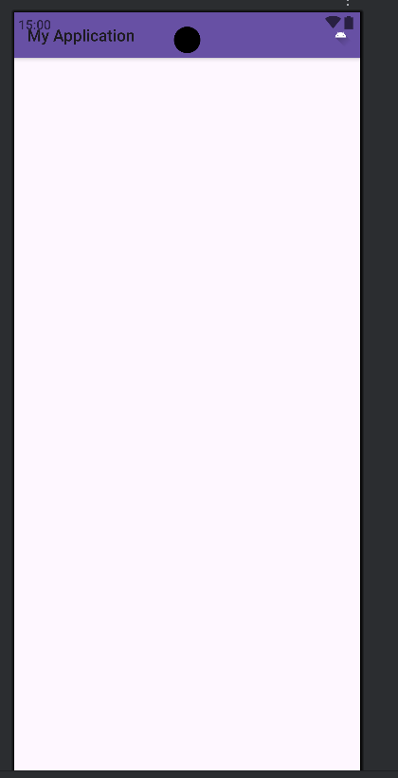

XML for activity_main.xml

<?xml version="1.0" encoding="utf-8"?>  
<androidx.constraintlayout.widget.ConstraintLayout xmlns:android="http://schemas.android.com/apk/res/android"  
 xmlns:app="http://schemas.android.com/apk/res-auto"  
 xmlns:tools="http://schemas.android.com/tools"  
 android:id="@+id/main"  
 android:layout_width="match_parent"  
 android:layout_height="match_parent"  
 tools:context=".MainActivity">  
  
 <ImageView  
 android:id="@+id/imageView"  
 android:layout_width="wrap_content"  
 android:layout_height="wrap_content"  
 app:layout_constraintBottom_toBottomOf="parent"  
 app:layout_constraintEnd_toEndOf="parent"  
 app:layout_constraintStart_toStartOf="parent"  
 app:layout_constraintTop_toTopOf="parent" />  
  
</androidx.constraintlayout.widget.ConstraintLayout>

XML for my_menu.xml

<menu xmlns:android="http://schemas.android.com/apk/res/android"  
 xmlns:app="http://schemas.android.com/apk/res-auto">  
 <item  
 android:id="@+id/my_menu"  
 android:title="My Menu"  
 android:icon="@drawable/ic_launcher_foreground"  
 app:showAsAction="ifRoom">  
 <menu>  
 <item  
 android:id="@+id/image1"  
 android:title="Image -1" />  
 <item  
 android:id="@+id/image2"  
 android:title="Image -2" />  
 </menu>  
 </item>  
</menu>

Modified themes.xml

<resources xmlns:tools="http://schemas.android.com/tools">  
 <!-- Base application theme. -->  
 <style name="Base.Theme.MyApplication" parent="Theme.Material3.DayNight">  
 <!-- Customize your light theme here. -->  
 <!-- <item name="colorPrimary">@color/my_light_primary</item> -->  
 </style>  
  
 <style name="Theme.MyApplication" parent="Base.Theme.MyApplication" />  
</resources>

Attested Drawable:

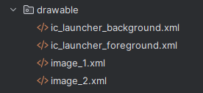

Java Code:

package com.example.myapplication;  
  
  
public class MainActivity extends AppCompatActivity {  
  
 private ImageView imageView;  
  
 @Override  
 protected void onCreate(Bundle savedInstanceState) {  
 super.onCreate(savedInstanceState);  
 EdgeToEdge.*enable*(this);  
 setContentView(R.layout.*activity_main*);  
 imageView = findViewById(R.id.*imageView*);  
 ViewCompat.*setOnApplyWindowInsetsListener*(findViewById(R.id.*main*), (v, insets) -> {  
 Insets systemBars = insets.getInsets(WindowInsetsCompat.Type.*systemBars*());  
 v.setPadding(systemBars.left, systemBars.top, systemBars.right, systemBars.bottom);  
 return insets;  
 });  
 }  
  
 @Override  
 public boolean onCreateOptionsMenu(Menu menu) {  
 MenuInflater inflater = getMenuInflater();  
 inflater.inflate(R.menu.*my_menu*, menu);  
 return true;  
 }  
  
 @Override  
 public boolean onOptionsItemSelected(@NonNull MenuItem item) {  
 int itemId = item.getItemId();  
 if (itemId == R.id.*image1*) {  
 imageView.setImageResource(R.drawable.*image_1*);  
 Toast.*makeText*(this, "This is Image 1", Toast.*LENGTH_SHORT*).show();  
 return true;  
 } else if (itemId == R.id.*image2*) {  
 imageView.setImageResource(R.drawable.*image_2*);  
 Toast.*makeText*(this, "This is Image 2", Toast.*LENGTH_SHORT*).show();  
 return true;  
 }  
 return super.onOptionsItemSelected(item);  
 }  
}

Output:

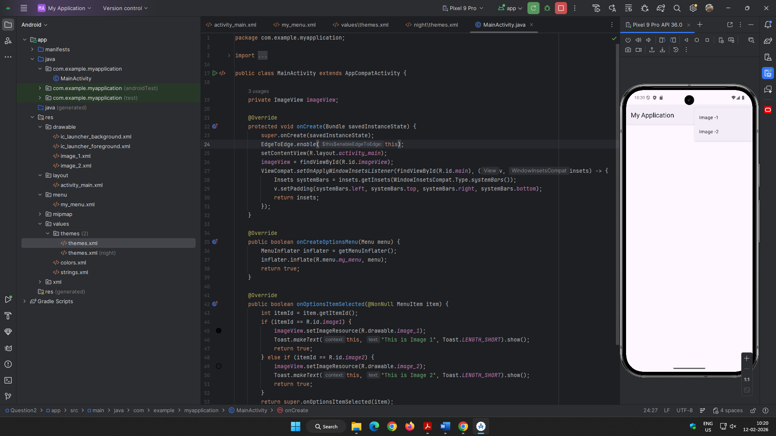 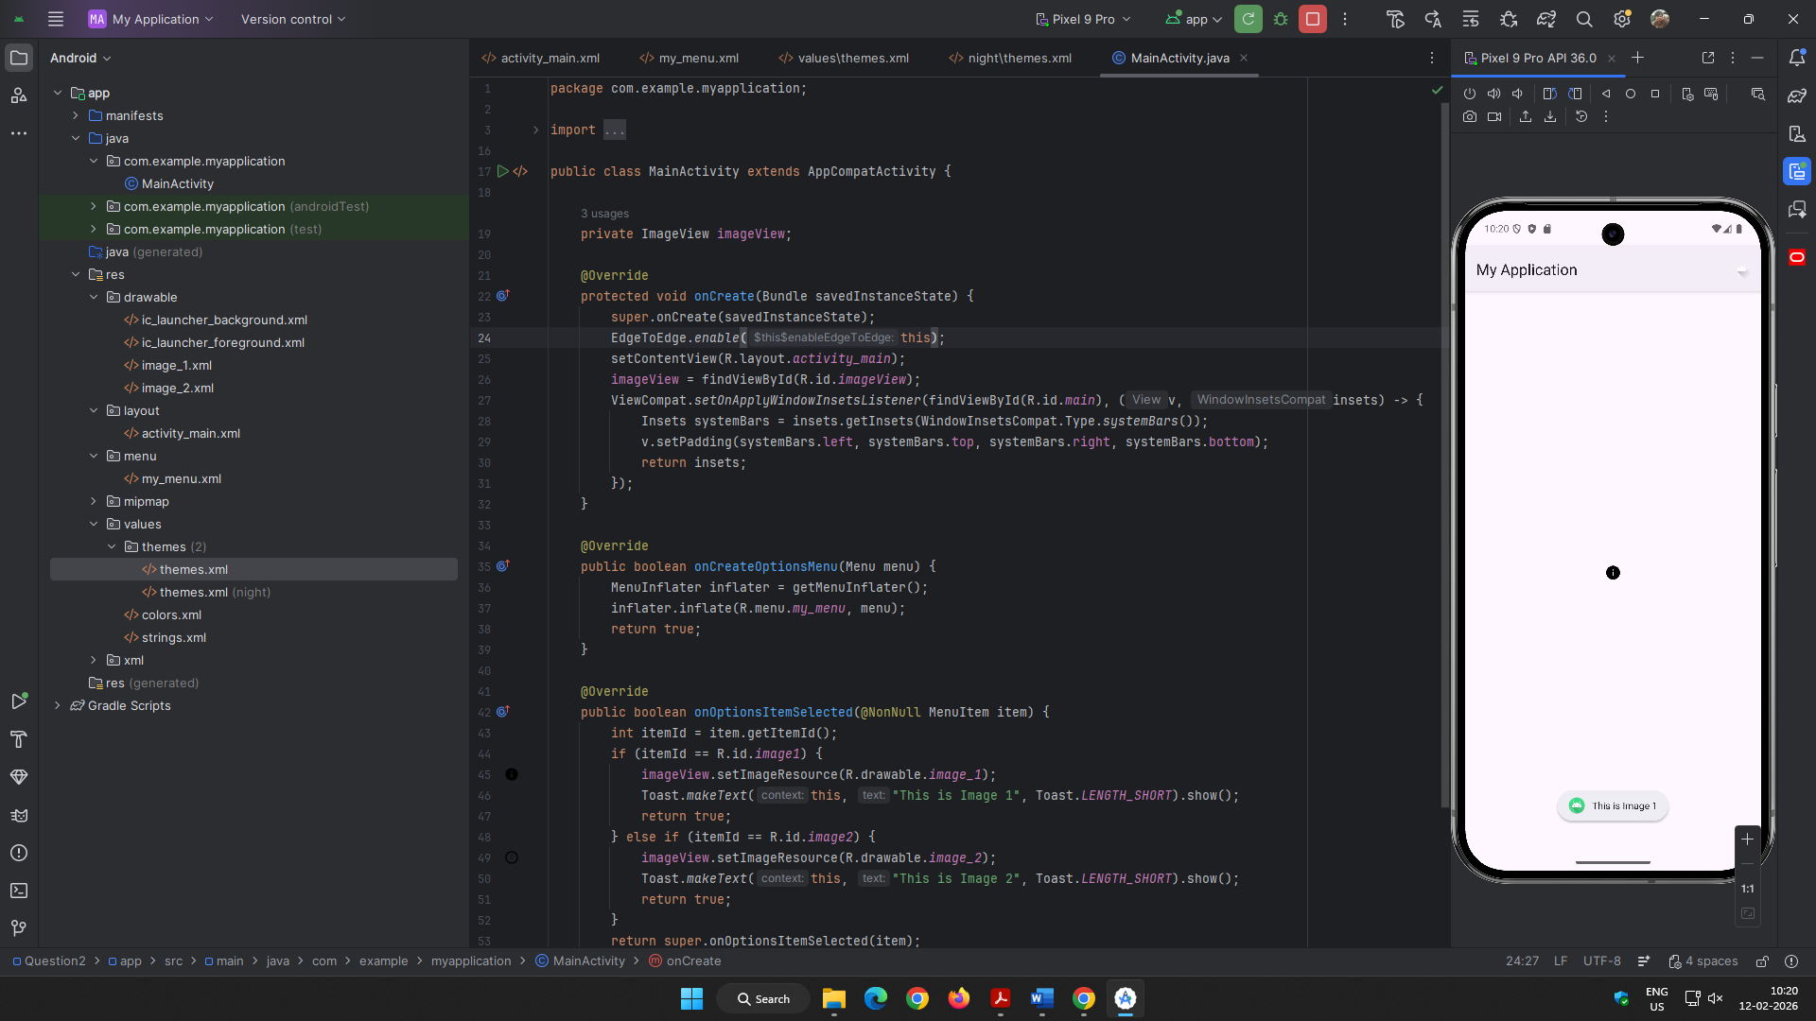 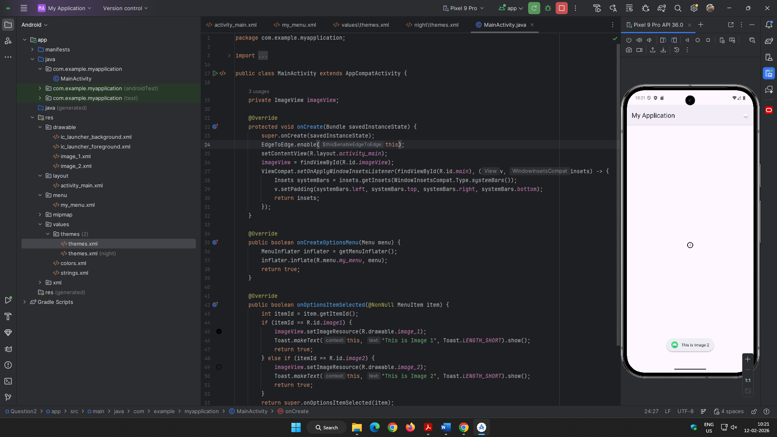

Question 3:

* 1. Create a view that displays textual content providing a description of "Digital Transformation". Add a filter option with submenus:

1. "Search Keywords" - Allow the user to input keywords that can be searched within the content.
2. "Highlight" - Highlight specific words or phrases provided by the user in the document.
3. "Sort" - Provide an option to sort the entire content either alphabetically or by relevance to the search keywords.

Layout Design:

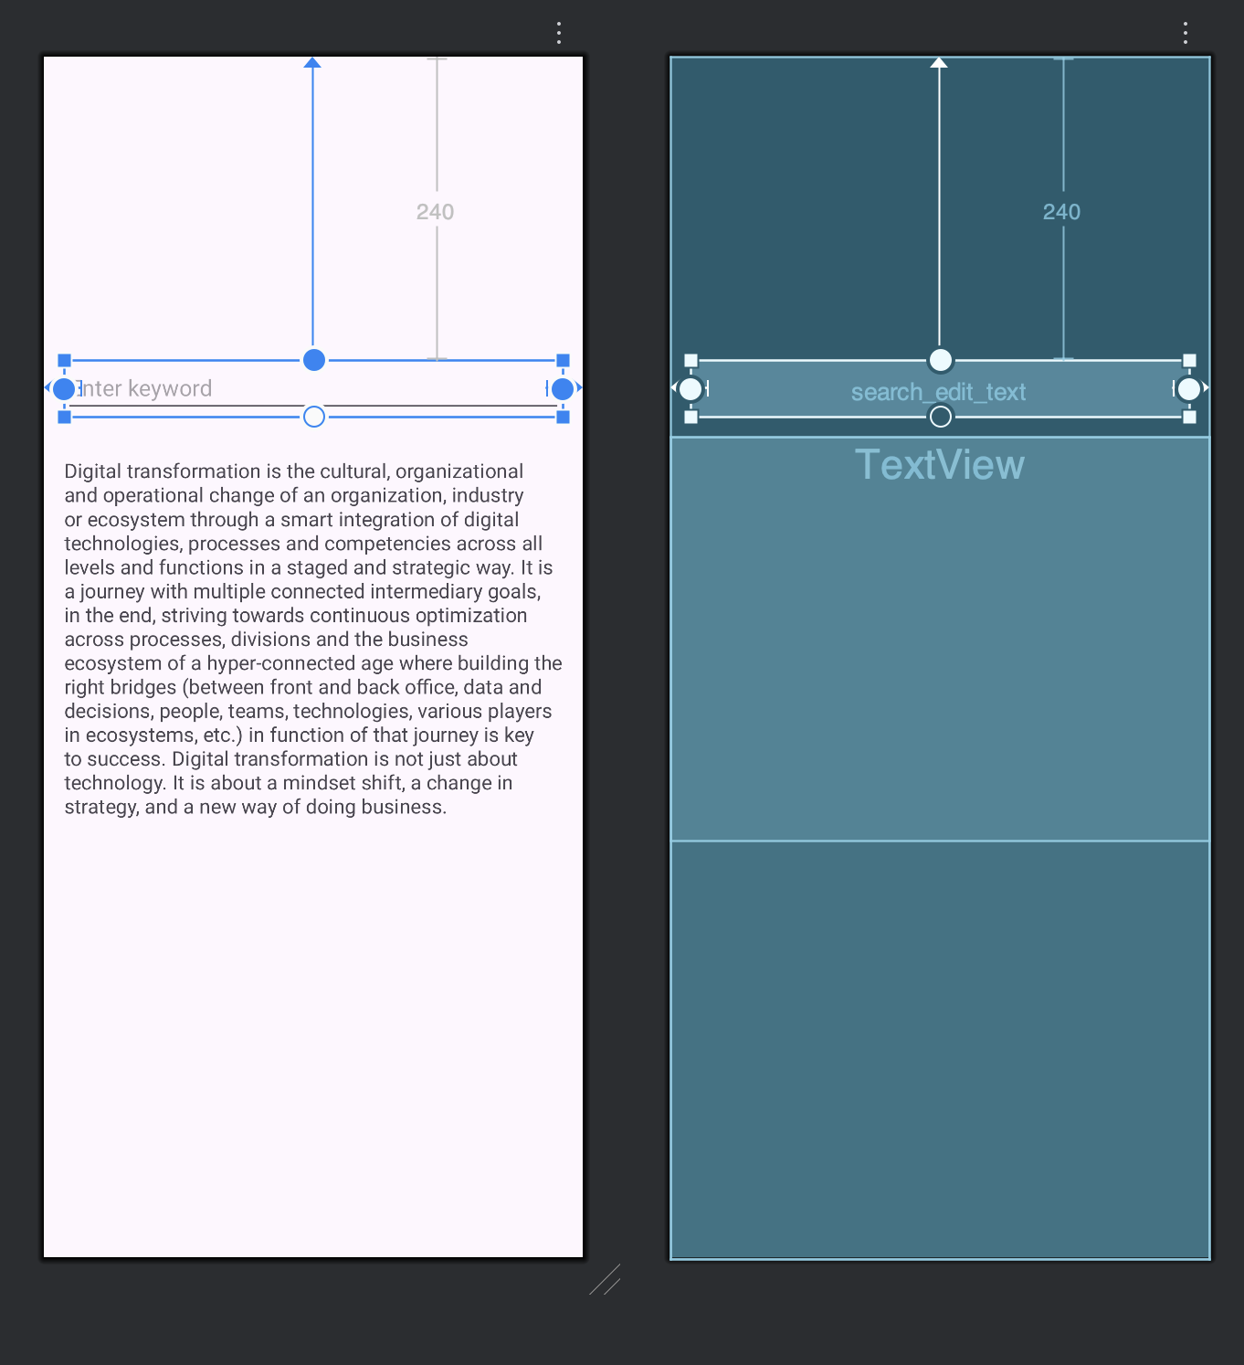 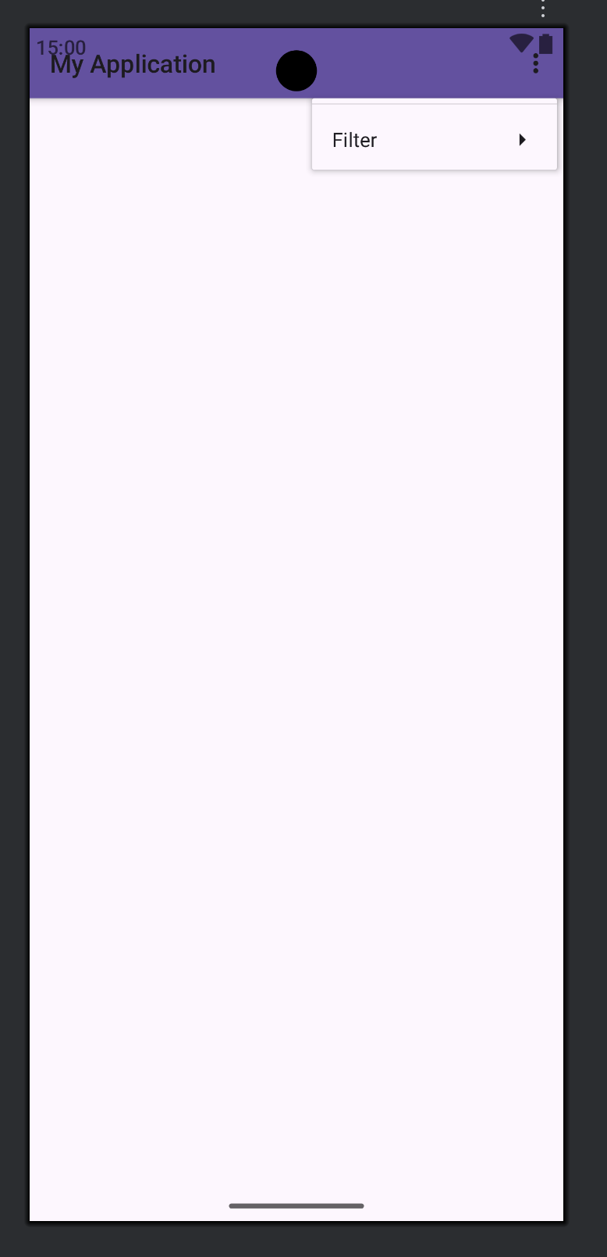

XML for activity_main.xml

<?xml version="1.0" encoding="utf-8"?>  
<androidx.constraintlayout.widget.ConstraintLayout xmlns:android="http://schemas.android.com/apk/res/android"  
 xmlns:app="http://schemas.android.com/apk/res-auto"  
 xmlns:tools="http://schemas.android.com/tools"  
 android:id="@+id/main"  
 android:layout_width="match_parent"  
 android:layout_height="match_parent"  
 tools:context=".MainActivity">  
  
 <EditText  
 android:id="@+id/search_edit_text"  
 android:layout_width="0dp"  
 android:layout_height="wrap_content"  
 android:hint="Enter keyword"  
 app:layout_constraintTop_toTopOf="parent"  
 app:layout_constraintStart_toStartOf="parent"  
 app:layout_constraintEnd_toEndOf="parent"  
 android:layout_marginTop="240dp"  
 android:layout_marginStart="16dp"  
 android:layout_marginEnd="16dp"/>  
  
 <ScrollView  
 android:layout_width="0dp"  
 android:layout_height="0dp"  
 app:layout_constraintTop_toBottomOf="@id/search_edit_text"  
 app:layout_constraintBottom_toBottomOf="parent"  
 app:layout_constraintStart_toStartOf="parent"  
 app:layout_constraintEnd_toEndOf="parent"  
 android:layout_marginTop="16dp">  
  
 <TextView  
 android:id="@+id/description_text_view"  
 android:layout_width="match_parent"  
 android:layout_height="wrap_content"  
 android:text="@string/digital_transformation_description"  
 android:padding="16dp"  
 android:textSize="16sp" />  
 </ScrollView>  
  
</androidx.constraintlayout.widget.ConstraintLayout>

XML for main_menu.xml

<?xml version="1.0" encoding="utf-8"?>  
<menu xmlns:android="http://schemas.android.com/apk/res/android">  
 <item  
 android:id="@+id/filter_menu"  
 android:title="Filter">  
 <menu>  
 <item  
 android:id="@+id/search_keywords"  
 android:title="Search Keywords" />  
 <item  
 android:id="@+id/highlight"  
 android:title="Highlight" />  
 <item  
 android:id="@+id/sort"  
 android:title="Sort">  
 <menu>  
 <item  
 android:id="@+id/sort_alphabetically"  
 android:title="Alphabetically" />  
 <item  
 android:id="@+id/sort_by_relevance"  
 android:title="By Relevance" />  
 </menu>  
 </item>  
 </menu>  
 </item>  
</menu>

XML for themes.xml

<resources xmlns:tools="http://schemas.android.com/tools">  
 <!-- Base application theme. -->  
 <style name="Base.Theme.MyApplication" parent="Theme.Material3.DayNight">  
 <!-- Customize your light theme here. -->  
 <!-- <item name="colorPrimary">@color/my_light_primary</item> -->  
 </style>  
  
 <style name="Theme.MyApplication" parent="Base.Theme.MyApplication" />  
</resources>

Java Code:

public class MainActivity extends AppCompatActivity {  
  
 private TextView descriptionTextView;  
 private EditText searchEditText;  
 private String originalText;  
  
 @Override  
 protected void onCreate(Bundle savedInstanceState) {  
 super.onCreate(savedInstanceState);  
 setContentView(R.layout.*activity_main*);  
  
 descriptionTextView = findViewById(R.id.*description_text_view*);  
 searchEditText = findViewById(R.id.*search_edit_text*);  
 originalText = getString(R.string.*digital_transformation_description*);  
 descriptionTextView.setText(originalText);  
 }  
  
 @Override  
 public boolean onCreateOptionsMenu(Menu menu) {  
 MenuInflater inflater = getMenuInflater();  
 inflater.inflate(R.menu.*main_menu*, menu);  
 return true;  
 }  
  
 @Override  
 public boolean onOptionsItemSelected(@NonNull MenuItem item) {  
 int itemId = item.getItemId();  
 if (itemId == R.id.*search_keywords*) {  
 searchKeywords();  
 return true;  
 } else if (itemId == R.id.*highlight*) {  
 highlightText();  
 return true;  
 } else if (itemId == R.id.*sort_alphabetically*) {  
 sortAlphabetically();  
 return true;  
 } else if (itemId == R.id.*sort_by_relevance*) {  
 sortByRelevance();  
 return true;  
 }  
 return super.onOptionsItemSelected(item);  
 }  
  
 private void searchKeywords() {  
 String keyword = searchEditText.getText().toString();  
 if (keyword.isEmpty()) {  
 Toast.*makeText*(this, "Please enter a keyword", Toast.*LENGTH_SHORT*).show();  
 return;  
 }  
 if (originalText.toLowerCase().contains(keyword.toLowerCase())) {  
 Toast.*makeText*(this, "Keyword found", Toast.*LENGTH_SHORT*).show();  
 } else {  
 Toast.*makeText*(this, "Keyword not found", Toast.*LENGTH_SHORT*).show();  
 }  
 }  
  
 private void highlightText() {  
 String textToHighlight = searchEditText.getText().toString();  
 if (textToHighlight.isEmpty()) {  
 Toast.*makeText*(this, "Please enter text to highlight", Toast.*LENGTH_SHORT*).show();  
 return;  
 }  
  
 Spannable spannable = new SpannableString(originalText);  
 String normalizedOriginal = Normalizer.*normalize*(originalText, Normalizer.Form.*NFD*).replaceAll("\\p{InCombiningDiacriticalMarks}+", "").toLowerCase();  
 String normalizedHighlight = Normalizer.*normalize*(textToHighlight, Normalizer.Form.*NFD*).replaceAll("\\p{InCombiningDiacriticalMarks}+", "").toLowerCase();  
  
 int index = normalizedOriginal.indexOf(normalizedHighlight);  
 while (index >= 0) {  
 spannable.setSpan(new BackgroundColorSpan(Color.*YELLOW*), index, index + textToHighlight.length(), Spannable.*SPAN_EXCLUSIVE_EXCLUSIVE*);  
 index = normalizedOriginal.indexOf(normalizedHighlight, index + 1);  
 }  
 descriptionTextView.setText(spannable);  
 }  
  
 private void sortAlphabetically() {  
 String[] words = originalText.split("\\s+");  
 Arrays.*sort*(words);  
 StringBuilder sortedText = new StringBuilder();  
 for (String word : words) {  
 sortedText.append(word).append(" ");  
 }  
 descriptionTextView.setText(sortedText.toString().trim());  
 }  
  
 private void sortByRelevance() {  
 final String keyword = searchEditText.getText().toString();  
 if (keyword.isEmpty()) {  
 Toast.*makeText*(this, "Please enter a keyword for relevance sorting", Toast.*LENGTH_SHORT*).show();  
 return;  
 }  
  
 String[] sentences = originalText.split("\\. ");  
 Arrays.*sort*(sentences, new Comparator<String>() {  
 @Override  
 public int compare(String s1, String s2) {  
 int count1 = countOccurrences(s1.toLowerCase(), keyword.toLowerCase());  
 int count2 = countOccurrences(s2.toLowerCase(), keyword.toLowerCase());  
 return Integer.*compare*(count2, count1);  
 }  
 });  
  
 StringBuilder sortedText = new StringBuilder();  
 for (String sentence : sentences) {  
 sortedText.append(sentence).append(". ");  
 }  
 descriptionTextView.setText(sortedText.toString().trim());  
 }  
  
 private int countOccurrences(String text, String keyword) {  
 int count = 0;  
 int index = 0;  
 while ((index = text.indexOf(keyword, index)) != -1) {  
 count++;  
 index += keyword.length();  
 }  
 return count;  
 }  
}

Output:

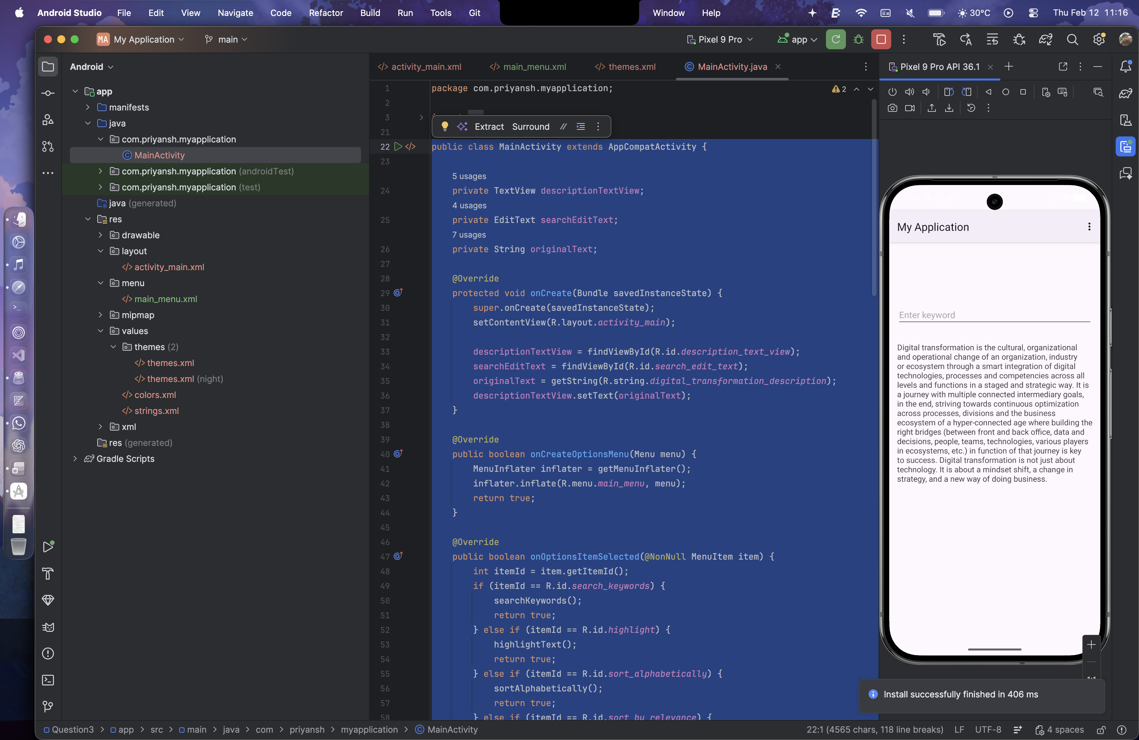 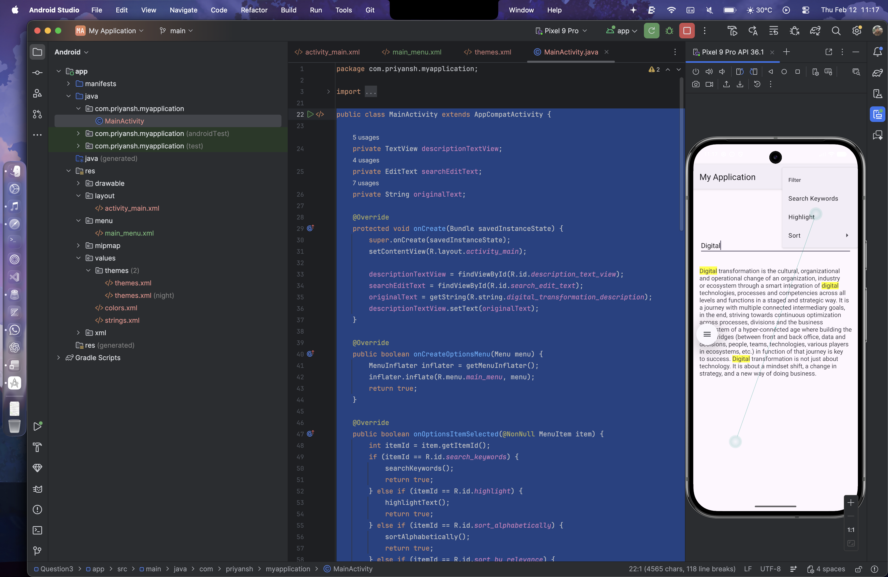 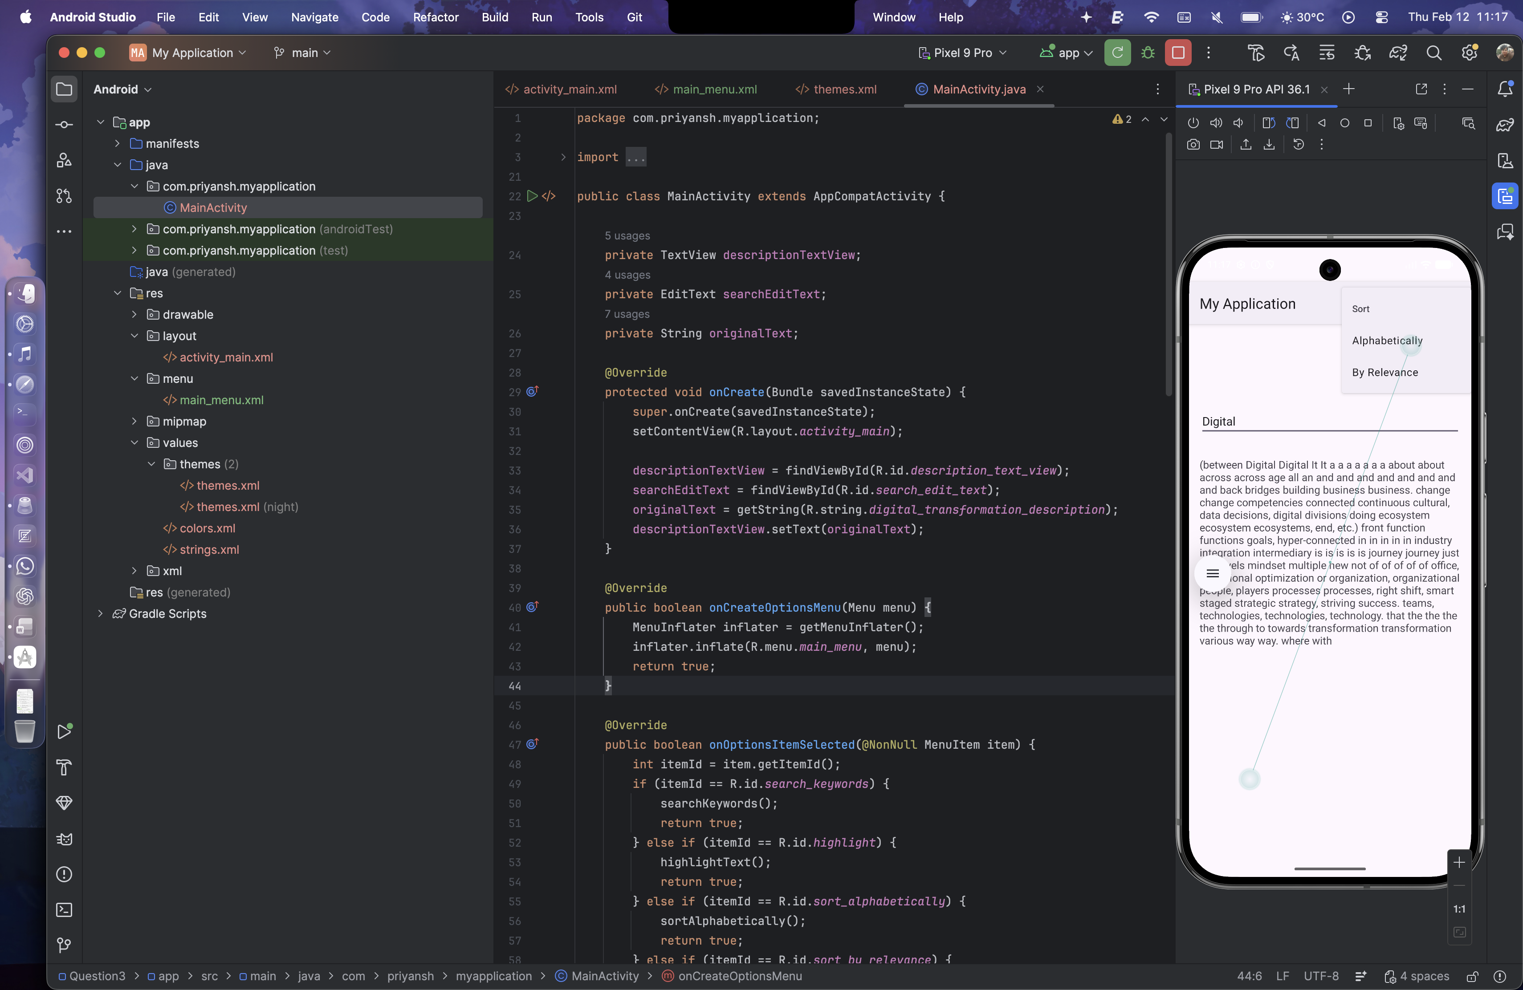 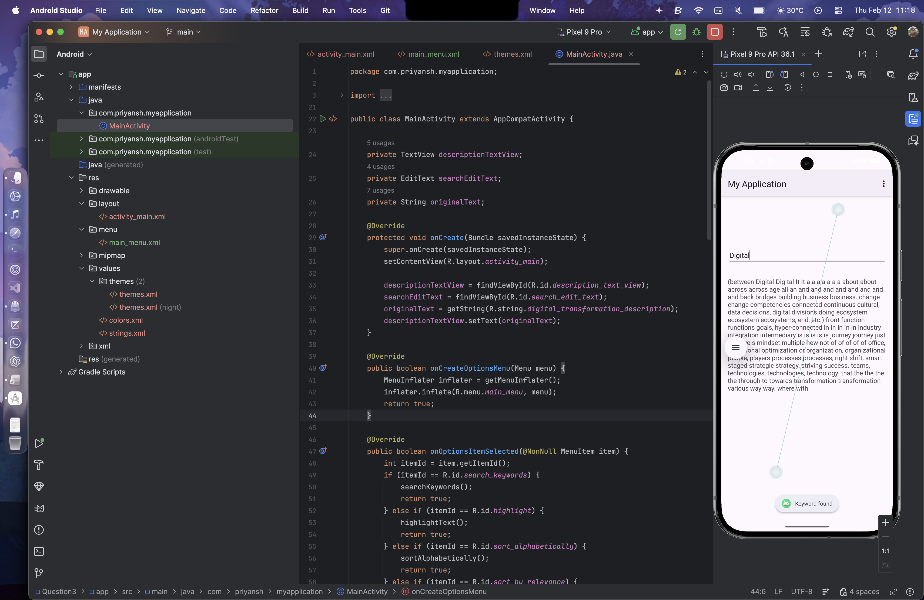

**Lab 8: Android SQLITE & Shared Preferences**

Question 1:

Write a program to create a "Task Manager" application with the following features:

1. A form to create and save tasks with fields like task name, due date, and priority level (High, Medium, Low).
2. A list view to display all the saved tasks with their details.
3. An option to edit or delete any task from the list.

Layout Design: